C178483F-5E49-40CB-B90A-626D06A82F06

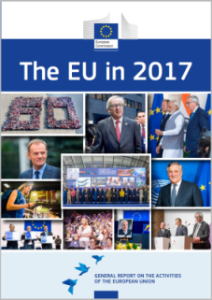



1. Over 900 employees of the European Commission formed a human number 60 to celebrate the 60th anniversary of the Treaties of Rome. (© European Union)

2. Jean-Claude Juncker, President of the European Commission. (© European Union)

3. Jean-Claude Juncker, President of the European Commission, Donald Tusk, President of the European Council, and Narendra Modi, Prime Minister of India, during the EU–India Summit in New Delhi, India, 6 October 2017. (© European Union)

4. On 9 March 2017 the European Council re-elected Donald Tusk as its President for a second term of 2½ years, from 1 June 2017 to 30 November 2019. (© European Union)

5. EU leaders pose for a group photo at the launch of the Permanent Structured Cooperation, enabling willing Member States to pursue greater cooperation in defence and security, during an EU summit in Brussels, 14 December 2017. (© European Union)

6. Antonio Tajani was elected President of the European Parliament on 17 January 2017, succeeding Martin Schulz. (© European Union)

7. Roaming charges ended in the EU on 15 June 2017. EU citizens travelling within the Member States can ‘roam like at home’ and pay domestic prices for roaming calls, text messages and data. (© European Union)

8. EU leaders proclaimed the European Pillar of Social Rights at the Social Summit for fair jobs and growth in Gothenburg, Sweden, 17 November 2017. (© European Union)

9. A partrcipantasks a question at one of the 316 Citizens’ Dialogues held across the EU in 2017, Toruń, Poland, 29 May 2017. (© European Union)

10. The European Union marks the passing of Helmut Kohl, former Chancellor of Germany, who died on 16 June 2017 aged 87. (© European Union)

11. Joseph Muscat, Prime Minister of Malta, Donald Tusk, President of the European Council, and Jean-Claude Juncker, President of the European Commission, at a press conference during the informal meeting of EU Heads of State or Government, Malta, 3 February 2017. (© European Union)

The EU in 2017

GENERAL REPORT ON THE ACTIVITIES OF THE EUROPEAN UNION

Published in accordance with Article 249(2) of the Treaty on the Functioning of the European Union

**An interactive version of this publication, containing links to online content,**

**is available in PDF, EPUB and HTML format:**

europa.eu/general-report/en

**The EU in 2017 — General Report on the Activities of the European Union**

European Commission

Directorate-General for Communication

Citizens’ Information

1049 Brussels

BELGIUM

*The EU in 2017 — General Report on the Activities of the European Union* was adopted by the European Commission on 00 February 2018 under reference number COM(2017) 1289.

|  |  |  |  |
| --- | --- | --- | --- |
| Print | ISBN 978-92-79-71221-0 | ISSN 1608-7321 | doi:10.2775/80487 |
| PDF | ISBN 978-92-79-71257-9 | ISSN 1977-3374 | doi:10.2775/063021 |
| EPUB | ISBN 978-92-79-71274-6 | ISSN 1977-3374 | doi:10.2775/279970 |
| HTML | | ISSN 1977-3374 | doi:10.2775/686136 |

Luxembourg: Publications Office of the European Union, 2018

© European Union, 2018

Reproduction is authorised provided the source is acknowledged. For any use or reproduction of individual photos, permission must be sought directly from the copyright holders.

CREDITS

All photos © European Union unless otherwise stated.

Cover: copyrights as stated on the inside cover.

**Contents**

Foreword 6

1 - A new boost for jobs, growth and investment 9

2 - A connected Digital Single Market 27

3 - A resilient Energy Union with a forward-looking climate change policy 36

4 - A deeper and fairer internal market with a strengthened industrial base 45

5 - A deeper and fairer Economic and Monetary Union 53

Reaching out to Citizens – Highlights from Citizens' Dialogues in 2017 63

6 - A balanced and progressive trade policy to harness globalisation 66

7 - An area of justice and fundamental rights based on mutual trust 76

8 - Towards a new policy on migration 87

9 – A stronger global actor 95

10 – A Union of democratic change 108

The withdrawal of the United Kingdom from the European Union 124

Exceptional moments in 2017 126

Foreword

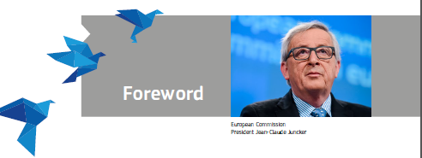

Foreword

2017 was a landmark year for the European Union. It was a year in which we celebrated the 60th anniversary of the Treaties of Rome. It was a year to reflect on how much has changed over the last six decades: our Union is now bigger, stronger and more diverse than it was back in 1957.

It was also the year in which we reaffirmed what we collectively stand for. The values and aspirations on which our Union was built remain the heartbeat of today's Europe. Freedom, democracy, equality and respect for human dignity and the rule of law: this is what unites and protects us.

We have come a long way in the last few years. We are delivering on all ten priorities that were established by the Commission and approved by the European Parliament and Member States. In that way, we are fulfilling the duty that European citizens and their Parliament entrusted to us following the 2014 European elections. This publication reports on our progress in 2017.

As the European Parliamentary Research Service says, three years after taking office, this Commission has now submitted 80% of the initiatives it has announced, and in some priority areas, such as the Digital Single Market where the figure is as high as 94%, almost all of the initiatives originally announced have already been presented.

We are now in the fifth year of an economic recovery that reaches every single Member State, with faster growth than the United States and Japan in 2016 and 2017. Employment is at a record high, unemployment at a nine year low. Our Investment Plan for Europe has already triggered over €256 billion of new investment, helping to create more than 300,000 jobs. I am very pleased that the European Parliament and Member States have agreed to increase and extend the European Fund for Strategic Investments to at least €500 billion by 2020.

I promised that we would be big on the big issues and small on the small ones. This meant cutting new legislation from well over 100 major initiatives per year under previous Commissions to just 21 in 2017. We have focused on concrete actions that improve people’s lives, such as ending roaming charges so people no longer pay extra for texting, calling or using the internet when travelling in the EU.

We are better equipped to face new migration and security challenges, thanks to the new European Border and Coast Guard patrolling in Greece, Italy, Bulgaria and Spain. We are working to tackle the root causes of migration and help people to build a better future for themselves at home. At the same time, solidarity remains at the heart of the EU’s migration policy. Europe will never turn its back on those in real need of protection.

The first EU-wide cyber security rules will be in place from May 2018 to protect our networks and keep our information systems safe. Europe is galvanizing global action and leading the world in implementing the Paris Agreement on climate change.

We have also delivered on commitments that many considered unthinkable even at the start of our mandate. 25 Member States signed up to Permanent Structured Cooperation on defence and security matters – a leap forward that will help make Europe that much stronger and safer. When I proposed this as President-elect in 2014 many thought it was a mere pipedream. It has now happened. And that goes to show what can be achieved with unity and ambition.

The same goes for making good on Europe's 60 year old promise of social fairness and progress. In November EU heads of state or government took part in a Social Summit in Gothenburg to look at common challenges and exchange our wealth of experience. It was there that we proclaimed the European Pillar of Social Rights to make good on that promise to fight for equality and better living and working standards.

We also showed the courage of our convictions when it came to free and fair trade. The Economic Partnership Agreement with Japan could increase our overall exports to Japan by more than a third and save €1 billion in customs duties for EU companies. Our trade agreement with Canada will save EU businesses almost €600 million annually. But we also showed that we are not naïve free traders, with a proposal on investment screening and modernisation of our trade defence instruments.

All of this shows that 2017 was the year when the wind truly came back into Europe's sails, with confidence and pride returning. We saw that as we honoured those who dedicated their life's work to fighting for our common values and putting peace above all else. The first ever European Ceremony of Honour in July in the European Parliament in Strasbourg was a fitting way to honour Dr. Helmut Kohl, Honorary Citizen of Europe.

In my eyes the most fitting tribute to Helmut Kohl, Simone Veil and all the other great Europeans who paved the way for today's Europe is to leave a better Union for our children., just as our parents and grandparents did for us.

It was in this spirit that in March we published the White Paper on the Future of Europe. The idea was to kick off an open and honest debate on our future by setting out how the Union could evolve by 2025, depending on the choices we make today. We have brought this debate to 27 countries through over 300 Citizens' Dialogues and reached millions of people through social media. The resounding message was that Europe has to take its future into its own hands, focusing on the things that matter the most and delivering for its citizens.

It was with this in mind that I presented in September during my State of the Union address my vision for a stronger, more democratic and more united Union. I want a Union of equals; a Union that focuses on the essentials; a Union that offers hope, stability, fairness and opportunity to all.

This future cannot remain abstract. We must start building it today. This is why I also set out a clear Roadmap for how we can get there before Europe's 27 leaders meet at a special Summit in Sibiu, Romania on 9 May 2019 to lay our common foundations after Brexit.

We have already taken the first steps by making significant proposals in December to make our Economic and Monetary Union stronger, helping to create an economy that provides security and opportunity for all. From a new European Monetary Fund, to a dedicated budget line for the euro area, through to a new European Minister of Economy and Finance, our proposals are a means to an end. They are about creating more jobs, growth and investment.

As we take the next steps on the road to Sibiu we must ensure that Europe stays united. This year showed us that Europe is more than just a single market, more than a single currency, more than a set of institutions and treaties. Europe is a Union of people and shared cultures. It is this rich mosaic of cultures and their legacy that we celebrate in the 2018 European Year of Cultural Heritage, launched in Milan in December.

This is the Europe we will continue to fight for in 2018.

Jean-Claude Juncker

Chapter 1

A new boost for jobs, growth and investment



‘My first priority as Commission President will be to strengthen Europe’s competitiveness and to stimulate investment for the purpose of job creation.’

Jean-Claude Juncker, political guidelines, 15 July 2014

Boosting jobs and growth remained the EU’s top priority in 2017, with economic trends being positive overall. In order to move on completely from the economic and financial crisis the challenge was to make the EU more resilient and competitive while ensuring that there were new opportunities for those who had been most affected by the crisis. This meant finding the right balance between ensuring the sustainability of public finances and achieving a fiscal stance that would help strengthen the recovery.

Efforts remained focused on supporting the clear trend of rising employment. This led in November to an [8.7% seasonally-adjusted unemployment rate](http://ec.europa.eu/eurostat/documents/2995521/8571046/3-09012018-AP-EN.pdf/0d35bf38-0dcc-4f3c-b3e8-5dbcdbe6908e) in the euro area, the lowest since January 2009.

The European Fund for Strategic Investments (the first pillar of the Investment Plan for Europe) has already mobilised over €256 billion in new investments across the EU, helping to create 300 000 jobs. Based on the projects approved in 2015 and 2016 it will have supported 700 000 jobs and added 0.7 % to the EU’s gross domestic product by 2020. In view of its success Jean-Claude Juncker, President of the European Commission, proposed that the Fund be extended.

In December it was agreed to increase the European Fund for Strategic Investments’ target and duration, to at least €500 billion by 2020. This is a considerable increase on the Investment Plan’s initial target of €315 billion in new investments. In November the European Parliament, the Council of the European Union and the European Commission proclaimed the European Pillar of Social Rights, which will serve as a compass for employment and social policymaking and a reference framework for measuring the performance of the Member States.

Throughout the year the EU helped national efforts to continue boosting the economy of the EU, including support for small and medium-sized enterprises, education, research and innovation, regional policy, transport, employment, the environment, agriculture and fisheries.

The Investment Plan for Europe

In 2015 the European Commission, together with the [European Investment Bank](http://www.eib.org/), launched the [Investment Plan for Europe](http://ec.europa.eu/priorities/jobs-growth-and-investment/investment-plan_en), which includes the [European Fund for Strategic Investments](http://www.eib.org/efsi/index.htm), created with an initial €21 billion of EU money and with the key aim of attracting private investment. Forecasts point to an additional 700 000 jobs and a 0.7 % increase in the EU’s gross domestic product by 2020 thanks to the investments approved in 2015 and 2016. This shows that, even in sectors and regions hard hit by the crisis a decade ago, strategic investment is boosting jobs and growth across the European Union. Following the [agreement in principle](http://europa.eu/rapid/press-release_IP-17-3207_en.htm) reached by the European Parliament and Member States in September, the Parliament voted in December to adopt a Regulation extending and enhancing the European Fund for Strategic Investments. The timeline of the new and improved European Fund for Strategic Investments 2.0 has been extended from mid 2018 to the end of 2020, and its investment target has been increased from €315 billion to at least €500 billion.

In 2017 the Fund remained firmly on track to mobilise at least €315 billion in additional investments in the real economy by mid 2018. It was active in all 28 Member States and was expected to trigger around €256 billion in total investments by the end of 2017.

WHAT’S NEW IN THE EUROPEAN FUND FOR STRATEGIC INVESTMENTS 2.0?

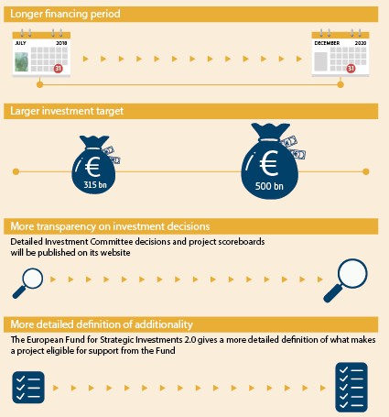

A total of 357 infrastructure and innovation projects, representing financing of €39.2 billion, had been approved under the Fund by the end of the year. In addition, 347 financing agreements for small and medium-sized enterprises, worth €11.9 billion, had been approved. Around 539 000 such businesses were expected to benefit from this.

In addition, advisory support for project development and preparation was stepped up through the [European Investment Advisory Hub](http://eiah.eib.org/), and projects looking for financing were given the necessary visibility on the [European Investment Project Portal](https://ec.europa.eu/eipp/desktop/en/index.html).

Concrete action was also taken to improve the business environment and to further reinforce the Single Market. At the EU level this included initiatives such as the Single Market Strategy, the Capital Markets Union, the Digital Single Market, the Energy Union and the Circular Economy Action Plan. As part of the European Semester the Commission also placed particular emphasis on identifying investment challenges at Member State level and the priority reforms to address them. These are well reflected in the country-specific recommendations for 27 Member States adopted by the Council on 11 July 2017.

NEW SECTORS ELIGIBLE FOR SUPPORT FROM THE EUROPEAN FUND FOR STRATEGIC INVESTMENTS 2.0

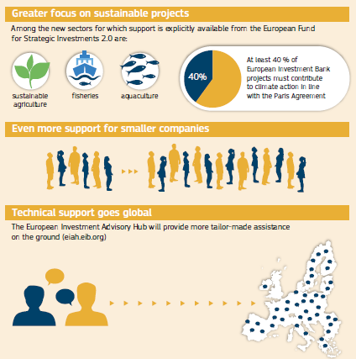

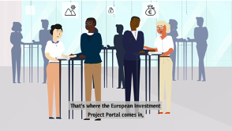

The European Investment Project Portal: finding the right partner for projects.

<https://ec.europa.eu/avservices/video/player.cfm?ref=I146756&lg=EN/EN&sublg=none>

Given the success of the Investment Plan, and following the September 2016 proposal to extend its duration and financing, the Parliament and the Council agreed in December to increase the European Fund for Strategic Investments’ target and duration to at least €500 billion by 2020.

The successful conclusion of the negotiations on a revision of the Financial Regulation at the end of 2017 will allow the enhanced interoperability of programmes and funds, with simpler rules for combining the [European Structural and Investment Funds](https://ec.europa.eu/info/funding-tenders/european-structural-and-investment-funds_en) and the European Fund for Strategic Investments. It will also provide the possibility to combine grants and financial instruments under the Connecting Europe Facility.

The Investment Plan in the real economy

The European Fund for Strategic Investments supports investment in sectors of strategic importance to the EU economy, including energy, transport, digital technologies, research, development and innovation, environment and resource efficiency, social infrastructure and small companies. This includes investment in social entrepreneurship, social impact and social innovation. For example, through the Fund the European Investment Bank financed 14 primary care centres in Ireland and provided money to construct a new campus for the Nova School of Business and Economics in Portugal. In addition, under its small-and-medium-sized-enterprise window, the Fund supported, through a €10 million investment, a payment-by-results scheme in Finland to foster the inclusion of refugees and migrants in the labour market.

Economic and fiscal policy

Economic policy coordination in the EU is organised annually in a cycle known as the [European Semester](https://ec.europa.eu/info/strategy/european-semester_en). It is launched towards the end of each year with, among other things, the publication of the Annual Growth Survey and a proposal for a recommendation on the economic policy of the euro area.

In February the 2017 [Country Reports](https://ec.europa.eu/info/publications/2017-european-semester-country-reports_en) were published, analysing the economic and social challenges in each of the EU’s Member States apart from Greece. The analysis also assessed macroeconomic imbalances and included a [report](https://ec.europa.eu/info/publications/fiscal-compact-taking-stock_en) on the national measures adopted to implement the [Treaty on Stability, Coordination and Governance in the Economic and Monetary Union](http://eur-lex.europa.eu/legal-content/EN/ALL/?uri=URISERV%3A1403_3), which stipulates that the national budgets of 22 of the 25 signatory Member States who have agreed to be bound by it must be balanced or in surplus. The reports served as the basis for discussions with Member States on their policy choices ahead of their national reform programmes and medium-term budgetary plans. In late spring these reports led to the formulation of the Commission’s proposals for [country-specific recommendations](https://ec.europa.eu/info/publications/2017-european-semester-country-specific-recommendations-commission-recommendations_en) addressed to the Council.

PROGRESS IS BEING MADE ON REDUCING UNEMPLOYMENT IN THE EU

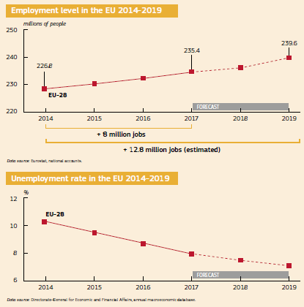

These recommendations propose guidance to be given by the Council to Member States on how to boost jobs and growth. They build on the finding that Member States were making headway in implementing the individual policy guidance they received in 2016 around the ‘virtuous triangle’ of boosting investment, pursuing structural reforms and ensuring sound public finances. Moreover, the unemployment rate for the EU as a whole in November was 7.3 % — the lowest since October 2008 (almost 9 million jobs have been created during the mandate of the Juncker Commission). As of 21 December there were 236 million people in work in the EU — more than ever before. Member States were invited to use the window of opportunity offered by the economic recovery, which is into its fifth year.

While priorities vary across the EU, further efforts across the board were seen as essential to achieve more inclusive, robust and sustainable growth. This approach also included an enhanced focus on the social priorities and challenges in the Member States. In November the Presidents of the European Parliament, the Council of the European Union and the European Commission proclaimed the [European Pillar of Social Rights](https://ec.europa.eu/commission/priorities/deeper-and-fairer-economic-and-monetary-union/european-pillar-social-rights/european-pillar-social-rights-20-principles_en), which, on the basis of its 20 principles, will serve as a compass for policymaking and a reference framework for measuring Member States’ performance in the areas of employment and social affairs.

On the fiscal front the recommendations made by the Commission to the Council in May confirmed that the Stability and Growth Pact is being applied intelligently and flexibly. When assessing Member States’ medium-term budgetary plans, specific expenditure related to structural reforms and to unusual events outside the control of the government, such as refugee programmes and counterterrorism, was taken into account. Based on the Commission’s recommendations the Council closed the excessive-deficit procedures for [Croatia](https://ec.europa.eu/info/business-economy-euro/economic-and-fiscal-policy-coordination/eu-economic-governance-monitoring-prevention-correction/stability-and-growth-pact/corrective-arm-excessive-deficit-procedure/ongoing-excessive-deficit-procedures/croatia_en) and [Portugal](https://ec.europa.eu/info/business-economy-euro/economic-and-fiscal-policy-coordination/eu-economic-governance-monitoring-prevention-correction/stability-and-growth-pact/corrective-arm-excessive-deficit-procedure/ongoing-excessive-deficit-procedures/portugal_en) in June, Greece in September and the United Kingdom in December. Further progress in this area was thus made in 2017, reducing the number of Member States found to be in [excessive deficit](https://ec.europa.eu/info/business-economy-euro/economic-and-fiscal-policy-coordination/eu-economic-governance-monitoring-prevention-correction/stability-and-growth-pact/corrective-arm-excessive-deficit-procedure/excessive-deficit-procedures-overview) to two, down from 24 in 2011.

Looking at the euro area in particular, in November [the Commission called](http://europa.eu/rapid/press-release_MEMO-17-4682_en.htm) for a broadly neutral fiscal stance and a balanced policy mix. This includes pursuing policies that support sustainable and inclusive growth and improve resilience, rebalancing and convergence. In addition, the Commission recommended making significant progress towards completing the Single Market, particularly in services, including financial, digital commerce, energy and transport. Given the positive cyclical conditions, all Member States should prioritise reforms that increase productivity and growth potential, improve the institutional and business environment, remove bottlenecks to investment, support the creation of quality jobs and reduce inequality.

The Commission also recommended that Member States with current-account deficits or high external debt should aim at containing growth in unit labour costs. Member States with large current-account surpluses should promote wage growth and, as a priority, implement measures that foster investment, support domestic demand and facilitate rebalancing in the euro area.

It also assessed whether the euro-area [Member States’ draft budgetary plans](https://ec.europa.eu/info/business-economy-euro/economic-and-fiscal-policy-coordination/eu-economic-governance-monitoring-prevention-correction/stability-and-growth-pact/annual-draft-budgetary-plans-dbps-euro-area-countries_en) for 2018 complied with the provisions of the [Stability and Growth Pact](https://ec.europa.eu/info/node/4287/).

As regards the monitoring of macroeconomic imbalances, it was concluded that 12 Member States (Bulgaria, Germany, Ireland, Spain, France, Croatia, Italy, Cyprus, the Netherlands, Portugal, Slovenia and Sweden) will be covered by an in-depth review in 2018 to determine whether they are still experiencing either imbalances or excessive imbalances. These are the same Member States identified in the previous round of the procedure. The Commission will present the in-depth reviews as part of its annual Country Reports in early 2018. The economic expansion is helping to correct existing imbalances, supporting the ongoing reduction of domestic and external debt ratios, easing some challenges that persist in the financial sector and improving the labour market situation. Further progress has been made on addressing external imbalances among net-debtor countries, and labour markets and growth conditions have generally continued to improve. Imbalances continued to be addressed on the basis of a reduced number of categories, with a focus on employment and social considerations.

In June the European Fiscal Board provided its first advice on the overall direction of fiscal policy in the euro area. The Board is independent and is composed of specialists appointed after consultations with the Member States, the national fiscal councils and the European Central Bank.

The Board was of the view that a neutral fiscal stance would be appropriate for the euro area as a whole in 2018, and that this could be implemented through differentiated national fiscal policies within the parameters of the Stability and Growth Pact. In addition, the Board considered that governments should target a recomposition of government expenditure to increase investment spending, which has borne the brunt of successive fiscal consolidation efforts in the aftermath of the financial and economic crisis.

In November the European Fiscal Board published its [first Annual Report](https://ec.europa.eu/info/publications/2017-annual-report-european-fiscal-board_en), which provides an independent evaluation of the way the EU’s fiscal framework has been implemented and of the appropriateness of the current fiscal stance at the euro-area and national levels. The Annual Report focuses on 2016 (the last complete surveillance cycle) and concludes that, against the backdrop of a very difficult economic context, there were some imperfections but no gross errors in the implementation of the Stability and Growth Pact. Fiscal policy provided some support for the recovery in the euro area as a whole. However, from a euro-area perspective, in some Member States it was more restrictive than warranted while in others it was looser than warranted. Based on its assessment the Board also put forward a number of proposals to improve the Stability and Growth Pact.

In 2017 the European Central Bank continued to fulfil its main aim of maintaining price stability to safeguard the value of the euro. Price stability is essential for economic growth and job creation, and it represents the most important contribution monetary policy can make in that area. The European Central Bank, alongside the European Stability Mechanism, also took part in the EU’s regular review visits to Member States in the framework of post-programme support.

Completing the Capital Markets Union

The [Capital Markets Union](https://ec.europa.eu/info/business-economy-euro/growth-and-investment/capital-markets-union_en), a key priority of the Investment Plan for Europe, comprises a mix of regulatory and non-regulatory reforms to better connect savings to investments. It aims to strengthen the EU’s financial system by providing alternative sources of financing and more opportunities for retail and institutional investors. For companies, especially small and medium-sized enterprises and start-ups, the Capital Markets Union will bring more funding opportunities, such as easier access to venture capital and the capital markets. It puts a strong emphasis on sustainable financing as the financial sector begins to help sustainability-conscious investors choose suitable projects and companies.

Around two thirds of the 33 actions mapped out in the Capital Markets Union project have been delivered. They included a major overhaul of the rules for investment firms. Smaller investment firms will benefit from simpler requirements that are more in line with their risk profile. At the same time, larger firms posing risks similar to those of banks should be regulated and supervised like banks. This will help all investment firms to link savings from consumers and investors to companies. The new rules will support properly functioning capital markets while ensuring financial stability.

New actions to be completed in the future include: a pan-European personal pension product to help people finance their retirement and to inject more savings into capital markets; continued work on enhancing the supervisory framework for integrated capital markets; a review of the rules for listing small and medium-sized enterprises; harnessing the potential of the financial technology sector; and reorienting investments to support the transition to a low-carbon, more resource-efficient and more circular economy.

WHO BENEFITS FROM THE CAPITAL MARKETS UNION?

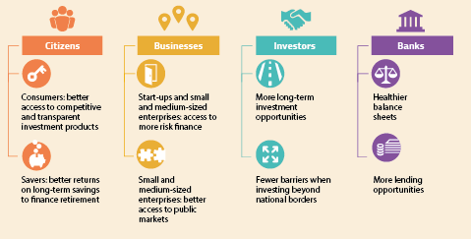

The EU as a trading partner

As the [reflection paper on harnessing globalisation](https://ec.europa.eu/commission/publications/reflection-paper-harnessing-globalisation_en) published in May 2017 states, the EU is committed to an open, rules-based and fair multilateral trading system that serves as the basis for its prosperity and is essential to making trade a positive force around the globe. In the annual [State of the Union](https://ec.europa.eu/commission/state-union-2017_en) address Jean-Claude Juncker, President of the European Commission, proposed a new EU framework for foreign-investment screening that will increase transparency and cooperation with Member States. The EU also made progress in opening up new markets for exports by launching trade negotiations with a number of partners. Two trade deals in particular are set to provide a boost for jobs, growth and investment. The EU and Japan concluded their negotiations on an [EU–Japan Economic Partnership Agreement](http://ec.europa.eu/trade/policy/in-focus/eu-japan-economic-partnership-agreement/) and the EU and Canada began to provisionally apply their Comprehensive Economic and Trade Agreement. See Chapter 6 for more information on developments in trade policy in 2017.

Promoting undistorted competition to underpin growth and investment

The EU’s competition policy and its enforcement show that any company is welcome to invest and do business in the Single Market as long as it plays by the rules. During the year the EU continued to enforce competition rules for the benefit of businesses and households.

In March new rules and tools were proposed to enable Member States’ competition authorities to enforce EU antitrust rules even more effectively. In May simplified rules were approved that exempt certain public support measures for ports, airports, culture and the EU’s outermost regions from prior notification under State aid rules. The new rules facilitate public investment in job creation and growth while preserving competition.

During the year the Commission made 338 merger decisions, four antitrust decisions, seven cartel decisions and 263 State aid decisions, generating significant benefits for EU consumers and supporting growth. In total it imposed fines of €4.398 billion on companies found to be in breach of EU competition rules and ordered the Member States concerned to recover an estimated €618.6 million in unlawful and incompatible aid from beneficiary undertakings.

To stimulate economic activity within the EU, import duties on raw materials, semi-finished goods and components amounting to over €1.2 billion were suspended. This measure also aimed at improving the competitive capacity of EU downstream industry and at allowing industry to maintain or create employment and modernise its structures.

Sustainable growth to create jobs and help the environment

The transition towards a more circular economy, in which resources, including energy, are used more efficiently and waste is reduced, brings great opportunities for people and businesses throughout the European Union.

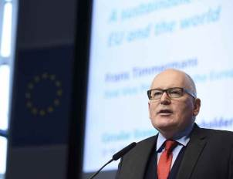

Commission First Vice-President Frans Timmermans participating in the Circular Economy Stakeholder Conference in Brussels, 9 March 2017.

The EU continued to make progress in implementing the 2015 [Circular Economy Package](http://europa.eu/rapid/press-release_IP-15-6203_en.htm). In order to help close the loop of design, production, consumption and waste management the Commission and the European Investment Bank together established a [Circular Economy Finance Support Platform](https://ec.europa.eu/environment/ecoap/community-platform) to boost investment in innovative, circular solutions. The Commission also offered guidance to Member States on making energy out of waste and proposed updates to legislation to restrict the use of certain hazardous substances in electrical and electronic equipment. It is estimated that the measures will prevent the creation of more than 3 000 tonnes of hazardous waste per year in the EU and enable savings in energy and raw materials. In the healthcare sector alone an estimated saving of €170 million could be made by allowing hospitals to buy and sell used medical devices.

As the cornerstone of the Package the Parliament and the Council have reached a provisional agreement on legislative proposals on waste, setting ambitious yet realistic waste-reduction and recycling targets up to 2035.

Continuing support for EU Member States

The [Structural Reform Support Programme](https://ec.europa.eu/info/funding-tenders/funding-opportunities/funding-programmes/overview-funding-programmes/structural-reform-support-programme-srsp_en) was set up in May with a budget of €142.8 million for the 2017-2020 period. At the request of Member States the Programme finances tailor-made technical support to help them in the key areas of their reform efforts. Through the Programme the Commission provides targeted support that reinforces the capacity of Member States to design and implement reforms they consider necessary to make their economies more competitive and investment friendly. This technical support covers reforms in the areas of governance and public administration, public financial management, the business environment, labour markets, education, health and social services, the financial sector and access to finance. It is available to all EU Member States, is demand driven and requires no co-financing.

The Programme is implemented by the [Structural Reform Support Service](https://ec.europa.eu/commission/sites/beta-political/files/srss-factsheet_en.pdf), in cooperation with other relevant Commission departments. So far the Service has engaged with 15 Member States to carry out more than 150 support projects. Under the 2018 project cycle it has received more than 400 requests for support from over 20 Member States, leading to substantial excess demand for the Programme’s budget, which is set at €30.5 million for the year.

INVESTMENT IN EU MEMBER STATES

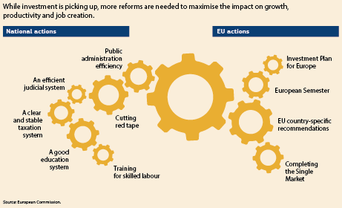

The EU continued to provide post-programme support to [Ireland](https://ec.europa.eu/info/business-economy-euro/economic-and-fiscal-policy-coordination/eu-financial-assistance/which-eu-countries-have-received-assistance/financial-assistance-ireland_en), [Spain](https://ec.europa.eu/info/business-economy-euro/economic-and-fiscal-policy-coordination/eu-financial-assistance/which-eu-countries-have-received-assistance/financial-assistance-spain_en), [Cyprus](https://ec.europa.eu/info/business-economy-euro/economic-and-fiscal-policy-coordination/eu-financial-assistance/which-eu-countries-have-received-assistance/financial-assistance-cyprus_en), [Portugal](https://ec.europa.eu/info/business-economy-euro/economic-and-fiscal-policy-coordination/eu-financial-assistance/which-eu-countries-have-received-assistance/financial-assistance-portugal_en) and [Romania](https://ec.europa.eu/info/business-economy-euro/economic-and-fiscal-policy-coordination/eu-financial-assistance/which-eu-countries-have-received-assistance/financial-assistance-romania_en). Good progress was again made in the course of the year in implementing the Greek programme, which was designed to create the conditions for the return of confidence and to lay the foundations for a lasting economic recovery in Greece. The second review was concluded in July, allowing the third tranche of funding from the European Stability Mechanism, amounting to €8.5 billion, to be authorised. The third review was ongoing in December, and a staff-level agreement was reached early in that month.

Greece also continued to receive economic support through the Investment Plan for Europe.

The Structural Reform Support Service has also taken up special assignments to help coordinate the response to the refugee crisis in Greece and to implement the EU Aid Programme for the Turkish Cypriot community.

Regional policy

The EU’s regional and urban policy continues to invest in jobs and growth through projects of all shapes and sizes, and in infrastructure that facilitates business, such as broadband and transport networks. Moreover, several initiatives and strategies have been implemented to spur growth and innovation on a larger scale, including a new set of actions to further help EU regions invest in their niche areas of competitive strength, known as ‘[smart specialisation](https://ec.europa.eu/commission/news/smart-specialisation-european-regions-2017-jul-18_en)’. Two pilot projects launched in 2017 will allow regions to work in partnership with teams of Commission experts to boost their innovation capacity, remove investment barriers and prepare for industrial and societal change. They will identify and scale up ‘bankable’ interregional projects that can create EU value chains in priority sectors.

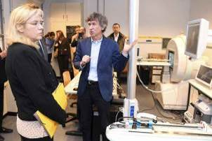

Commissioner Corina Crețu visits Biopark Charleroi Brussels South, Belgium, 24 March 2017.

As part of the [Urban Agenda for the EU](http://ec.europa.eu/regional_policy/en/policy/themes/urban-development/agenda/), to help cities have their say during the development of policies that affect them, 12 new thematic partnerships have been launched on topics such as the circular economy, digital transition, jobs and skills, and urban mobility. To facilitate investment in these areas the European Commission, together with the European Investment Bank, has set up a new service. Urban Investment Support provides tailor-made financial and technical advisory services for cities throughout the key stages of preparing and implementing integrated urban projects. Action plans from three of the partnerships have already been published, and the rest will follow in 2018.

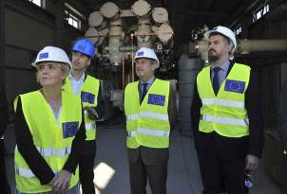

Dragica Sekulić, Minister for Economy of Montenegro, Commissioner Johannes Hahn and Aleksandar Andrija Pejović, Minister for European Affairs of Montenegro, visit the construction site of the Lastva substation of the Trans-Balkan Electricity Corridor, part of the Connectivity Agenda that will contribute to the creation of the regional electricity market, 9 June 2017.

The aim of the EU’s cohesion policy is to narrow the development gaps and reduce disparities between EU Member States and regions. The Commission has launched [an initiative to help less-developed regions catch up](http://ec.europa.eu/regional_policy/en/information/publications/reports/2017/competitiveness-in-low-income-and-low-growth-regions-the-lagging-regions-report). Its objective is to analyse what holds back growth in these regions and to provide recommendations and assistance to unlock their growth potential. Poland and Romania are the first Member States to pilot this initiative, with two regions each. Based on the results of the pilot projects this model will then be transferred to other regions facing similar challenges.

The [EU’s outermost regions](http://ec.europa.eu/regional_policy/en/policy/themes/outermost-regions/#1) will also benefit from a [new strategy](http://ec.europa.eu/regional_policy/en/newsroom/news/2017/10/24-10-2017-the-outermost-regions-and-the-eu-a-privileged-renewed-and-strengthened-partnership) launched in October for a privileged, renewed and strengthened partnership based on making the most of their unique assets.

Research and innovation

An [assessment](http://ec.europa.eu/research/evaluations/index_en.cfm?pg=h2020evaluation) of the first years of [Horizon 2020](https://ec.europa.eu/programmes/horizon2020/), the EU’s research and innovation programme, showed that it is on track to help create jobs and growth, tackle our biggest societal challenges and improve people’s lives. In 2017 alone Horizon 2020 invested €8.62 billion. More than 4 900 projects were supported, bringing together more partners from the EU, the 16 countries associated with the programme and other countries around the world. In October the Commission launched the [last package of Horizon 2020 calls for proposals](http://ec.europa.eu/programmes/horizon2020/en/news/horizon-2020-work-programme-2018-2020) and other activities, with around €30 billion available for researchers and innovators.

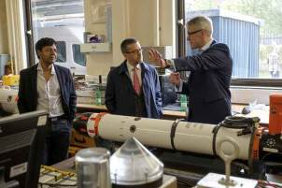

Commissioner Carlos Moedas and Professor David Lane, Founding Director of the Edinburgh Centre for Robotics, talk over an autonomous underwater vehicle called Iver during a visit to Heriot-Watt University, Edinburgh, United Kingdom, 18 October 2017.

Connecting Europe

The first [Connecting Europe Facility blending call](https://ec.europa.eu/inea/en/connecting-europe-facility/cef-transport/apply-funding/2017-cef-transport-blending-map-call) was launched in February, making €1.35 billion available to finance transport projects. The blending call combines grants with financing from the European Fund for Strategic Investments, the European Investment Bank, national promotional banks or private-sector investors.

To support competitive, clean and connected mobility the Commission agreed on a list of 152 transport projects that will [share €2.7 billion of EU funding](https://ec.europa.eu/inea/en/connecting-europe-facility/2016-cef-synergy-call) under the Connecting Europe Facility.

Growth and jobs through agriculture

The EU’s agro-food sector accounts for nearly 44 million jobs and exports goods worth over €130 billion per year. The common agricultural policy supports this with an annual budget of roughly €59 billion, divided among different complementary instruments. In 2017 the Commission consulted widely on the simplification and modernisation of the common agricultural policy. This included a broad public consultation that generated over 322 000 submissions and more than 1 400 policy papers.

As a result the [Communication ‘The future of food and farming](https://ec.europa.eu/agriculture/future-cap_en)’ was adopted in November, providing broad policy orientation for the future development of the common agricultural policy. The Communication will further steer the debate on the future policy in view of the proposals for the next Multiannual Financial Framework in 2018, but will not prejudge them.

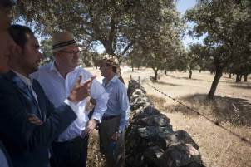

Commissioner Phil Hogan (centre) visiting an irrigation project in Pozoblanco, Spain, 8 June 2017.

Taking care of the oceans

As part of its work to forge a global ocean alliance on maritime issues with international partners, the EU hosted the fourth International Our Ocean Conference in Malta in October. One thousand high-level ‘ocean champions’ pledged action for healthy, productive oceans and followed up on previous commitments.

Participants from governments, businesses and civil society made history by committing more than €7 billion to the health of the oceans. They also pledged to create new marine protected areas spanning over 2.5 million km2, and for the first time the Conference saw large-scale mobilisation of the corporate sector in ocean conservation. The EU announced €550 million worth of measures on marine protection, marine pollution, climate change, sustainable fisheries, maritime security and a sustainable blue economy.

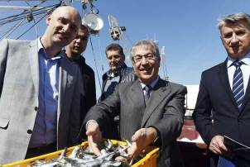

Commissioner Karmenu Vella (centre) meets local fishermen at the port of Zadar, Croatia, 20 March 2017.

Helping small and medium-sized enterprises find new funding, new partners and new markets

Every year the EU supports more than 200 000 businesses with various types of financing, including loans, microfinance, guarantees and venture capital. EU funding is available to start-ups, entrepreneurs and companies of any size and in any economic sector. The decision to provide EU-backed finance is made by local financial institutions such as banks, venture capitalists and angel investors. EU backing, often in the form of matching the funds provided by local financial institutions, allows businesses to receive more financial support than they otherwise would.

The EU also provides advice and practical support to businesses. In 2017 the [Enterprise Europe Network](http://een.ec.europa.eu/) helped more than 3 500 small businesses with international ambitions find funding, new partners and new markets. The Network is active in more than 60 countries worldwide. It brings together experts from more than 600 member organisations to help businesses in the EU innovate and grow internationally.

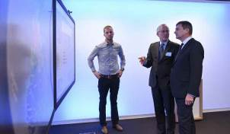

Commission Vice-President Andrus Ansip participating in the launch event of the 2017 Startup Europe Week, Brussels, 6 February 2017.

Investing in people

2017 marked the 60th anniversary of the [European Social Fund](http://ec.europa.eu/social/main.jsp?langId=en&catId=325), which helps workers gain a qualification and increase their skill levels (it is set to support 8 million EU workers between 2014 and 2020).

Four years after its launch in 2013 the [European Alliance for Apprenticeships](http://ec.europa.eu/social/main.jsp?catId=1147) (which is also open to European Free Trade Association members and to EU candidate countries), includes more than 35 countries. Some 230 pledges have been made by stakeholders, including businesses and intermediaries committing to providing over 800 000 training and first-job opportunities. A new European Network of Apprentices was launched under this framework in June to give a stronger voice to young learners. In October the Commission put forward a proposal for a [European Framework for Quality and Effective Apprenticeships](https://ec.europa.eu/commission/news/quality-and-effective-apprenticeships-2017-oct-05_en), and a new [ErasmusPro action](https://ec.europa.eu/programmes/erasmus-plus/programme-guide/part-b/three-key-actions/key-action-1/mobility-vet-staff_en) was launched to support long-term mobility for apprentices and for vocational education and training learners.

THE EUROPEAN SOCIAL FUND IN ACTION

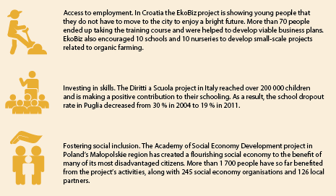

[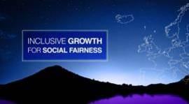](https://ec.europa.eu/info/business-economy-euro/economic-and-fiscal-policy-coordination/european-economy-explained/videos-economic-topics_en)

Economic and Monetary Union: promoting social fairness for all EU citizens.

<https://ec.europa.eu/info/business-economy-euro/economic-and-fiscal-policy-coordination/european-economy-explained/videos-economic-topics_en>

In July the EU launched the [European Classification of Skills, Competences, Qualifications and Occupations](https://ec.europa.eu/esco/portal/home) and the [EU Skills Profile Tool for Third-Country Nationals](https://ec.europa.eu/migrantskills/#/), including asylum seekers and refugees. These two new online tools enhance learning and working mobility throughout the EU by making skills and qualifications more transparent.

On 20 December the Commission proposed a new Directive to complement and modernise existing obligations to inform each worker of his or her working conditions. It would create minimum standards to ensure that all workers, including those on atypical contracts, benefit from more predictability and clarity. Some 2-3 million additional workers on atypical contracts would be covered and protected by the proposal.

Promoting digital skills

The EU is promoting initiatives to increase possibilities for citizens to acquire [digital skills](https://ec.europa.eu/digital-single-market/en/policies/digital-skills). A project to provide digital internships for 5 000-6 000 graduate students over the 2018-2020 period was announced in March. Investments are being made in projects that design training solutions to improve the skills of people working in small and medium-sized enterprises and retrain unemployed people for jobs in small businesses.

Connecting people

In 2017 the EU celebrated the 30th anniversary of the Erasmus programme with events across Europe. What started as a modest mobility scheme for higher education students back in 1987 has developed into the [Erasmus+ programme](http://ec.europa.eu/programmes/erasmus-plus/node_en) for education, training, youth and sport.

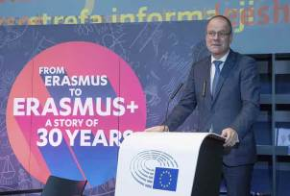

Commissioner Tibor Navracsics at the launch ceremony of the 30th anniversary of the Erasmus programme at the European Parliament, Brussels, 25 January 2017.

Over the past 30 years some 9 million people have benefited from a wide range of Erasmus opportunities to expand their horizons and acquire new knowledge and skills through study, traineeships, apprenticeships, youth exchanges, teaching and sport activities all over Europe and beyond. In 2017, with a budget of more than €2.5 billion, the programme enabled around 560 000 young people and 160 000 members of staff from educational institutions and youth organisations to benefit. In June the Member States gave the go-ahead to implement the ErasmusPro initiative, which will provide up to 50 000 new opportunities for learners and apprentices in vocational education and training to benefit from long-duration work placements abroad over the next 3 years.

With the help of the Parliament and the Council, the Commission increased funding for the Youth Employment Initiative, the dedicated EU financial support programme, and assisted Member States in mobilising their share of the European Social Fund. Overall more than 18 million young people have entered Youth Guarantee schemes since January 2014, and 11 million have taken up an offer of employment, apprenticeship, traineeship or continued education.

Helping young people to become entrepreneurs

[Erasmus for Young Entrepreneurs](https://www.erasmus-entrepreneurs.eu/) provides aspiring European entrepreneurs with the skills necessary to start and/or successfully run a small business in Europe. New entrepreneurs gather and exchange knowledge and business ideas with an experienced entrepreneur for a period of 1-6 months. The new entrepreneur acquires the skills needed to run a small firm, while the host benefits from fresh perspectives on his or her business and learns about new markets.

This programme is financed by the European Commission and operates across the participating countries with the help of local contact points that are competent in business support (e.g. chambers of commerce, start-up centres and business incubators). During the year over 1 000 would-be entrepreneurs followed this mentoring programme.

The European Solidarity Corps

Since its launch in December 2016 quick action has been taken to get the [European Solidarity Corps](https://europa.eu/youth/solidarity_en) up and running. In May 2017 the Commission proposed a dedicated legal base and a budget for the next 3 years. By the end of December more than 45 000 people had registered and over 2 500 had participated in solidarity activities across Europe. For example, in August 16 volunteers arrived in Norcia, Italy, to help with the ongoing efforts to repair damage and rebuild social services for the local community affected by the severe earthquakes that hit the region in 2016. In addition, the occupational strand of the European Solidarity Corps was launched in mid 2017. It is envisaged that up to 6 000 young people will be offered a solidarity-related job or traineeship over the next 2 years through projects funded under the EU Programme for Employment and Social Innovation, coordinated by the public employment services of France and Italy.

[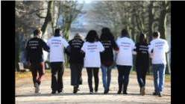](https://www.youtube.com/watch?v=KNk0QN2rxAc)

The European Solidarity Corps: volunteering for communities and people around Europe.

<https://www.youtube.com/watch?v=KNk0QN2rxAc>

Protecting people’s health, helping the economy

In June the Commission adopted the new [Action Plan against Antimicrobial Resistance](https://ec.europa.eu/health/amr/sites/amr/files/amr_action_plan_2017_en.pdf). The Action Plan’s ‘one health’ approach addresses [antimicrobial resistance](http://europa.eu/!Nx99xx) in both people and animals, a growing threat responsible for 25 000 human deaths and losses of €1.5 billion in the EU every year. The first 2-year cycle of the [State of Health in the EU](http://europa.eu/!yh37hr) initiative ended with the publication of individual [country health reports](https://ec.europa.eu/health/state/country_profiles_en) for each Member State and an accompanying Commission paper linking them to a broader EU agenda. In carrying out this initiative the Commission partnered with the Organisation for Economic Cooperation and Development and the European Observatory on Health Systems and Policies.

An EU budget focused on results

The [2017 EU budget](http://ec.europa.eu/budget/library/biblio/documents/2016/factsheet-on-eu-%20budget-2017_en.pdf) contributed to stimulating job creation, especially for young people, and boosting strategic investments. Building on actions in previous years, it continued to put a particular focus on the migration challenge. Nearly half of the budget (€75 billion) was allocated to growth, employment and competitiveness, supporting research and innovation (Horizon 2020), education, training and youth (Erasmus+), small and medium enterprises (the EU Programme for the Competitiveness of Enterprises and Small and Medium-Sized Enterprises) and transport infrastructure (the Connecting Europe Facility). The EU budget also backed the European Fund for Strategic Investments, which has encouraged key investment projects in the EU. Farmers received around €43 billion. The EU contributed, with a total of nearly €6 billion, to reinforcing the protection of its external borders and tackling migration and refugee flows.

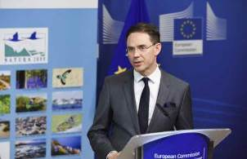

Commission Vice-President Jyrki Katainen at the signing of the first loan agreement backed by the Natural Capital Financing Facility, Brussels, 11 April 2017.

In May the Commission proposed funding of more than €340 million to enable 100 000 placement opportunities by 2020 for young people to engage in solidarity activities (volunteering, traineeships or jobs) through the [European Solidarity Corps](https://europa.eu/youth/solidarity_en).

The [mid-term revision of the current Multiannual Financial Framework (2014-2020)](http://ec.europa.eu/budget/mff/figures/index_en.cfm) was adopted in June. The purpose of this revision was to provide additional financial means to tackle migration flows and security risks, to foster economic growth, job creation and competitiveness and to increase the ability of the EU budget to address unforeseen circumstances.

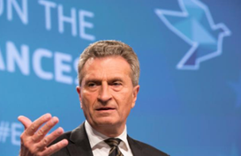

Commissioner Günther Oettinger at the launch of the Commission’s reflection paper on the future of EU finances, Brussels, 28 June 2017.

The Commission also adopted a legislative proposal to reduce the administrative burden for the recipients of EU funds. On 28 June the Commission published a [reflection paper](http://ec.europa.eu/budget/library/biblio/publications/2017/ReflectionPaper_FutureEUfinances_en.pdf) to open a debate on the future of EU finances.

Chapter 2

A connected Digital Single Market



‘I believe that we must make much better use of the great opportunities offered by digital technologies, which know no borders.’

Jean-Claude Juncker, political guidelines, 15 July 2014

The EU continued to complete the Digital Single Market to break down online barriers. It also worked to enable citizens, governments and businesses to take full advantage of the opportunities provided by the internet and other digital technologies. 2017 saw the delivery of the majority of the legislative proposals and policy initiatives announced in the 2015 Digital Single Market Strategy.

The EU also said goodbye to roaming charges. This means consumers now pay the same price for calls, text messages and mobile data when they are travelling in the European Union as when they are at home.

By 2018 citizens will be able to enjoy prepaid online films, sport, music and video games when travelling in the EU, and European Union funding will be helping to provide Wi-Fi access in public places.

The EU used its enforcement powers to protect consumers and ensure fair competition in the online platform economy. It fined Google €2.42 billion for abusing its market dominance as a search engine by giving an illegal advantage to its own comparison shopping service. In September’s State of the Union address Jean-Claude Juncker, President of the European Commission, announced several measures to protect the EU from cyberattacks. In the same month the Commission set out measures to improve the free flow of non-personal data, along with guidelines and principles to tackle, using online platforms, illegal content online.

The Estonian Presidency organised a summit in Tallinn in September that confirmed that the EU recognises its economic future has to be built on strong and united digital policies.

Delivering on the Digital Single Market

The Commission has delivered all 43 of the key legislative proposals and policy initiatives for the completion of the Digital Single Market that were identified by the May 2015 [Digital Single Market Strategy](https://ec.europa.eu/commission/priorities/digital-single-market_en). Twenty-four of these legislative initiatives had been proposed to the European Parliament and the Council of the European Union as of the end of 2017.

The [mid-term review](http://europa.eu/rapid/press-release_IP-17-1232_en.htm) of the progress made, published in May 2017, outlines further actions on online platforms, data economy and cybersecurity. In September, as part of the State of the Union package, the Commission presented a proposal for new rules on cybersecurity and on the free flow of non-personal data in the EU. A Communication on the responsibility of platforms for tackling illegal content online was also published in September.



In July 2017 Mariya Gabriel was appointed the new Commissioner for Digital Economy and Society.

People in the EU need digital know-how for a changing job market and a changing society, but 37 % of the workforce still does not have basic digital skills. The [Digital Skills and Jobs Coalition](https://ec.europa.eu/digital-single-market/en/digital-skills-jobs-coalition) will train 1 million young unemployed people by 2020, and the [eGovernment Action Plan 2016-2020](https://ec.europa.eu/digital-single-market/en/european-egovernment-action-plan-2016-2020) will simplify life for citizens and businesses and enable public authorities to offer new services. The focus is now on obtaining [political agreement](http://europa.eu/rapid/press-release_IP-16-4405_en.htm) with the Parliament and the Council on all [proposals](https://ec.europa.eu/commission/sites/beta-political/files/digital-summit-timeline-factsheet_en.pdf).

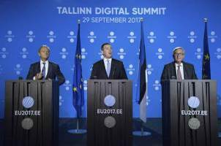

Donald Tusk, President of the European Council, Jüri Ratas, Prime Minister of Estonia, and Jean-Claude Juncker, President of the European Commission, at the Tallinn Digital Summit, Estonia, 29 September 2017.

The [Tallinn Digital Summit](https://ec.europa.eu/commission/publications/tallinn-digital-summit-factsheets_en) in September saw high-level discussions on how the European Union can keep ahead of the technological curve and remain a front-runner in the sector. These discussions included talks on fair taxation in the digital economy, improving citizens’ digital skills and building a strong cybersecurity structure in the EU. Member States also agreed to complete the Digital Single Market by 2018, invest in digital infrastructure and pursue the free movement of data.

Building stronger cybersecurity in the EU

Digital technologies open up new opportunities for citizens to connect. They facilitate the exchange of information and form the backbone of the EU economy, however they have also brought new risks into being. The EU has made progress in keeping people safe online, and from 2018 citizens and businesses will benefit from stronger protection. These rules will also apply to new players providing electronic communications services.

However, the EU still needs to be better equipped to deal with the worrying rise in cyberattacks. In September, as part of President Juncker’s State of the Union speech, the Commission proposed a comprehensive approach to improving [cybersecurity](http://europa.eu/rapid/press-release_IP-17-3193_en.htm). This includes a reinforced EU Cybersecurity Agency, a blueprint for coordinated action between Member States in the event of a cyberattack and a new EU cybersecurity certification scheme that will ensure products and services in the digital world are safe to use. For the first time the Commission is also putting a specific focus on cyberdefence, mirroring its renewed commitment to a European Security and Defence Union.

EU RESILIENCE TO CYBERATTACKS

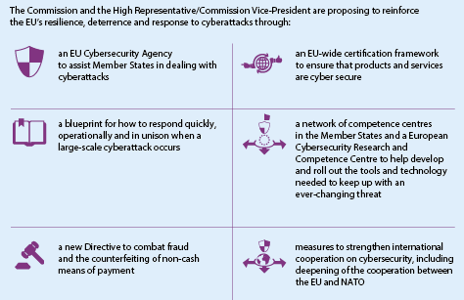

Unlocking the full potential of the EU data economy

By 2020 it is estimated that 10.4 million people will be employed in the EU data economy. The Commission has proposed [new rules](http://europa.eu/rapid/press-release_IP-17-3190_en.htm) to govern the free flow of non-personal data. Together with existing rules on personal data, the new measures will enable the storage and processing of non-personal data across the EU. This will boost the competitiveness of businesses in the EU and modernise public services in an effective EU Single Market for data services. Removing data localisation restrictions is an important factor for the data economy, and could increase internet-of-things revenues to €112 billion and improve the gross domestic product of the EU by 4 % by 2020.

Looking ahead, the EU is investing to make Europe a world-class hub in high-performance computing, capable of analysing a huge quantity of data in real time. It is also preparing the ground to launch a €1 billion flagship initiative on quantum technologies in 2018.

Ensuring fair competition in the online platform economy

The Commission fined Google for abusing its market dominance

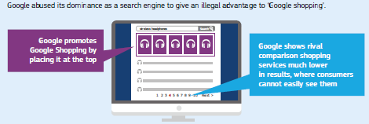

Online platforms are subject to EU rules in areas such as competition and consumer protection. This creates trust for both businesses and the general public. Whenever necessary the EU acts to enforce these rules.

In May 2017 a [decision](http://europa.eu/rapid/press-release_IP-17-1223_en.htm) that makes the commitments offered by Amazon legally binding was adopted. This addresses preliminary competition concerns relating to a number of clauses in Amazon's distribution agreements with e-book publishers in Europe. In June the Commission [fined Google €2.42 billion](http://europa.eu/rapid/press-release_IP-17-1784_en.htm) for abusing its market dominance as a search engine by giving an illegal advantage to another Google product, namely its own comparison shopping service.

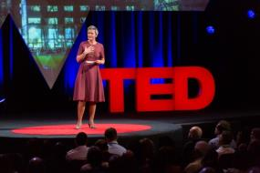

Commissioner Margrethe Vestager takes part in a Ted Talk at The Town Hall, New York, United States, 20 September 2017.

Improving connectivity

The EU has approved a scheme to bring public Wi-Fi hotspots to 6 000-8 000 communities across the EU. The €120 million [WiFi4EU initiative](https://ec.europa.eu/digital-single-market/en/policies/wifi4eu-free-wi-fi-europeans) will help to provide Wi-Fi access in public spaces such as parks, squares, public buildings, libraries, health centres and museums.

WiFi4EU is part of the ambitious package of measures adopted by the Commission in September 2016 that are designed to meet citizens’ growing connectivity needs and boost the competitiveness of the EU. They also include an Action Plan to promote the deployment of state-of-the-art 5G wireless networks across the EU.

An important step towards this goal was taken in May 2017 when the Parliament and the Council adopted a Decision aiming to ensure the availability of the 700-MHz band for wireless broadband services by 2020.

The modernisation of current EU telecoms rules (the proposed European Electronic Communications Code) offers a more attractive regulatory environment that will encourage investment in top-quality infrastructure across the Member States.

Ending roaming charges

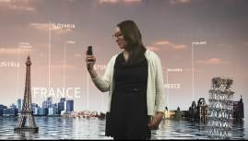

The end of roaming charges: roam like at home.

<https://ec.europa.eu/digital-single-market/en/news/roaming-downloadable-material-use-promotion>

[Mobile roaming charges ended](https://ec.europa.eu/digital-single-market/en/policies/roaming) on 15 June 2017. This means that, when travelling within the EU, roaming customers will be able to call, send text messages or surf the internet on their mobile phones for the same price as they pay at home.

ROAMING CHARGES FOR TRAVELLERS IN THE EU

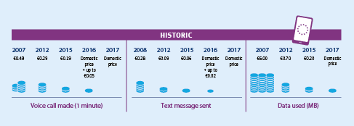

Enjoying access to digital content

From 2018, people living in the EU will be able to enjoy paid for online content services wherever they are in Europe. [New rules adopted in June 2017](https://ec.europa.eu/digital-single-market/en/cross-border-portability-online-content-services) will allow consumers who have paid for online content services in their home country to access them when visiting another Member State.. Free-to-air services, such as those provided by certain public broadcasters, will have the option of benefiting from the Regulation provided that they verify the country of residence of their subscribers.

In July EU legislation that will help millions of blind and other print-disabled people to get better access to books was approved as part of the ongoing modernisation of EU copyright law. The new EU rules will enter into force in October 2018.

In November the Parliament, the Council and the Commission reached a political agreement to end [unjustified geoblocking](http://europa.eu/rapid/press-release_IP-17-4781_en.htm) for consumers wishing to buy products or services online within the EU. The new rules will boost e-commerce for the benefit of both consumers and businesses.

Boosting high-performance computing leadership in Europe

The [European Declaration on High-Performance Computing](https://ec.europa.eu/digital-single-market/en/news/eu-ministers-commit-digitising-europe-high-performance-computing-power), aiming to financially support the next generation of high-performance computing and data-support infrastructure, was signed in March by ministers from seven countries (France, Germany, Italy, Luxembourg, Netherlands, Portugal and Spain). Belgium, Bulgaria, Croatia, Greece, Slovenia and Switzerland joined later in the year.

Sharing data for better research

The new [European Open Science Cloud](http://ec.europa.eu/research/index.cfm?eventcode=44D86060-FBA1-1BD1-9355822B162BB0EE&pg=events), launched in 2017, will offer the EU’s 1.7 million researchers and 70 million science and technology professionals a virtual environment to store, share and reuse their data across disciplines and borders. [Horizon 2020](https://ec.europa.eu/programmes/horizon2020/what-horizon-2020) is providing more than €260 million in funding to help establish the Cloud.

Education

In 2017 the Commission launched a self-assessment tool to help schools evaluate their digital capacity. With it they can get support to develop and improve their use of technologies for teaching and learning. By December 650 schools from 14 countries had taken part in the pilot of the [‘Selfie’ tool](https://ec.europa.eu/jrc/en/digcomporg/selfie-tool). In 2018 Selfie will be made accessible to schools across the EU.

E-government

A proposal was put forward in May that will give people and companies easier access, through a single digital entry point, to high-quality information, online administrative procedures and assistance services. Each year the [Single Digital Gateway](https://ec.europa.eu/info/law/better-regulation/initiatives/com-2017-256-0_en) could help companies save more than €11 billion and EU citizens up to 855 000 hours.

Citizens and private companies can now search for information on companies registered in any EU Member State, and also in Iceland, Liechtenstein and Norway. The Business Registers Interconnection System is part of [the European eJustice Portal](http://ec.europa.eu/justice/criminal/european-e-justice/portal/index_en.htm), the one-stop shop for citizens, businesses and legal professionals across Europe, and is a joint effort by governments and the Commission. It provides public access to information on companies in the participating states and ensures that all European business registers can communicate with each other electronically in a safe and secure way. The ultimate aim is to boost confidence in the Single Market through transparency and up-to-date information and to reduce unnecessary burdens on companies. Between its launch in June and the end of the year the Business Registers Interconnection System was used to perform over 139 000 searches on companies.

In July the [Electronic Exchange of Social Security Information system](http://ec.europa.eu/social/main.jsp?catId=869&langId=en) was also launched. This new IT platform connects around 15 000 social security institutions in the EU Member States, Iceland, Liechtenstein, Norway and Switzerland, making it easier to combat errors and fraud. National social security institutions will use standardised electronic documents in their own language, ensuring that the data they exchange are correct and complete. The new tool will also benefit citizens who have lived and worked in several of the participating countries, enabling their social security benefits to be calculated more easily and quickly.

In OctoberMember States agreed to follow a common approach when making their public services available online, including across borders and policy areas. This will contribute to reducing bureaucracy for people and businesses, for example when requesting certificates, enrolling for services and handing in tax declarations.

Funding connectivity and digital entrepreneurship

The [European Structural and Investment Funds](https://ec.europa.eu/info/funding-tenders/european-structural-and-investment-funds_en) and the EU’s cohesion policy make key contributions to delivering the objectives of the Digital Single Market. Based on the tailored digital-growth strategies of the Member States and regions, over €20 billion of European Structural and Investment Funds are fostering the emergence of digital start-ups. This is enabling small and medium-sized enterprises to reap the benefits of digitisation; helping public administrations to work more efficiently and to deliver faster and better services to citizens and businesses; and providing affordable broadband access to underserved areas. A network of [Broadband Competence Offices](https://ec.europa.eu/digital-single-market/en/broadband-competence-offices) was launched in November 2017 to facilitate the spread of fast broadband and help overcome the digital gap between urban and rural areas. They are available at the regional and national levels to provide information and support on broadband roll-out. Work continued during the year on providing broadband for 18 million rural inhabitants by 2020.

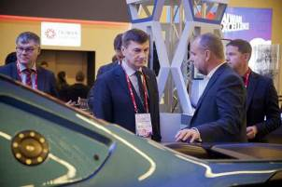

Commission Vice-President Andrus Ansip taking part in the GSM Association Mobile World Congress 2017 in Barcelona, Spain, 27 February 2017.

Digital health and care

In March the [first 24 European Reference Networks](http://europa.eu/rapid/press-release_IP-17-323_en.htm) for rare and complex diseases were launched, involving more than 900 highly specialised healthcare units from over 300 hospitals in 25 EU Member States, plus Norway. These networks tackle complex or rare medical conditions that require very specific types of treatment and a concentration of knowledge and resources. They will work on a range of thematic issues, including bone disorders, childhood cancer and immunodeficiency.

Understanding the impact of digitisation in the financial sector

Technology is transforming the financial sector. As the world’s largest user of IT products and services, finance stands to benefit from new generations of processing, storage, mobile and authentication technologies, along with social networks, artificial intelligence and distributed systems. New business models are emerging that could help turn the EU’s Single Market for financial services into a practical reality; one where the relationship between customers and suppliers is no longer restricted by physical distance or even linguistic differences. This raises important policy and regulatory questions for the EU’s financial services policy that have been addressed in a wide-ranging public consultation to determine whether concrete action is needed at EU level.

Digital technologies on the move

During Digital Day, held in Rome on 23 March, 29 countries (EU Member States and European Economic Area members) signed a letter of intent to establish a legal framework for [cross-border trials in connected automated driving](https://ec.europa.eu/digital-single-market/en/news/eu-and-eea-member-states-sign-cross-border-experiments-cooperative-connected-and-automated), based on harmonised rules on data access, liability and connectivity. They agreed to intensify cooperation on the testing of automated road transport at cross-border sites, and are now working with industry partners to put this agreement into practice. The Commission is now facilitating [cross-border connected transport corridors](https://ec.europa.eu/digital-single-market/en/news/cooperative-connected-and-automated-mobility-stepping-efforts-frankfurt).

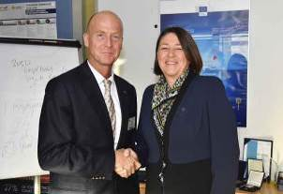

Commissioner Violeta Bulc welcoming Tom Enders, Chief Executive Officer of Airbus SE, Brussels, 18 October 2017.

Proposals were presented in May to modernise mobility and transport in the EU. [Europe on the Move](https://ec.europa.eu/transport/modes/road/news/2017-05-31-europe-on-the-move_en) is a wide-ranging set of initiatives that will make traffic safer; encourage fairer road charging; reduce carbon dioxide emissions, air pollution and congestion; cut red tape for businesses; fight illicit employment; and ensure proper conditions and rest times for workers. The Commission is also promoting seamless mobility solutions to make travel easier across the European Union. One example is the proposal to ensure that tolling systems work together so that people can drive throughout the EU without having to worry about different administrative formalities. Common specifications for public transport data will also allow passengers to plan their journey better and follow the best route, even when crossing borders.

Drone technology

A [blueprint](https://www.sesarju.eu/u-space-blueprint) to make drone use in low-level airspace safe, secure and environmentally friendly was [unveiled in June](https://ec.europa.eu/transport/modes/air/news/2017-06-16-aviation-commission-taking-european-drone-sector-new-heights_en). The U-Space drone management system initially covers altitudes of up to 150 metres and will pave the way for the development of a strong and dynamic drone-services market in the EU. Registration of drones and drone operators, their e-identification and a system to define virtual boundaries around locations (geofencing) should be in place by 2019.

Stronger customer authentication in electronic payments

Increasing the level of security of electronic payments continued to be one of the main objectives of the EU’s digital policy during 2017. To that end, in November the Commission introduced a number of security requirements that must be observed by payment service providers, be they banks or other payment institutions, when processing payments or providing payment-related services.

Chapter 3

A resilient Energy Union with a forward-looking climate change policy

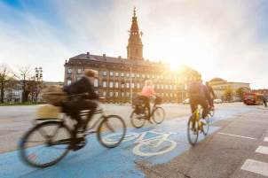

‘I want to reform and reorganise Europe’s energy policy into a new European Energy Union … We need to strengthen the share of renewable energies on our continent. This is not only a matter of a responsible climate change policy. It is, at the same time, an industrial policy imperative.’

Jean-Claude Juncker, political guidelines, 15 July 2014

We cannot tackle climate change without addressing how we produce and use energy. Transforming our energy systems is essential to making the EU a low-carbon society. Two years after the launch of the Energy Union strategy there are clear signs that the modernisation of the EU economy and the transition to a low-carbon era are underway.

The EU and its Member States have continued to make good progress on delivering the objectives of the Energy Union, in particular on the 2020 energy and climate targets for greenhouse gas emissions, energy efficiency and renewables. Clean energy can create 900 000 new jobs and can unlock €177 billion in investment every year from 2021. The political agreement on the energy performance of buildings signals the closure of the first of eight legislative proposals from the [Clean Energy for All Europeans](http://europa.eu/rapid/press-release_IP-16-4009_en.htm) package, which was launched in 2016.

In 2017 the EU continued to lead efforts to fight climate change, including by galvanising the international community to maintain the momentum of the Paris Agreement, which aims to put the world on track to avoid dangerous climate change.

Substantial progress was made on legislative proposals to implement the EU’s climate commitments on reducing domestic greenhouse gas emissions by at least 40 % by 2030.

In December political agreements were reached on the Effort-Sharing Regulation — to reduce emissions in transport, buildings, waste and agriculture — and on new rules on the accounting of emissions from land use, land-use change and forestry. These agreements, together with the revision of the EU Emissions Trading System after 2020, mean that the legal framework of the EU’s 2030 climate policy is now in place.

The European Commission also set out its agenda for a socially fair transition towards clean, competitive and connected mobility and transport.

Towards a modern and ambitious Energy Union

The European Union’s transition to a low-carbon society is becoming a reality on the ground. Thanks to progress in 2017 the EU is on track to implement the [Energy Union](https://ec.europa.eu/energy/en/topics/energy-strategy-and-energy-union/building-energy-union) and to deliver jobs, growth and investment. Two years after the launch of the strategy the Commission has presented all the main proposals needed to increase energy efficiency, support EU global leadership in climate action and renewable energy and provide a fair deal for energy consumers.

The [Third Report on the State of the Energy Union](https://ec.europa.eu/commission/publications/third-report-state-energy-union_en), published in November 2017, shows that the EU is well on track to reach its 2020 climate and energy targets. Final energy consumption is already below the 2020 target. In addition, [greenhouse gas emissions have fallen by 23 % since 1990](https://ec.europa.eu/clima/news/eu-cut-emissions-23-1990-2016-while-economy-grew-53_en), while the EU economy [has grown by 53 %](https://ec.europa.eu/clima/sites/clima/files/strategies/progress/docs/swd_2017_xxx_en.pdf). This trend shows that the EU is continuing to prove that action to reduce emissions goes hand in hand with economic growth. With energy from renewable sources already accounting for more than 16 % of its energy mix, the EU is well on its way to meeting its 20 % target by 2020. By March 2017 a total of [11 Member States](http://ec.europa.eu/eurostat/documents/2995521/7905983/8-14032017-BP-EN.pdf/af8b4671-fb2a-477b-b7cf-d9a28cb8beea) had already reached their national targets for 2020.

Considerable progress was made in 2017 on the [Clean Energy for All Europeans](https://ec.europa.eu/energy/en/news/commission-proposes-new-rules-consumer-centred-clean-energy-transition) package, presented in November 2016, and a provisional agreement was achieved on the energy performance of buildings dossier. With the Council of the European Union reaching a general approach on seven of the eight files by December and the European Parliament’s positions on all eight dossiers expected in early 2018, political agreement on the other issues is now within reach. Consumers across the EU will have a better choice of energy supply, access to reliable energy price comparison tools and the possibility to produce and sell their own electricity.

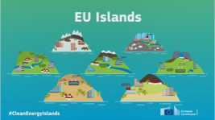

Helping EU islanders shift to clean energy.

<https://www.youtube.com/watch?v=h0ycAyFOCeQ>

The Clean Energy for EU Islands initiative, launched in May, aims to help the EU’s islands to reduce their dependency on energy imports by making better use of their own renewable energy sources and embracing more modern and innovative energy systems. They will therefore benefit not only from reduced energy costs, but also from improved air quality and lower greenhouse gas emissions.

No regions should be left behind when moving away from an economy driven by fossil fuels. A new [platform](http://europa.eu/rapid/press-release_IP-17-5165_en.htm) was launched in December to help develop projects and long-term strategies in coal regions. Its aims are to kick-start the transition process and to respond to environmental and social challenges.

Energy efficiency

An agreement on clearer [energy efficiency labelling rules](http://europa.eu/rapid/press-release_IP-17-691_en.htm), including a rescaling of product information categories to take account of progress in recent years, was signed in March. Together with eco-design, the revised energy efficiency label could save households close to €500 per year.

Along with the [political agreement](http://europa.eu/rapid/press-release_IP-17-5129_en.htm) on new rules for improving the energy performance of buildings, 2017 saw revised [guidance](http://europa.eu/rapid/press-release_IP-17-3268_en.htm) on how to record energy performance contracts in national accounts. This will make it easier for schools, hospitals and other public [buildings](https://ec.europa.eu/energy/en/topics/energy-efficiency/buildings), which make up more than 10 % of the overall building stock in the EU, to invest in improving energy efficiency.

The [European Local Energy Assistance](http://www.eib.org/products/advising/elena/index.htm) initiative was launched in May by the European Investment Bank. It will help regional authorities to prepare energy efficiency and renewable energy projects.

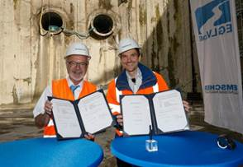

Werner Hoyer, President of the European Investment Bank, and Uli Paetzel, Chairman of the Executive Board of Emschergenossenschaft, signing the contract for [the Bank’s loan of €450 million](http://www.eib.org/infocentre/press/releases/all/2017/2017-199-450-millionen-euro-eu-bank-stellt-weiteren-kredit-fur-emscher-umbau-bereit.htm) for the large-scale rehabilitation of the Emscher river system, Oberhausen, Germany, 13 July 2017.

In September all of the Member States signed the [Tallinn e-Energy Declaration](https://www.eu2017.ee/tallinn-e-energy-declaration) with the aim of encouraging cooperation between Member States and the private sector to develop a broad-based strategy for the digitisation of energy.

The EU published a [report](https://ec.europa.eu/energy/sites/ener/files/documents/report_energy_efficiency_final_2017_en.pdf) in November assessing progress made by Member States towards the national energy efficiency targets for 2020. One of the main findings was that although energy consumption increased in 2015, in part due to a colder winter and lower fuel prices, the EU was still on track to meet the 2020 energy efficiency target.

Energy security, solidarity and trust

Securing energy supplies for EU consumers is one of the cornerstones of the Energy Union. [New rules](https://www.consilium.europa.eu/en/press/press-releases/2017/10/09/gas-supply-closer-cooperation/) entered into force on 1 November, just ahead of the winter heating season, to help improve coordination between Member States and deal more quickly and efficiently with any gas-supply crises. Member States are required to help their neighbours out in the event of a serious crisis so that households are not left in the cold.

As part of a wider effort to develop diversified and secure gas markets in the Baltic states, Latvia opened its [gas market](https://ec.europa.eu/energy/en/news/latvias-gas-market-now-liberalised) to competition in April, which means consumers no longer need to rely on a single supplier.

The fourth High-Level Ministerial [Meeting](http://europa.eu/rapid/press-release_IP-17-3506_en.htm) of the Commission Initiative on Central and South-Eastern European Energy Connectivity marked a landmark moment for the entire region. Ministers signed a memorandum of understanding, including a joint approach on electricity markets, energy efficiency and renewable development. An [agreement](http://europa.eu/rapid/press-release_STATEMENT-17-5271_en.htm) was reached on how to find a solution, by the end of May 2018 at the latest, on the best way to synchronise the Baltic states’ electricity grid with the system in continental Europe.

Nuclear safety remains a top priority for the EU. In May 2017 the EU published its first [report](https://ec.europa.eu/energy/sites/ener/files/documents/staff_working_document_progress_of_implementation_of_council_directive_201170euratom_swd2017_159_final.pdf) on the safe and responsible management of radioactive waste and spent fuel in the EU. The report provides a clear picture of the current situation, finding that standards have improved in the EU, and highlights important areas where further improvements and attention are required. Developments at the international level during the year included the EU–Iran High-Level Seminar on International Nuclear Cooperation, which took place on 28 February and 1 March in Brussels.

A fully integrated internal energy market

Efforts continue on building a Single Market in which clean energy can [flow freely](https://ec.europa.eu/commission/priorities/energy-union-and-climate/fully-integrated-internal-energy-market_en) and securely. The Third Report on the State of the Energy Union confirmed that the energy transition is not possible without adapting the infrastructure to the needs of the future energy system. A considerable amount has been achieved, but bottlenecks remain, particularly in the field of electricity. To address this, in November the Commission adopted a Communication on a 2030 electricity interconnection target of 15 %. It also published the third list of [projects of common interest](https://ec.europa.eu/energy/en/topics/infrastructure/projects-common-interest), containing 173 projects of European importance. For the first time this list provides for four cross-border carbon dioxide network projects.

To support the implementation of the projects the EU has invested €1.7 billion in 96 electricity, gas and smart-grid infrastructure projects under the [Connecting Europe Facility](https://ec.europa.eu/inea/en/connecting-europe-facility/cef-energy/cef-energy-projects-and-actions), which is providing €5.35 billion for energy projects from 2014 to 2020. In April the EU released €800 million worth of funding through the Facility for projects in the areas of electricity, gas and smart-grid infrastructure.

The EU has continued to work on connecting electricity grids and gas pipelines between Member States, including the establishment of a northern gas corridor linking Norway to Poland through Denmark; the [Celtic Interconnector](https://ec.europa.eu/energy/en/news/eur-4-million-eu-funding-proposed-electricity-link-between-france-and-ireland) to link the French and Irish electricity systems; and helping to abolish barriers for the free flow of gas in central and south-eastern Europe. The EU will also invest €101.4 million in the construction of the [liquefied natural gas terminal](https://ec.europa.eu/info/news/eu-invests-energy-security-and-diversification-central-and-south-eastern-europe-2017-dec-18_en) in Krk, Croatia.

In 2017 the EU followed up on the [State aid sector inquiry into national capacity mechanisms](http://ec.europa.eu/competition/sectors/energy/state_aid_to_secure_electricity_supply_en.html#2). In particular it examined whether such mechanisms ensure a sufficient supply of electricity without distorting competition or trade in the Single Market. Some Member States have introduced capacity mechanisms to guarantee that there is a sufficient supply at all times. The EU is now working with Member States to ensure that both existing and planned measures are in line with State aid rules.

International developments included the Commission’s proposal of the terms of a mandate to negotiate with Russia on the operating principles of the [Nord Stream 2 project](http://europa.eu/rapid/press-release_IP-17-1571_en.htm), which will connect the Russian gas supply to the EU market.

To improve the functioning of the EU’s internal energy market and enhance solidarity between Member States, in November the Commission [proposed](http://europa.eu/rapid/press-release_IP-17-4401_en.htm) common rules for gas pipelines entering the internal gas market.

Decarbonisation of the economy

Forging ahead on global climate action

Throughout the year the EU continued to galvanise international action on climate change. In June the United States announced its intention to withdraw from the landmark global climate deal agreed in Paris, France, in 2015. Subsequently, the EU and international partners strongly reaffirmed their common resolve to fully implement the Paris Agreement, which aims to limit the rise in global average temperatures to well below 2 °C compared to pre-industrial levels.

[Together with 79 African, Caribbean and Pacific countries](https://ec.europa.eu/clima/news/eu-and-79-african-caribbean-pacific-countries-joint-push-defend-and-implement-global-climate_en), the EU called on the global community to maintain the momentum for ambitious action on climate change. A [ministerial meeting](https://ec.europa.eu/clima/news/eu-co-hosts-major-international-climate-meeting-canada-and-china_en) in September in Montreal, Canada, co-hosted by the EU, Canada and China, brought together countries from around the world to accelerate the transition towards a global low-carbon economy.

The EU continued to engage in international negotiations to develop the procedures and guidelines necessary to put the Paris Agreement into practice, in particular at the [UN Climate Change Conference](https://ec.europa.eu/clima/news/un-climate-conference-makes-progress-paris-agreement-implementation_en) in Bonn in November.

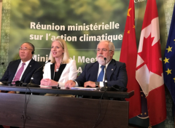

Xie Zhenhua, Chinese Special Envoy, Catherine McKenna, Canadian Minister for Environment and Climate Change, and Commissioner Miguel Arias Cañete join forces to strengthen global climate action in Montreal, Canada, 16 September 2017.

At the One Planet Summit in December, hosted in Paris by Emmanuel Macron, President of France, the Commission presented its [new Action Plan for the Planet](https://ec.europa.eu/commission/sites/beta-political/files/one-planet-summit-ten-initiatives-modern-clean-economy_en.pdf), which includes 10 transformative initiatives for a modern economy and a fair society.

As an example, the Commission announced [investments in three targeted areas](https://ec.europa.eu/clima/news/eu-external-investment-plan-climate-smart-investments-worth-eur-9bn-unveiled-one-planet-summit_en) as part of the [EU External Investment Plan](https://ec.europa.eu/commission/external-investment-plan_en), which is set to mobilise at least €44 billion in sustainable investment for Africa and the European neighbourhood countries by 2020. This expenditure is expected to generate up to €9 billion of investment by 2020.

The EU remains committed to the collective global goal of mobilising, from a variety of sources, $100 billion a year by 2020 and through to 2025 to finance climate action in developing countries. It will continue to significantly increase financing for action to adapt to the impacts of climate change. In 2016 the EU and its Member States contributed a total of €20.2 billion in climate finance, an increase of more than 15 % from 2015.

WHAT DO EU CITIZENS THINK ABOUT CLIMATE CHANGE AND CLEAN ENERGIES?

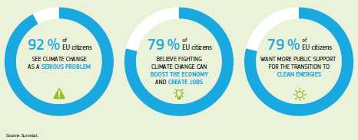

Delivering on the EU’s Paris commitments

The EU is [leading international efforts](https://ec.europa.eu/clima/news/eu-paves-way-global-phase-down-climate-warming-hfcs_en) on a global phase-down of hydrofluorocarbons: dangerous climate-warming gases commonly used in heating and cooling equipment. Reversing the rapid growth in hydrofluorocarbon emissions, which are thousands of times more powerful than carbon dioxide, will make a significant contribution to achieving the temperature goal set out in the Paris Agreement. In October 2016, in Kigali, Rwanda, almost 200 countries agreed to gradually limit their production and use of these gases. In November 2017 EU Member States triggered the entry into force of the [deal](https://ec.europa.eu/clima/news/eu-countries-trigger-entry-force-kigali-amendment-montreal-protocol_en), which will take effect in January 2019. The EU received an [award](https://ec.europa.eu/clima/news/european-union-receives-2017-ozone-award_en) for political leadership for its role in the adoption of the agreement.

On the domestic front all of the main proposals necessary to achieve the EU’s commitment under the Agreement to reduce EU greenhouse gas emissions by at least 40 % by 2030 have been agreed to. These include the [revision of the EU Emissions Trading System](https://ec.europa.eu/clima/policies/ets/revision_en), [national emissions targets for Member States](https://ec.europa.eu/clima/news/commission-welcomes-ambitious-agreement-key-legislation-cut-down-greenhouse-gas-emissions_en), [integrating the land-use sector into the EU’s climate legislation](https://ec.europa.eu/clima/news/commission-welcomes-agreement-key-legislation-tackle-climate-change_en) and tackling [aviation emissions](http://europa.eu/rapid/press-release_IP-17-189_en.htm).

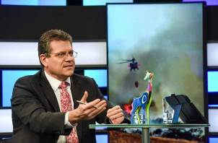

Commission Vice-President Maroš Šefčovič participating in a Facebook Live session during the One Planet Summit in Paris, France, 11 December 2017.

In November the Parliament and the Council reached a [provisional agreement](https://ec.europa.eu/clima/news/eu-emissions-trading-system-landmark-agreement-between-parliament-and-council-delivers-eus_en) to revise the EU Emissions Trading System for the period after 2020. This reform of the EU’s key tool for reducing greenhouse gas emissions in a cost-effective manner will help put the EU on track to achieve a significant part of its commitment to reduce emissions by at least 40 % by 2030.

The revision will bring: significant changes to the system to speed up emissions cuts and the reduction of the current oversupply of emission allowances on the carbon market; additional safeguards to provide industry in the EU with extra protection, if needed, against the risk of carbon leakage; and several support mechanisms to help the industry and the power sectors to meet the innovation and investment challenges of the transition to a low-carbon economy.

The EU also [adopted measures](https://ec.europa.eu/clima/news/climate-change-committee-approves-safeguard-measures-eu-emissions-trading-system_en) to safeguard the environmental integrity of the Emissions Trading System when EU law ceases to apply in the United Kingdom due to its withdrawal from the Union.

An agreement was reached by the International Civil Aviation Organization on a global market-based measure aiming at stabilising international aviation emissions at 2020 levels through offsetting. Following this, the [EU amended](http://www.europarl.europa.eu/legislative-train/theme-resilient-energy-union-with-a-climate-change-policy/file-eu-ets-aviation-implementation-of-the-2016-icao-agreement) its Emissions Trading System to keep its geographic scope limited to intra-European flights. This will maintain the contribution of the aviation sector to EU climate objectives and contribute to the smooth implementation of the global market-based measure.

Linking the EU Emissions Trading System with similar systems increases the market size for reducing greenhouse gas emissions, thereby cutting the cost of fighting climate change. The [EU and Switzerland signed an agreement](https://ec.europa.eu/clima/news/eu-and-switzerland-sign-agreement-link-emissions-trading-systems_en) in November to link their systems. This is the first agreement of its kind for the EU and between two parties to the Paris Agreement on climate change. Furthermore, the [EU and China are stepping up cooperation on carbon markets](https://ec.europa.eu/clima/news/eu-china-boost-carbon-market-cooperation-ahead-china-launch_en) ahead of the launch of China’s own emissions trading system.

Political agreement was reached in December on the [Effort-Sharing Regulation](http://europa.eu/rapid/press-release_STATEMENT-17-5382_en.htm), which reduces emissions in transport, buildings, waste and agriculture in line with the EU’s climate target for 2030. Agreement was also reached on [new rules](http://europa.eu/rapid/press-release_STATEMENT-17-5286_en.htm) on the accounting of emissions from land use, land-use change and forestry. The new rules will enhance the role of land and forests as carbon sinks and will incentivise their productive and sustainable use, further improving the bio-based economy and climate-smart agriculture.

Towards clean, competitive and connected mobility

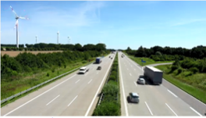

Clean mobility package: promoting clean transport to fight climate change.

<http://ec.europa.eu/avservices/video/player.cfm?ref=I147898&sitelang=en&lg=EN>

In 2017 the Commission launched a series of proposals to modernise EU mobility and transport. These proposals were aimed at helping the sector make the transition towards clean energy and digitisation while ensuring it remains competitive and socially inclusive.

The [Europe on the Move](https://ec.europa.eu/transport/modes/road/news/2017-05-31-europe-on-the-move_en) package was presented in May. Its main aims include making traffic safer and reducing carbon dioxide emissions, air pollution and congestion.

This was followed in November by another [package of measures](http://europa.eu/rapid/press-release_IP-17-4242_en.htm) to stimulate innovation in new technologies and business models and to promote the more efficient use of all modes for transporting goods. The measures include a [proposal](https://ec.europa.eu/clima/policies/transport/vehicles/proposal_en) for new carbon dioxide emission targets for cars and vans to help accelerate the transition to low- and zero-emission vehicles. Under the proposal the fleet-wide average of carbon dioxide emissions for new cars and vans sold in the EU will have to be 30 % lower in 2030 than in 2021.

ENCOURAGING CLEAN AND SUSTAINABLE MOBILITY

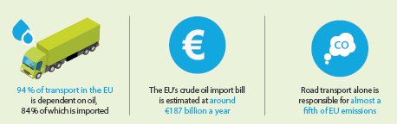

The Commission is launching a number of initiatives for clean, connected and competitive mobility. Extensive electromobility across the EU means the demand for batteries will increase significantly. The Commission is therefore working towards establishing an EU Battery Alliance, bringing together Member States and industries active in the battery value chain, to be launched in February 2018 at the Clean Energy Industrial Forum.

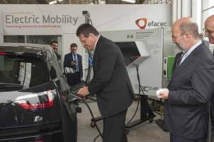

Commission Vice-President Maroš Šefčovič recharges an electric car watched by João Pedro Matos Fernandes, Portuguese Minister for Environment, Lisbon, Portugal, 17 July 2017.

Integrating climate action into different policies

To support the EU’s transition to a more sustainable and low-carbon future the Commission approved an [investment package of €222 million](http://europa.eu/rapid/press-release_IP-17-3429_en.htm) from the EU budget under the [LIFE Programme](http://ec.europa.eu/environment/life/index.htm) for the environment and climate action. This will mobilise additional investment, leading to a total of €379 million for 139 new projects in 20 Member States. Projects will help Member States in their transition to a more [circular economy](http://ec.europa.eu/environment/circular-economy/index_en.htm) and will support the implementation of the [EU Action Plan for Nature](http://ec.europa.eu/environment/nature/legislation/fitness_check/action_plan/index_en.htm). The funding will, for example, help improve the resilience of the Scheldt Estuary in Belgium (one of Europe’s busiest waterways), develop tools to forecast desert dust storms and counteract the heat-island effect in cities.

Chapter 4

A deeper and fairer internal market with a strengthened industrial base



‘Our internal market is Europe’s best asset in times of increasing globalisation. I therefore want the next Commission to build on the strength of our Single Market and to fully exploit its potential in all its dimensions.’

Jean-Claude Juncker, political guidelines, 15 July 2014

The internal market, also known as the Single Market, is one of the EU’s greatest achievements. It has been a significant source of economic growth for EU Member States and makes everyday life easier for people and businesses. However, obstacles to its smooth functioning remain, which means there is still untapped potential for further growth and jobs.

The EU is striving to make the Single Market work better in practice in two ways: first by making sure that existing rules are duly respected; second by making it easier for professionals in certain sectors to provide their services in another EU Member State and avoiding situations where traders find their goods blocked at the border. All this within a system in which competition is fair, fraud is tackled and cross-border taxation is kept simple.

During 2017 action was taken to strengthen EURES, the European Job Mobility Portal, helping people find jobs and enabling companies to find the talent they need. Since people can work in one Member State while registered under the social security system of another, negotiations continued on a proposal to ensure fairness and social sustainability. This was flanked by measures to limit undeclared work and to continue strengthening occupational health and safety.

For goods and people to move easily across borders there must be good transport networks in place. Work to strengthen these continued throughout the year, notably in the less well-served regions. These regions also receive support to allow them to play to their strengths, so that even the farthest-flung areas can participate in the Single Market.

A renewed EU industrial policy

In his State of the Union speech in September Jean-Claude Juncker, President of the European Commission, announced a [new Industrial Policy Strategy](https://ec.europa.eu/commission/news/new-industrial-policy-strategy-2017-sep-18_en) that aims to empower industries in the EU to continue delivering sustainable growth and jobs. It brings together all existing and new initiatives in a comprehensive industrial strategy and clarifies the tasks ahead for all actors involved.

Making free trade in goods and services work in practice

Most products traded between Member States are subject to harmonised rules. This means product standards are the same for everyone and there are no barriers to trading them across borders. Where there are no common rules, however, the principle of [mutual recognition](http://ec.europa.eu/growth/single-market/goods/free-movement-sectors/mutual-recognition_en) applies. This means that if a product is deemed fit for sale in one Member State it is fit for sale in all of them. This does not always work as well as it should in practice, however, as goods can be stopped at the border when they should be freely traded in all of the countries in the [Single Market](https://ec.europa.eu/growth/single-market_en). Under a [new proposal](http://ec.europa.eu/avservices/video/player.cfm?ref=I148506&lg=EN&sublg=none) sellers in one country could use a mutual-recognition declaration to prove that the product meets all of the requirements in another. This proposal has been developed alongside another on reinforcing market surveillance so that national authorities can better control goods sold in their country.

The EU’s focus remains on making the Single Market work better for people and businesses. However, barriers continue to stop firms from starting up and expanding, and can lead to higher prices and less choice for consumers. To reverse this trend, and create more jobs and growth, Member States need to make better use of the potential of the [Single Market for Services](https://ec.europa.eu/growth/single-market/services_en).

ENABLING PROFESSIONALS TO OFFER SERVICES IN THE EU QUICKLY AND CONVENIENTLY

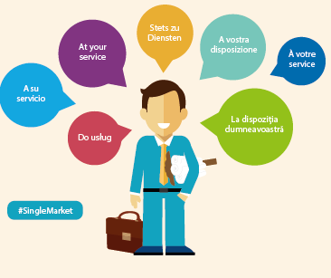

A [package of measures](http://europa.eu/rapid/press-release_IP-17-23_en.htm) that could make it easier for companies and professionals to provide services to anyone in the EU was presented in 2017. This includes a new European Services e-card: a simplified electronic procedure to make it easier for providers of business and construction services to complete the administrative formalities required to provide services abroad. Another proposal seeks to ensure that the requirements that Member States apply to the regulation of professions are proportionate and justified.

Stimulating procurement and innovation

To strengthen the Single Market, and as part of continuous efforts to stimulate investment in the EU, the Commission put forward a proposal in October on ‘Making public procurement work in and for Europe’. This sets out an approach for more efficient and sustainable [public procurement](https://ec.europa.eu/growth/single-market/public-procurement_en) while making full use of digital technologies to simplify and accelerate procedures.

In a bid to encourage companies, in particular small and medium-sized enterprises and start-ups, to invest in innovation and creativity, the Commission also proposed measures to ensure that [intellectual property rights](https://ec.europa.eu/growth/industry/intellectual-property_en) are well protected. The measures will boost the EU’s collective ability to catch the ‘big fish’ behind fake goods and pirated content that harm companies and jobs. They will also protect consumers’ health and safety in areas such as medicines and toys. A proposed patent-licensing system is also expected to help the roll-out of technologies that enable interconnection and connectivity (the internet of things), from smartphones to connected cars.

Financial services: better products and more choice for consumers

The EU is committed to developing a deeper and fairer Single Market, including through digital means. In terms of [financial services](https://ec.europa.eu/info/topics/banking-and-finance_en) this means enhancing competition and improving choice so that consumers can enjoy lower prices and better quality, regardless of whether they shop abroad or at home for financial services such as bank accounts, car insurance, money transfers and pensions. Financial service providers should also be able to reap the benefits of the entire EU market.

This is why the Commission has launched the [Consumer Financial Services Action Plan](https://ec.europa.eu/info/publications/consumer-financial-services-action-plan_en), which identifies where further work is needed to give consumers the best value for their money. The plan seeks, among other objectives, to make it easier for drivers to take their no-claims bonus abroad, to reduce fees for cross-border transactions involving non-euro currencies and to reduce legal and regulatory obstacles affecting businesses seeking to expand abroad.

NEW TYPES OF PERSONAL PENSION IN THE EU

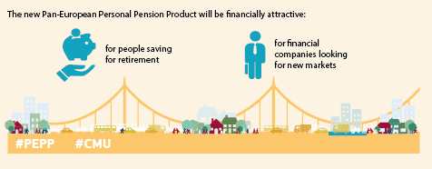

Consumers in the EU will soon benefit from more choice when saving for retirement thanks to Commission plans to create a new class of [pension products](https://ec.europa.eu/info/business-economy-euro/banking-and-finance/insurance-and-pensions/personal-pension-products_en). Currently, the market for personal pensions in the EU is fragmented and uneven. The new type of voluntary personal pension being proposed will allow consumers to complement their retirement savings while benefiting from solid consumer protection.

Enabling people to find jobs and work safely and legally

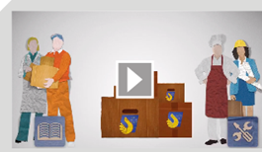

Your First EURES Job: helping young people find jobs in other EU Member States.

<https://www.youtube.com/watch?v=Df-3QE6fDj0>

The Single Market for workers functions best when people are able to find jobs that suit them in other Member States. Significant progress was made during the year towards expanding [EURES](https://ec.europa.eu/eures/public/en/homepage), the European Job Mobility Portal, which offers a free service to jobseekers, workers and employers looking for a job or staff anywhere in the EU. In the course of 2018 the network will be opened up to more partners, such as private employment services, and more jobs and CVs will be advertised on the Portal.

The EU also continues to protect people’s health and safety at work. [Carcinogens and mutagens](http://eur-lex.europa.eu/legal-content/AUTO/?uri=CELEX:52017PC0011&qid=1499326796914&rid=2) were targeted in a new legislative proposal in 2017 aimed at lowering occupational exposure to seven substances, such as used engine oils and trichloroethylene. A proposal made in 2016 on 13 other substances was approved by the European Parliament in October.

POSTED WORKERS IN THE EU

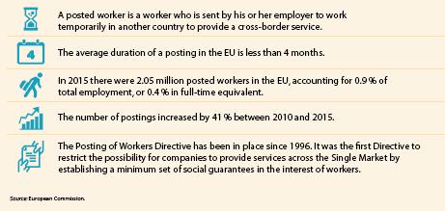

The Commission also helped Member States enforce rules on the free movement of workers, while efforts continued to revise those on the [posting of workers](https://ec.europa.eu/commission/sites/beta-political/files/posting-workers_en.pdf) to make them fit for the future. These rules protect the rights of workers who are sent by their employer to work temporarily in another Member State. The revised rules should establish the principle of the same pay for the same work in the same place, strengthening the fairness and social sustainability of the Single Market and benefiting both companies and workers by helping to ensure a level playing field. In October the Council of the European Union agreed on a general approach on revising the existing Directive, and in November the Parliament and the Council entered into negotiations in order to come to an agreement on this file. The negotiations were still ongoing at the end of 2017.

Work also continued in the Parliament and the Council to find agreement on the Commission’s 2016 proposal to modernise the rules on the coordination of social security systems. The proposal aims to ensure that the rules are fair, clear and easier to enforce, for the benefit of those who cross borders in the EU and of taxpayers.

Rules that are respected and procedures that are made easier

Single Market rights for both people and companies can only be fully exercised if the commonly agreed rules are fit for purpose and correctly applied throughout the EU. To ensure this, timely access to accurate market information is crucial, as is support when problems arise. The [Your Europe](http://europa.eu/youreurope/index.htm) portal helped citizens and businesses to find practical information about their Single Market rights more than 20 million times in 2017. During the year, [Your Europe Advice](https://europa.eu/youreurope/advice/index_en.htm) answered more than 22 000 questions on Single Market legislation and [Solvit](http://ec.europa.eu/solvit/index%5Fen.htm) handled more than 2 000 concrete cases in which citizens and businesses had problems with authorities in the EU. Based on the kinds of requests for help it receives, Solvit also informs the Commission about areas in which the application of EU law needs improvement.

The Commission launched a proposal in May for a [Single Digital Gateway](http://europa.eu/rapid/press-release_IP-17-1086_en.htm) to give people and companies easier access through a single digital entry point to high-quality information, online administrative procedures and assistance services. This means that any procedure currently available online for domestic users will also be accessible to users from other Member States, and will be available in one additional EU language besides the domestic language to make it easier for people from another Member State to use it.

Under certain circumstances the proposed [Single Market Information Tool](https://ec.europa.eu/info/law/better-regulation/initiatives/com-2017-257-0_en) could also allow data to be collected in cases involving serious difficulties with the application of Single Market legislation.

In July the Commission adopted a [notice](http://eur-lex.europa.eu/legal-content/EN/TXT/?uri=uriserv:OJ.C_.2017.250.01.0001.01.ENG&toc=OJ:C:2017:250:TOC) on the [market surveillance](http://ec.europa.eu/growth/single-market/goods/building-blocks/market-surveillance/organisation_en) of products sold online. The rapid development of e-commerce has brought challenges for Member States’ authorities when checking whether products are safe and comply with EU rules. The notice aims to clarify questions and provide solutions. This will help enhance the market surveillance of products sold online, to the benefit of consumers, and ensure a level playing field for businesses.

Smart, socially fair and competitive mobility

Transport and mobility are vital for the economy and competitiveness of the EU. The sector is nevertheless facing a number of unprecedented challenges. Existing social legislation is not applied and enforced consistently across the EU; letterbox companies establish themselves in Member States where they have no real activities but where they benefit from more lenient rules; and road transport alone accounts for almost a fifth of the EU’s greenhouse gas emissions. In May the Commission set out a [long-term strategy](https://ec.europa.eu/transport/modes/road/news/2017-05-31-europe-on-the-move_en) to deliver competitive, clean and connected mobility by 2025.

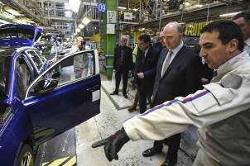

Commissioner Pierre Moscovici visiting a car plant to discuss EU funding, Bourgogne-Franche-Comté, France, 6 October 2017.

This strategy is set out in the Commission’s [Communication ‘Europe on the move’](http://eur-lex.europa.eu/legal-content/EN/TXT/?uri=CELEX:52017DC0283). The Communication is accompanied by eight legislative proposals specifically targeting road transport. The proposals are intended, among other objectives, to improve the functioning of the road-haulage market, to help improve workers’ social and employment conditions and to simplify the application of national minimum-wage laws. The Commission’s wider aim is to promote more sustainable road transport, with tolls that reflect the external cost of air pollution and using digital solutions to cut red tape and integrate different modes of transport. The long-term benefits are expected to extend far beyond the transport sector by promoting jobs, growth and investment.

In June the Commission adopted a set of initiatives intended to bring about improvements in the aviation sector in line with the [Aviation Strategy for Europe](https://ec.europa.eu/transport/modes/air/aviation-strategy_en). One of these initiatives is a proposal intended to ensure the competitiveness of EU airlines, which will also support employment and growth in sectors such as airports and air-navigation service providers. The Commission also listed a number of practical steps capable of improving service continuity in air-traffic management in the context of industrial action. While not in any way affecting the right to strike, these practical measures can minimise disruptions.

[Guidelines](https://ec.europa.eu/transport/sites/transport/files/c20173711-guidelines-ownership-control-carriers.pdf) were also set out on ownership and control requirements applicable to airlines in the EU. The aim is to contribute to a better understanding of those rules and hence to facilitate foreign investment, which in turn is beneficial to employment in the EU’s aviation industry. The Commission also urged the Parliament and the Council to adopt the measures proposed under the EU’s [Single European Sky](https://ec.europa.eu/transport/modes/air/single_european_sky_en) initiative. These measures would improve the efficiency of the air-traffic management system, reduce fragmentation and minimise air-traffic disruption.

The Parliament and the Council agreed to simplify and improve [safety rules](https://ec.europa.eu/transport/modes/maritime/news/2017-10-23-maritime-transport-final-adoption-passenger-ship-safety-package_en) for passenger ships in EU waters. This legislative update is a response to lessons learned, including from accidents and technological developments. Among other improvements it will allow competent authorities to access relevant data immediately in case of emergency.

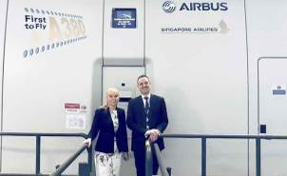

Commissioner Elżbieta Bieńkowska with Captain Yann Lardet at the Airbus Training Centre in Singapore, 10 October 2017.

Competition that encourages innovation

The Commission’s job as a competition authority in the area of merger control is to make sure that a merger does not deny people in the EU the benefits of competition, such as lower prices, greater consumer choice and greater product innovation. Two significant mergers were approved in 2017 in the agro-chemical sector, subject to conditions. These were [ChemChina’s acquisition of Syngenta](http://europa.eu/rapid/press-release_IP-17-882_en.htm) and the merger of [Dow and DuPont](http://europa.eu/rapid/press-release_IP-17-772_en.htm). Innovation is a key factor in the agro-chemical industry, and the Commission assessed the consequences the mergers would have for innovation in the future. In the Dow–DuPont merger, both companies had a number of similar projects underway to develop new pesticide products. One important part of the remedy that allowed the merger to be approved included the divestment of DuPont’s entire worldwide research and development organisation for pesticides.

In June the Commission approved €377 million in State aid from Germany and France to develop the innovative [Airbus X6 helicopter project](http://europa.eu/rapid/press-release_IP-17-1683_en.htm). This was on the grounds that while financial markets were reluctant to finance such an ambitious project with a return on investment only expected over a long period, support for the project would stimulate further investment.

The Commission concluded in October that [Luxembourg had granted undue tax benefits to Amazon](http://europa.eu/rapid/press-release_IP-17-3701_en.htm) of around €250 million. This is illegal under EU State aid rules because it allowed Amazon to pay substantially less tax than other businesses. Luxembourg must now recover the illegal aid.

Also in October the Commission decided to [refer Ireland to the Court of Justice of the European Union](http://europa.eu/rapid/press-release_IP-17-3702_en.htm) for failing to recover from Apple illegal State aid worth up to €13 billion. In August 2016 the Commission had concluded that Ireland’s tax benefits to Apple were illegal under EU State aid rules because they allowed the company to pay substantially less tax than other businesses. In fact, this selective treatment allowed Apple to pay an effective corporate tax rate of 1 % on its European profits in 2003, falling to 0.005 % in 2014.

[Google was fined €2.42 billion](http://europa.eu/rapid/press-release_IP-17-1784_en.htm) in June for breaching EU antitrust rules by abusing its market dominance as a search engine (see also Chapter 2).

Taxation made simpler and fraud tackled

In order to ensure the smooth functioning of the Single Market, [new transparency rules](http://europa.eu/rapid/press-release_IP-17-1663_en.htm) have been proposed for intermediaries, such as tax advisors, accountants, banks and lawyers, who design and promote tax planning schemes for their clients. Cross-border schemes bearing certain characteristics that could result in losses for governments will now have to be automatically reported to the tax authorities before they are used.

With 360 million people in the EU using the internet every day, the Digital Single Market needs a modern and stable tax framework. In September the Commission launched a new EU agenda to ensure that the digital economy is taxed in a fair and growth-friendly way.

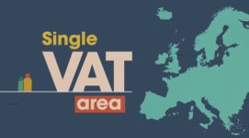

The Single VAT Area: making VAT simpler and fairer.

<https://www.youtube.com/watch?v=k9HHdzXlCpo>

The Commission also presented a [legislative proposal](https://ec.europa.eu/info/law/better-regulation/initiatives/com-2017-569_en) to introduce a definitive VAT system for the taxation of trade between Member States. The proposed new system is based on the principle of taxation in the Member State of destination of the goods, with the supplier charging the VAT of that state.

Every year over €150 billion of VAT receipts are lost, meaning that Member States miss out on revenue that could be used for schools, roads and healthcare for example. Around €50 billion of this, or some €100 per EU citizen per year, is estimated to be due to cross-border VAT fraud.



Stopping cross-border tax fraud.

<https://www.youtube.com/watch?v=7rPzXzCoxkI>

A [legislative proposal](https://ec.europa.eu/taxation_customs/sites/taxation/files/vat_administrative_cooperation_proposal.pdf) aiming at tackling VAT fraud was put forward in November to strengthen cooperation between tax authorities and customs and law enforcement bodies. In December the Council adopted a decision to sign an agreement on administrative cooperation, recovery assistance and combating VAT fraud between the EU and Norway.

Empowering the EU’s regions to build on their strengths

Globalisation has brought enormous benefits to the less-developed economies of the world and many opportunities for EU citizens. However, while the benefits are widely spread, the costs are often borne unevenly. The European Union needs to become more resilient, and also needs to empower its regions and help them create value. This means embracing innovation, digitisation and decarbonisation, along with developing people’s skills. It also means making EU funds available to all EU regions so that they can invest in their niche areas through partnerships between innovation actors, leading to smart specialisation. In 2017 the Commission launched two pilot projects to test innovative approaches to interregional cooperation.

Those who live in the outermost regions of the EU can also suffer from their relative isolation. Simplified rules are making it easier for public authorities to [compensate](http://europa.eu/rapid/press-release_IP-17-1341_en.htm) companies for the additional costs they face when operating in the EU’s outermost regions. This takes into account the specific challenges they face, such as their remoteness and their dependence on a few traded products.

Chapter 5

A deeper and fairer Economic and Monetary Union

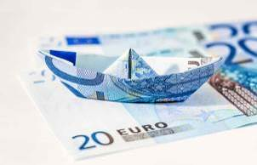

‘Over the next five years, I want to continue with the reform of our Economic and Monetary Union to preserve the stability of our single currency and to enhance the convergence of economic, fiscal and labour market policies between the Member States that share the single currency.’

Jean-Claude Juncker, political guidelines, 15 July 2014

In 2017 the EU reached several milestones on the road to achieving deeper and fairer Economic and Monetary Union, which includes a comprehensive Banking Union. Completing this work will help the EU face existing and new challenges, ensuring further economic and social convergence, higher growth and more employment with the help of strong institutions and democratic accountability.

Building on the Five Presidents’ Report of June 2015, the European Commission published a reflection paper in May 2017 on deepening Economic and Monetary Union as part of the wide debate begun in March with the White Paper on the Future of Europe.

In October the Commission called for the completion of the Banking Union as an integral part of its vision for a deeper Economic and Monetary Union that delivers tangible benefits for citizens and business.

Another milestone was reached in December when the Commission presented its Economic and Monetary Union package of proposals. With a roadmap for action and several concrete measures, the Commission delivered on the commitment to deepen Europe’s Economic and Monetary Union made by Jean-Claude Juncker, President of the European Commission, in his 2017 State of the Union address.

The proposals include transforming the European Stability Mechanism into a European Monetary Fund within the EU’s legal framework, to assist euro area Member States in financial distress. The proposals also include the Commission’s vision of how certain budgetary functions essential for the euro area and the EU as a whole can be developed to provide further support. This would help Member States implement their structural reforms.

Towards deeper Economic and Monetary Union

2017 demanded stamina and a clear vision from all those working to design a stronger, more democratic and more united European Union. Economic and Monetary Union is a vital part of the debate, with a central role to play in forging an EU of equals that is focused on the things that matter most.

On 1 March the Commission presented a White Paper setting out five scenarios for how the EU could evolve by 2025 and the key choices that each path would entail. Each choice would have implications for the future of Economic and Monetary Union. Do we as a Union want to carry on as we are today? Should we just focus on the Single Market? Should we allow those who are ready to go ahead and do more together? Should we choose to focus on doing fewer things more efficiently? Or should we try to accomplish much more together?

In May the Commission broadened the specific debate on deepening [Economic and Monetary Union](https://ec.europa.eu/commission/publications/five-presidents-report-completing-europes-economic-and-monetary-union_en) with the publication of its [reflection paper](https://ec.europa.eu/commission/publications/reflection-paper-deepening-economic-and-monetary-union_en) on the issue. The ideas presented in the paper form part of the vision for a stronger, more democratic and more united EU. In September President Juncker presented the wider context in his State of the Union address: a vision offering hope, stability, fairness and opportunity to all.

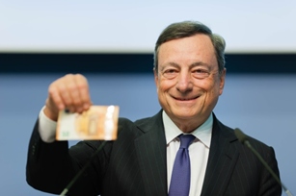

Mario Draghi, President of the European Central Bank, at the Bank’s headquarters in Frankfurt, Germany, with the new €50 note that entered into circulation on 4 April 2017.

The reflection paper underlined that effective and stable Economic and Monetary Union needed to rely on an integrated and properly functioning financial system. Building on the momentum of what has already been achieved in recent years, it is now time to reach a consensus on how to move ahead until 2025. Completing the [[Banking Union](https://ec.europa.eu/info/business-economy-euro/banking-and-finance/banking-union_en)](https://ec.europa.eu/info/business-economy-euro/banking-and-finance/banking-union_en), reducing and sharing risks in the banking sector and making banks in the EU even more resilient are necessary further steps, along with providing more diverse and innovative financing opportunities for the real economy in a true [Capital Markets Union](https://ec.europa.eu/info/business-economy-euro/growth-and-investment/capital-markets-union_en).

Calling for a complete Banking Union

The Banking Union protects financial stability and is essential for the smooth functioning of the euro area and the EU as a whole. Risk reduction and risk sharing go hand in hand in completing it. Significant progress has been made in making banks in the EU more resilient and thereby reducing risks in the banking sector, and further steps are being prepared. Since the crisis the Commission has made over 50 proposals to increase the resilience of the financial sector.

The time to complete the Banking Union has arrived. The creation of a [backstop](https://ec.europa.eu/commission/sites/beta-political/files/backstop-banking-union_en.pdf) (or safety net) for the Single Resolution Fund was agreed by Member States in 2013, but 4 years on it is still not operational. President Juncker’s 2017 State of the Union address emphasised the need for it to be made operational as a matter of priority. The Commission is [proposing](http://eur-lex.europa.eu/legal-content/EN/TXT/?uri=CELEX:52017DC0822) to make the backstop part of the future European Monetary Fund. This will be an important step towards completing the Banking Union.

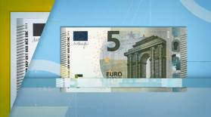

Completing Europe’s Economic and Monetary Union.

[europa.eu/!dG63kj](http://europa.eu/!dG63kj)

COMPLETING EUROPE’S ECONOMIC AND MONETARY UNION

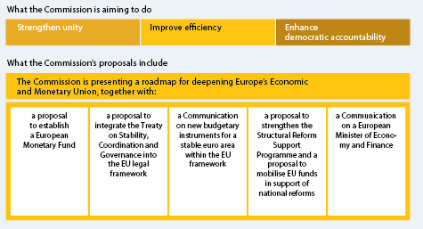

Making economic and social structures in Member States more resilient was also identified as an essential element of successful Economic and Monetary Union in the long run. The other key elements identified were further strengthening the [European Semester](https://ec.europa.eu/info/strategy/european-semester_en) (the framework for the coordination of economic and fiscal policies across the EU) and creating a link between financial support from the EU budget and structural reforms. The creation of a central capacity to help euro-area Member States hit by macroeconomic shocks was also proposed.

The Commission’s reflection paper highlighted that it would only be possible to reform Economic and Monetary Union in tandem with increasing democratic accountability and strengthening euro-area institutions. The way forward is to share more responsibilities and decisions on euro-area matters within a common legal framework.

The paper confirmed a commitment to real convergence between richer and poorer parts of the EU.

In December the Commission launched the [Economic and Monetary Union package](http://europa.eu/rapid/press-release_IP-17-5005_en.htm), which includes proposals to transform [the European Stability Mechanism](https://www.esm.europa.eu/) into a European Monetary Fund anchored within the EU’s legal framework. The Fund would continue to assist euro-area Member States in financial distress. In addition, it would provide a common backstop to the [Single Resolution Fund](https://ec.europa.eu/info/business-economy-euro/banking-and-finance/banking-union/single-resolution-mechanism_en) and act as a lender of last resort to facilitate the orderly resolution of distressed banks. More rapid decision-making in cases of urgency and more direct involvement in the management of financial assistance programmes are also envisaged. Over time the European Monetary Fund could also develop new financial instruments, for example to support a possible stabilisation function.

In addition, the Commission opened a discussion on new budgetary instruments for a stable euro area within the European Union framework. It set out its vision of how certain budgetary functions essential for the euro area and the EU as a whole can be developed within the framework of the EU’s public finances. These functions are as follows.

* Support to Member States for structural reforms through a reform-delivery tool and technical support at the request of Member States.
* A dedicated convergence facility for Member States on their way to joining the euro.
* A backstop for the Banking Union, through the European Monetary Fund/European Stability Mechanism, to be agreed by mid 2018 and made operational by 2019.
* A stabilisation function to protect investments in the event of large asymmetric shocks across Member States.

64 % OF CITIZENS IN THE EURO AREA SAY THE EURO IS A GOOD THING

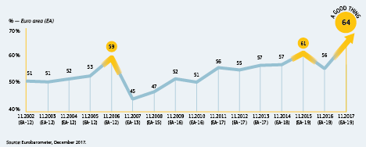

The Commission will present the necessary initiatives in May 2018 within the context of its proposals for the post-2020 Multiannual Financial Framework. For the 2018-2020 period the Commission has proposed strengthening the technical support it delivers to Member States through the [Structural Reform Support Programme](https://ec.europa.eu/info/funding-tenders-0/overview-funding-programmes/structural-reform-support-programme-srsp_en) by doubling the financial envelope to reach €300 million by 2020.

The Commission has suggested testing the new reform-delivery tool in a pilot phase. To that end it has proposed targeted changes to the Common Provisions Regulation governing the European Structural and Investment Funds, which would allow Member States to use their performance reserve in the Funds to support the implementation of agreed reforms.

The Commission also proposed to integrate the substance of the [Treaty on Stability, Coordination and Governance in the Economic and Monetary Union](http://eur-lex.europa.eu/legal-content/EN/TXT/?uri=LEGISSUM:1403_3) into EU law, taking into account the appropriate flexibility built into the Stability and Growth Pact.

In addition, the Economic and Monetary Union package explained how the Commission envisages the possible functions of a double-hatted European Minister of Economy and Finance. As both a Vice-President of the Commission and President of the Eurogroup, the Minister would bring together existing responsibilities and available expertise. He or she would also strengthen the coherence, efficiency, transparency and democratic accountability of economic policymaking for the EU and the euro area in full respect of national competences.

Using the window of opportunity for growth and jobs

The 2017 [European Semester](http://ec.europa.eu/economy_finance/economic_governance/the_european_semester/index_en.htm) benefited from new, streamlined procedures. Following the [recommendations](https://ec.europa.eu/info/publications/2017-european-semester-country-specific-recommendations-commission-recommendations_en) adopted in May, which were subsequently adopted by the Council of the European Union, the Commission provided guidance for all Member States and for the euro area as a whole. The key message was that now is the time to seize the window of opportunity offered by the economic recovery to achieve more inclusive, robust and sustainable economic growth through reforms that create more jobs, increase convergence and resilience and contribute to a fairer society.

While priorities varied across the EU, the Semester process identified structural reforms, boosting investment and further strengthening public finances as indispensable tools to bolster and sustain economic recovery.

The 2018 cycle of the European Semester was launched on 22 November. The Commission recommends further structural reforms and calls on Member States to boost investment as a way to support expansion and to increase productivity and long-term growth. This cycle brings into practice the [Social Scoreboard](http://ec.europa.eu/eurostat/web/european-pillar-of-social-rights/overview), launched as one of the tools to implement the European Pillar of Social Rights.

Ensuring undistorted competition and controlling State aid

2017’s [State aid cases](http://ec.europa.eu/competition/state_aid/overview/index_en.html) showed that the gradual implementation of the [Banking Union](https://ec.europa.eu/info/business-economy-euro/banking-and-finance/banking-union_en) framework can progressively reduce the burden on taxpayers resulting from rescuing banks. Further ongoing improvements, especially the build-up of [minimum requirements for own funds and eligible liabilities](https://ec.europa.eu/info/business-economy-euro/banking-and-finance/financial-supervision-and-risk-management/managing-risks-banks-and-financial-institutions_en), will further reduce reliance on taxpayers’ money in the future.

The first case under the [Banking Union's resolution framework](https://ec.europa.eu/info/business-economy-euro/banking-and-finance/financial-supervision-and-risk-management/managing-risks-banks-and-financial-institutions/bank-recovery-and-resolution_en) occurred in 2017, and concerned Spain’s [Banco Popular](http://europa.eu/rapid/press-release_IP-17-1556_en.htm). Following the conversion and write-down of its capital instruments by the [Single Resolution Board](https://srb.europa.eu/), the bank was sold to the Santander Group. Since Fund aid was not involved the Commission, in its capacity as State aid authority, did not need to intervene.

However, State aid control in the banking sector remains important. For example, in cases of precautionary recapitalisation (in which a state injects own funds into a solvent bank to preserve financial stability), the specific banking State aid rules apply. A case in point is [Banca Monte dei Paschi di Siena](http://europa.eu/rapid/press-release_IP-17-1905_en.htm), which received aid approved under State aid rules in 2017 on the basis of an in-depth restructuring plan.

Liquidation aid within national insolvency proceedings can be authorised under certain conditions. Thus, in June, the [Commission approved](http://europa.eu/rapid/press-release_IP-17-1791_en.htm) the aid that Italy granted to Banca Popolare di Vicenza and Veneto Banca for an orderly exit from the market, thereby avoiding economic disturbance in the Veneto region, along with a moral hazard and the distortion of competition in the banking sector.

The Commission’s approval of the aid for these three banks was conditional on burden sharing by existing shareholders and subordinated debt holders, thereby reducing the amount to be paid by taxpayers.

Finally, assessment under State aid rules may conclude that the state acts as a normal market operator and should receive risk-reflecting remuneration at market terms so that State aid is not involved. This was the case for the Portuguese state’s capital injection into [Caixa Geral de Depósitos](http://europa.eu/rapid/press-release_IP-17-556_en.htm) to support a far-reaching turnaround strategy.

The Banking Union

WHAT THE BANKING UNION WILL DELIVER

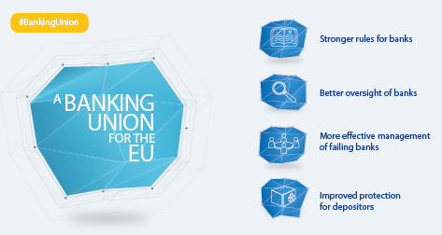

European supervisory authorities

In September the Commission [published proposals](https://ec.europa.eu/info/business-economy-euro/banking-and-finance/financial-supervision-and-risk-management/european-system-financial-supervision_en#reviewoftheesfs) to make EU supervision of banks, financial markets and insurance and pensions stronger and more integrated. The intention is to better ensure the uniform implementation of EU rules and make the markets concerned more resilient. The proposals take account of new developments in the area of financial technologies and the growing importance of sustainability considerations.

The Banking Union must be completed if it is to deliver its full potential in making the Economic and Monetary Union more stable and resilient to shocks, while limiting the need for public risk sharing. Together with the Capital Markets Union, a complete Banking Union will promote a stable and integrated financial system in the EU.

Building on the significant progress already achieved, the Commission set out an ambitious yet realistic path to ensure agreement on all the outstanding elements of the Banking Union, based on existing commitments by the Council. During the year the European Parliament and the Council agreed on important further steps to reduce risks in the banking sector based on the [Commission’s proposals](http://europa.eu/rapid/press-release_IP-16-3731_en.htm) of November 2016. They will, for example, give banks more clarity on building up buffers to absorb losses and make it easier, if needed, to resolve a bank without recourse to taxpayers’ money.

Significant progress has already been achieved in reducing the stock of non-performing loans on banks’ balance sheets, but more needs to be done. Non-performing loans affect the profitability of banks and their ability to lend to the economy. They also cast doubts on the stability of the banking system. The EU is therefore rolling out an Action Plan to further reduce non-performing loans and prevent loans from becoming non-performing in the first place through a variety of measures.

Retail financial services

New financial technologies are having a major impact on the financial sector from the perspective of both consumers and providers. In March the Commission published a [Consumer Financial Services Action Plan](https://ec.europa.eu/info/publications/consumer-financial-services-action-plan_en) to strengthen the Single Market for retail financial services. The Action Plan seeks to improve consumer protection in this sector and to harness the potential of digitisation and technological development so as to improve consumer choice and access to financial services across the EU. A [public consultation](https://ec.europa.eu/info/finance-consultations-2017-fintech_en) on technological innovation in financial services (FinTech) was also launched, on issues such as opportunities in terms of access to financial services, cost efficiency or competition, but also risks related to cybersecurity or data protection. The consultation also aimed to assess the existing barriers that may prevent such innovation from being scaled up across Europe.

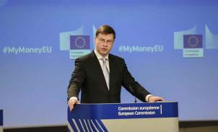

Commission Vice-President Valdis Dombrovskis presenting the Consumer Financial Services Action Plan, Brussels, 23 March 2017.

The European Pillar of Social Rights

In April the Commission proposed an extensive social package as a further step towards a fairer EU with a strong social dimension. The proposal for a [[European Pillar of Social Rights](https://ec.europa.eu/commission/priorities/deeper-and-fairer-economic-and-monetary-union/european-pillar-social-rights_en)](https://ec.europa.eu/commission/priorities/deeper-and-fairer-economic-and-monetary-union/european-pillar-social-rights_en) was at the heart of this initiative. It sets out 20 key principles and rights to support fair and properly functioning labour markets and welfare systems. It is designed as a compass for a renewed process of providing better working and living conditions in the EU.

WHAT THE EUROPEAN PILLAR OF SOCIAL RIGHTS OFFERS

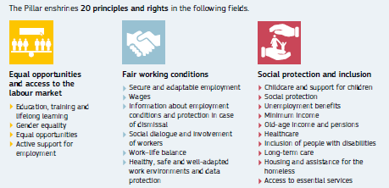

THE 12 AREAS COVERED BY THE SOCIAL SCOREBOARD

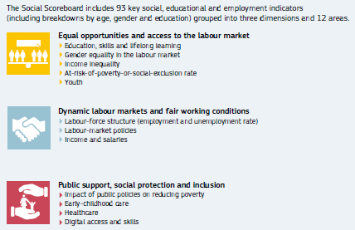

A number of legislative and non-legislative initiatives accompany the Pillar, in particular on the work–life balance of parents and carers, on working conditions, on access to social protection and on working time.

The Commission’s December [proposal](http://europa.eu/rapid/press-release_IP-17-5285_en.htm) on transparent and predictable working conditions complements and modernises existing obligations to inform each worker of his or her working conditions. In addition, the proposal aims to create new minimum standards to ensure that all workers, including those on atypical contracts, benefit from more predictability and clarity as regards their working conditions.

Moreover, a [Social Scoreboard](http://ec.europa.eu/eurostat/web/european-pillar-of-social-rights) has been established to track trends and performances across EU Member States in 12 areas and to assess progress towards a social ‘triple A’ rating for the EU as a whole. The [results of the Social Scoreboard](http://ec.europa.eu/eurostat/web/european-pillar-of-social-rights/indicators/scoreboard) will feed into the European Semester of economic policy coordination and will help enhance its focus on employment and social performance. On 17 November in Gothenburg, Sweden, Jean-Claude Juncker, President of the European Commission, and Stefan Löfven, Prime Minister of Sweden, hosted a Social Summit for Fair Jobs and Growth, at which the European Pillar of Social Rights was proclaimed.

Balancing work and family life

In April the Commission made a [proposal on work–life balance](http://europa.eu/rapid/press-release_IP-17-1006_en.htm) that sets a number of new or higher minimum standards for parental, paternity and carer’s leave. The proposed measures are intended in particular to increase possibilities for men to take up parental and caring responsibilities. This will benefit children and help increase women’s participation in the labour market, thereby reducing the difference between men and women in employment. The proposal will also give parents of children up to 12 years old and other carers the right to request flexible working arrangements.

The social dimension of Europe

Following the publication in March of the [White Paper on the Future of Europe](https://ec.europa.eu/commission/white-paper-future-europe-reflections-and-scenarios-eu27_en), in April the Commission published a [reflection paper on the social dimension of Europe](https://ec.europa.eu/commission/files/reflection-paper-social-dimension-europe_en), raising questions on how to sustain our standards of living, create more and better jobs, equip people with the right skills and create more unity within our society, in light of tomorrow’s society and world of work. The [Social Summit for Fair Jobs and Growth](https://ec.europa.eu/commission/publications/social-summit-fair-jobs-and-growth-factsheets_en) in Gothenburg in November, culminating in the proclamation of the European Pillar of Social Rights, was a key contribution to this debate.

In October an awareness-raising campaign on [energy efficiency and energy poverty](https://ec.europa.eu/energy/en/topics/markets-and-consumers/consumer-rights-and-protection) was launched. Actions included the design and dissemination of communication materials and events organised with key stakeholders and multipliers, such as municipalities and consumer organisations, as a pilot project in four Member States (the Czech Republic, Greece, Portugal, and Romania). If this project proves successful a wider roll-out to other Member States will be considered. The campaign is a priority at a time when many households across the EU are still suffering from the impact of the financial and economic crisis. Levels of energy poverty in many Member States remain high, and the households most harshly affected are often single-parent families with dependent children.

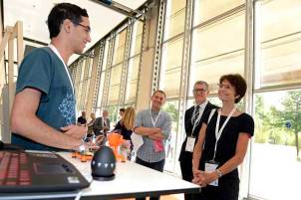

Discussion between an exhibitor and Commissioner Marianne Thyssen (right), with Alastair Macphail of the European Training Foundation (second right) and Oren Lamdan, teacher (centre), at the Torino Process 2016-2017 conference ‘Changing Skills for a Changing World’, Turin, Italy, 8 June 2017.

European social dialogue

The EU continued to deliver on the [New Start for Social Dialogue](http://ec.europa.eu/social/main.jsp?catId=329&langId=en/) and the [joint statement](http://ec.europa.eu/social/main.jsp?langId=en&catId=89&newsId=2562) of June 2016 on the fundamental role of European social dialogue as a significant component of EU employment and social policymaking. The Commission consulted trade unions, employers and other social partners on key initiatives. In line with the principle of the European Pillar of Social Rights on social dialogue, social partners will play an important role during the implementation phase.

Education and training to improve people’s potential

Effective education and training systems provide young people with the knowledge, competences and skills to find fulfilling work and to become independent, engaged citizens. They also give workers the opportunity to upgrade their skills to cope with changing working methods and the needs of the labour market and to help increase productivity and growth.

Education and training system reforms are a high priority in most Member States, and featured prominently in the 2017 European Semester (see Chapter 1 for more information on the Semester). Fourteen Member States received a country-specific recommendation in the area of education and training.

Reforms were also at the heart of the EU’s strategy for quality education for all, adopted in May, which included new initiatives on [school development](http://eur-lex.europa.eu/legal-content/EN/TXT/HTML/?uri=CELEX:52017DC0248&from=EN) and on a renewed agenda for [higher education](http://eur-lex.europa.eu/legal-content/EN/TXT/HTML/?uri=CELEX:52017DC0247&from=EN). In November the Council adopted the proposal on [graduate tracking](http://eur-lex.europa.eu/legal-content/EN/TXT/HTML/?uri=CELEX:32017H1209(01)&rid=9) to help Member States collect information on what graduates do after their studies, and the Commission formulated a proposal to EU leaders on how to work jointly towards a European Education Area by [strengthening European identity via education and culture](https://ec.europa.eu/commission/sites/beta-political/files/communication-strengthening-european-identity-education-culture_en.pdf). In December EU leaders called on the European Commission to work towards increased mobility through an extended Erasmus+ programme; to set up 20 European universities by 2024; to promote language learning; to design a European Student Card; to work with Member States towards mutual recognition of higher education and school diplomas; and to promote culture through the [2018 European Year of Cultural Heritage](http://europa.eu/cultural-heritage/).

Reaching out to citizens — highlights from Citizens’ Dialogues in 2017

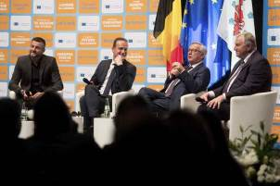

Jean-Claude Juncker, President of the European Commission, attending a Citizens’ Dialogue in St. Vith, Belgium, 15 November 2017.

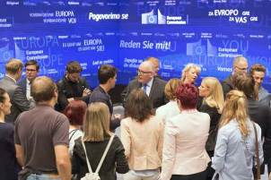

Commission First Vice-President Frans Timmermans participating in a Citizens’ Dialogue live from the studios of TV Slovenija, Ljubljana, Slovenia, 4 September 2017.

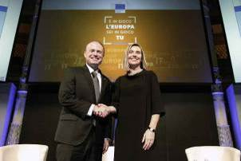

High Representative/Commission Vice-President Federica Mogherini and Joseph Muscat, Prime Minister of Malta, attending a Citizens’ Dialogue in Rome, Italy, 24 March 2017.

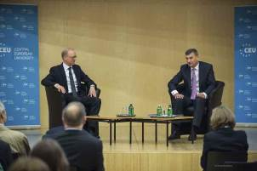

Commission Vice-President Andrus Ansip at a Citizens’ Dialogue on the opportunities offered by the Digital Single Market, Budapest, Hungary, 9 November 2017.

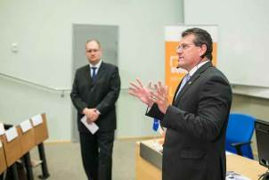

Commission Vice-President Maroš Šefčovič presenting the Energy Union during a Citizens’ Dialogue in Tallinn, Estonia, 21 September 2017.

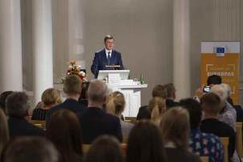

Commission Vice-President Valdis Dombrovskis at a Citizens’ Dialogue on investment and the state of the EU’s fiscal and economic policies, Tartu, Estonia, 31 October 2017.

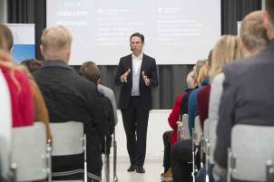

Commission Vice-President Jyrki Katainen at a Citizens’ Dialogue on the future of Europe in Kuopio, Finland, 24 November 2017.

Chapter 6

A balanced and progressive trade policy to harness globalisation

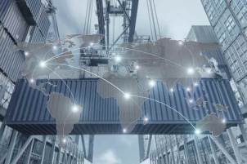

‘I will not sacrifice Europe’s safety, health, social and data protection standards or our cultural diversity on the altar of free trade. Notably, the safety of the food we eat and the protection of Europeans’ personal data will be non-negotiable for me as Commission President. Nor will I accept that the jurisdiction of courts in the EU Member States is limited by special regimes for investor disputes. The rule of law and the principle of equality before the law must also apply in this context.’

Jean-Claude Juncker, political guidelines, 15 July 2014

The EU is one of the world’s most open economies, and pursues an ambitious trade-negotiation agenda. It aims to open markets and create a level playing field for EU firms around the globe. The economy of the EU depends on trade: every €1 billion in exports supports 14 000 extra jobs in Europe. Openness combined with high standards remains the best way to make globalisation work for all EU citizens.

With 31 million EU jobs depending on exports, four fifths of imports into the EU being used as input for EU goods or services and 90 % of global growth in the coming decades expected outside the EU, open trade is more important than ever for the European Union.

The EU is committed to a rules-based multilateral trading system as the basis for its prosperity and continues to play a leading role in the World Trade Organization. When others break global trade rules or engage in unfair trading practices the EU defends European businesses and workers.

In 2017 the EU and Japan concluded their negotiations for an EU–Japan Economic Partnership Agreement, and the EU and Canada began to provisionally apply their Comprehensive Economic and Trade Agreement. The EU made good progress in various bilateral trade negotiations and began trade talks with Chile. The European Commission also proposed that trade talks be launched with Australia and New Zealand.

The European Parliament and the Council of the European Union agreed on a proposal to modernise trade-defence instruments, and a new method for calculating dumping entered into force to make such EU instruments stronger. The Commission proposed a new framework for screening strategic investments from outside the European Union, and the EU took concrete steps to counter unethical practices such as trading in conflict minerals.

A balanced and progressive trade policy

In recent years international trade has faced mounting challenges, with renewed doubts about the effects of globalisation, questions about the purpose and value of trade agreements and the real danger of resurgent protectionism. The Commission realises that, to respond to such challenges, a trade policy that is effective, transparent and based on values is needed more than ever before. As such, the fundamentals of the Trade for All strategy, launched in October 2015, continued to guide the approach taken in 2017: openness combined with high standards remains the most appropriate way to make globalisation work for everybody in the EU.

In the context of the State of the Union speech in September by Jean-Claude Juncker, President of the European Commission, which had been preceded by the publication in May of a [reflection paper on harnessing globalisation](https://ec.europa.eu/commission/publications/reflection-paper-harnessing-globalisation_en), Commission Vice-President Jyrki Katainen and Commissioner Cecilia Malmström presented a package of initiatives on a range of trade issues. These included a Communication on trade policy; draft mandates for negotiations with Australia and New Zealand and for a new Multilateral Investment Court; and a framework for the screening of foreign direct investment to ensure that it remains a major source of growth in the EU while protecting the Union’s essential interests. The package also included a progress report on the Trade for All strategy. In November the Commission published a report on the implementation of the EU’s free trade agreements.

The EU continued to play a leading role in the World Trade Organization, in particular at the 11th Ministerial Conference in Buenos Aires, Argentina, in December. Although the Ministerial Conference did not deliver any multilateral outcomes, the EU reiterated its strong commitment to the Organisation and its continued support for finding solutions to important issues in the global multilateral trading system.

Through its Market Access Strategy the EU aims to open markets by tackling market-access barriers around the globe, while remaining committed to balanced, rules-based and responsible trade.

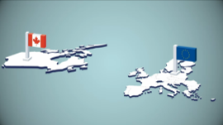

The EU–Canada trade deal enters into force.

<https://ec.europa.eu/avservices/video/player.cfm?ref=I120807>

A Europe that protects

The EU is committed to a rules-based multilateral trading system that serves as the basis for its prosperity and is essential in making trade a positive force around the globe. Its trade policy also robustly defends businesses and workers within the EU when others break global trade rules or engage in unfair trading practices.

The EU is one of the most active and successful users of the World Trade Organization's dispute-settlement mechanism. When diplomatic interventions fail the EU does not hesitate to use these procedures to enforce its rights under the Organization's rules to ensure it receives the full benefits of its membership for its businesses, workers and farmers. As an example of the achievements in 2017, the World Trade Organization ruled that the Russian import ban on pork and pork products from the EU is illegal; China removed its restrictions on exports of certain critical raw materials; and Russia lowered its import duties on several products from the EU.

In line with World Trade Organization rules and Union legislation, the EU imposed 34 trade-defence measures against unfair trade practices by non-EU countries, including anti-dumping duties on steel from China (an anti-dumping duty is a tariff that a domestic government imposes on foreign imports that it believes are priced below fair market value). In 2017 the EU imposed 11 measures to defend Europe's steel industry. According to publicly available reports, the EU's steel industry is returning to profitability.

The EU also defends its industries when non-EU countries conduct anti-dumping and countervailing duties inquiries against exports from the Union, as in the recent proceedings launched by Australia (processed tomatoes), China (potato starch) and the United States (olives).

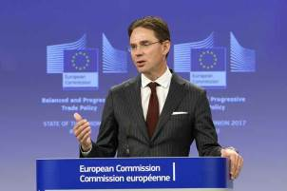

Commission Vice-President Jyrki Katainen giving a press conference to present the Commission’s agenda for a balanced and progressive trade policy, Brussels, 14 September 2017.

In December the EU agreed to modernise its anti-dumping and anti-subsidy regulations to make its trade-defence instruments better adapted to the challenges of the global economy. They will become more effective, transparent and easier for companies to use, and in some cases will enable the EU to impose higher duties on dumped products. The EU also changed the way it calculates dumping in anti-dumping investigations on imports from members of the World Trade Organization if prices and costs are distorted because of state intervention.

EU exporters continue to face barriers to trade around the world. The Commission’s annual report on trade and investment barriers showed a 10 % increase in trade barriers faced by EU exporters in 2016, with 372 barriers in place in over 50 countries throughout the world. The report indicated that 36 new obstacles in 2016 could affect EU exports worth €27 billion, but that the Commission’s Market Access Strategy had succeeded in removing 20 other obstacles affecting exports worth €4.2 billion.

In September the EU launched three intellectual-property key cooperation and assistance programmes with China, south-east Asia and Latin America. The aim is to reduce the illegal trade in goods that infringe the intellectual property rights of artists, inventors and brands from the European Union, and to promote the international protection of such rights.

The EU also took concrete steps to counter unethical practices, such as trading in conflict minerals. A new Regulation to stop trade in natural resources that are sold to fuel and sustain armed violence in war zones was adopted in April and took effect 2 months later. The Regulation imposes due-diligence rules on companies importing tin, tantalum, tungsten, their ores and gold. Such metals and ores are used in the production of everyday products such as mobile phones, cars and jewellery. The rules will cover up to 95 % of EU imports as of January 2021.

The EU also stood up against torture and the death penalty, launching the Alliance for Torture-Free Trade, together with Argentina and Mongolia, at the United Nations General Assembly in September. Delegations from 58 countries signed a political declaration in which they committed to put in place measures, such as legislation and efficient enforcement systems, to restrict and eliminate trade in goods that could be used for capital punishment and torture.

A Europe that takes the lead

The trade agreements the EU has negotiated, or is negotiating, with countries around the world aim to ensure that trade works for everyone. These trade agreements open up markets and project EU values, such as protecting labour rights and the environment.

With this in mind, the Commission proposed to open negotiations to establish a multilateral court for the settlement of investment disputes, which would be a major innovation in global governance.

The EU–Japan Economic Partnership Agreement

Japan is the world’s fourth-largest economy. In July the EU and Japan agreed in principle on the main elements of the [EU–Japan Economic Partnership Agreement](http://ec.europa.eu/trade/policy/in-focus/eu-japan-economic-partnership-agreement/), and in December they announced the successful conclusion of the final discussions. The Agreement will remove trade barriers and help the EU and Japan to jointly shape global trade rules. The trade agreement will be the most important bilateral deal ever concluded by the EU.

It will include, for the first time in an EU trade agreement, a specific commitment to the Paris Climate Agreement and a dedicated chapter for small companies covering transparency and a specific institutional set-up.

THE EU AND JAPAN HAVE NEGOTIATED A TRADE DEAL

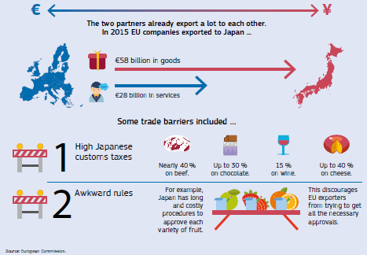

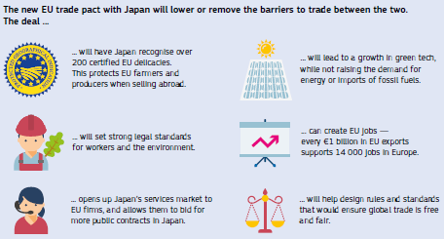

The Economic Partnership Agreement will remove the vast majority of the €1 billion in duties paid by companies in the EU every year. It will increase exports and create [new opportunities for EU companies](http://trade.ec.europa.eu/doclib/docs/2017/july/tradoc_155694.pdf), both big and small, along with their employees and consumers. It will open the Japanese market to key EU agricultural exports and expand opportunities in a range of sectors. The value of exports from the EU could increase by as much as €20 billion. The Agreement will also make it easier for EU firms to provide services in Japan in areas such as maritime transport and telecoms.

The Economic Partnership Agreement sets the highest standards of labour, safety, environmental and consumer protection, fully safeguards public services and has a dedicated chapter on sustainable development. In parallel to the agreement the EU and Japan committed to facilitating the flow of data between the two economies.

The Comprehensive Economic and Trade Agreement with Canada

The EU’s [Comprehensive Economic and Trade Agreement](http://ec.europa.eu/trade/policy/in-focus/ceta/) with Canada started to be provisionally applied on 21 September.

The EU–Canada trade deal will save EU businesses over €500 million a year, money that had previously been paid in tariffs on goods they exported to Canada. Almost 99 % of these savings started from day one of the deal, which will also give EU companies the best access they have ever had to Canadian public procurement contracts at the federal, provincial and municipal levels.

All businesses will save time and money due to reduced export-related costs per unit, for example by avoiding duplicative testing requirements, lengthy customs procedures and costly legal fees.

The Agreement with Canada will create new opportunities for the EU’s farmers and food producers. For certain products the EU has opened its market in a limited and calibrated way. Increased Canadian access to the market in the EU is balanced out by Canada opening its own market in areas in which producers in the European Union are keen to increase exports, such as cheese, wine and spirits, fruit and vegetables, and processed products. The Trade Agreement also protects 143 high-quality distinctive EU regional food and drink products (known as geographical indications) on the Canadian market so that imitation goods cannot be sold under the same name. The agreement safeguards intellectual property, bringing Canada’s rules in line with EU laws protecting new technologies and managing digital rights.

THE EU–CANADA COMPREHENSIVE ECONOMIC AND TRADE AGREEMENT IN 60 SECONDS

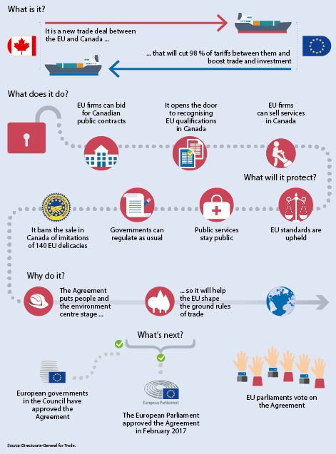

The EU’s 500 million consumers will also benefit from the Agreement, as only products and services that fully respect all EU regulations will be able to enter the market. This means that the Agreement will not change the way the EU regulates food safety, including rules on products containing genetically modified organisms and the ban on hormone-treated beef.

The Agreement will provide more legal certainty in the service economy, better mobility for company employees and a framework for recognising qualifications in professions ranging from architects to crane operators.

A transparent and inclusive negotiating process

Transparency and engagement with the public remained essential in 2017 to ensure democracy, public trust and accountability in trade policy. There must be transparency and engagement before, during and after negotiations, and when agreements are implemented. In 2017 the EU took further steps in this domain, making it a leader in transparency in trade policy.

In September the Commission published its recommendations on launching negotiations for trade agreements with Australia and New Zealand and on the Multilateral Investment Court. The recommendations were automatically sent to the European Parliament and to all national parliaments in the Member States at the same time as they were sent to the Council. This will make it easier for national parliaments and stakeholders to express their views at the earliest possible stage to the governments that represent them in Council discussions. The Council published the negotiating directives for the EU–Japan Economic Partnership Agreement.

The Commission continued to publish negotiation-round reports, position papers and proposals for text in trade agreements it was negotiating. It also published extensive additional material on the EU’s trade agreements with Canada and Japan so that the public and businesses were aware of them and how to benefit from them.

TRANSPARENCY IN TRADE NEGOTIATIONS

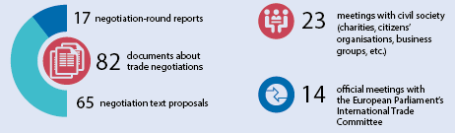

During the year the Commission published its first comprehensive annual report assessing the implementation of the EU’s trade agreements. This enabled other EU institutions, stakeholders and civil society to scrutinise how the EU is implementing the agreements. The Commission also carries out regular impact assessments, sustainability impact assessments and evaluations of its trade negotiations and subsequent agreements. These include in-depth consultations with stakeholders and regular meetings with civil-society groups throughout the process.

In December the Commission set up the Group of Experts on EU Trade Agreements, an advisory body comprising trade unions, employers’ organisations, consumer groups and other non-governmental organisations. It provides the Commission with different perspectives on and insights into trade.

Other trade negotiations

Work continued during the year to open up new markets for EU exports by increasing the number of partners with which it has trade agreements from the current 91. The EU launched new trade negotiations and made good progress in ongoing talks. With the negotiations for a Transatlantic Trade and Investment Agreement with the United States having stopped, the EU’s trade focus with the United States has been on identifying areas in which they should cooperate more closely to help better address global challenges together. In the meantime, the two sides signed a bilateral agreement on insurance and reinsurance, which will boost consumer protection and cut costs and red tape for EU insurers and reinsurers active in the United States.

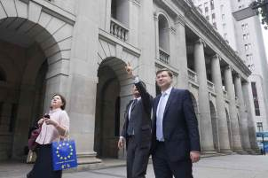

Commission Vice-President Valdis Dombrovskis attending the EU–Asia-Pacific Forum, Hong Kong, 1 December 2017.

Southern and eastern neighbourhood

In the southern neighbourhood the EU focused on the negotiations for a Deep and Comprehensive Free Trade Area with Tunisia, setting the pace for progress with north Africa. In June, as a complement to the negotiations, the Commission and the International Trade Centre in Geneva launched the [EuroMed Trade Helpdesk](http://euromed.macmap.org/euromed). By providing businesses with essential information about markets, tariffs and import requirements, the Helpdesk aims at strengthening economic ties between the EU and nine Mediterranean partners, as well as between Mediterranean countries themselves.

In the eastern neighbourhood the EU concentrated on implementing its agreements for Deep and Comprehensive Free Trade Areas with Georgia, Moldova and Ukraine.

Latin America

The EU continued the negotiations launched in 2016 to modernise the trade agreement it signed with Mexico in 2000. Five rounds of negotiations were held and good progress was made. The new agreement will simplify administrative burdens, cut red tape, boost growth and competitiveness, widen consumer choice and create jobs on both sides, while supporting sustainable development. In line with the EU’s progressive trade agenda the agreement includes specific anti-corruption provisions.

Trade talks with the four founding members of the Mercosur trading bloc (Argentina, Brazil, Paraguay and Uruguay) continued in 2017. The talks aim to integrate two regional markets, cut tariffs, greatly increase business opportunities in Mercosur, widen consumer choice, simplify administrative burdens, cut red tape, boost growth and competitiveness and create jobs on both sides.

In November the EU launched negotiations with Chile to update the 2002 EU–Chile Free Trade Agreement. As part of the modernisation of the existing agreement the EU will propose to include pilot provisions on gender.

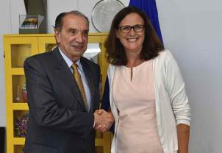

Commissioner Cecilia Malmström welcoming Aloysio Nunes Ferreira, Brazilian Minister for Foreign Affairs, Brussels, 28 August 2017.

Asia and Australasia

Negotiations also continued on trade agreements with Indonesia and the Philippines. The talks aim to increase trade between the EU and the two countries and to expand direct investment. The objective is to reach agreements similar to those signed with Singapore in 2014 and Vietnam in 2015. During the year the EU held three rounds of negotiations with Indonesia and two rounds with the Philippines.

In March the EU and the Association of Southeast Asian Nations agreed to take new steps towards resuming free trade talks between the two regions.

The EU also held four rounds of talks in its negotiations for an investment agreement with China, but paused its negotiations for an investment agreement with Myanmar/Burma. The Commission proposed that trade talks be launched with Australia and New Zealand.

African, Caribbean and Pacific countries

[The EU’s Economic Partnership Agreement with the Southern African Development Community](http://www.europarl.europa.eu/RegData/etudes/BRIE/2017/608686/EPRS_BRI(2017)608686_EN.pdf) began to be implemented at the start of 2017. Similar agreements with Côte d’Ivoire and Ghana began during the spring. In July the EU’s Economic Partnership Agreement with the eastern and southern African countries of Madagascar, Mauritius, Seychelles and Zimbabwe was further strengthened by the addition of Comoros.

Chapter 7

An area of justice and fundamental rights based on mutual trust



‘I intend to make use of the prerogatives of the Commission to uphold, within our field of competence, our shared values, the rule of law and fundamental rights, while taking due account of the diversity of constitutional and cultural traditions of the 28 Member States.’

Jean-Claude Juncker, political guidelines, 15 July 2014

Fighting terrorism remained a top political priority on the EU’s agenda in 2017, and great strides were taken towards building an effective and genuine Security Union, in full respect of fundamental rights.

The EU delivered on the European Agenda on Security by making it a criminal offence to travel and train for terrorist-related purposes, and took a tougher stance against the financing of terrorism and the trafficking of firearms, drugs and people. New improvements were also proposed to enable Member States to exchange data on criminals more efficiently.

Work continued on implementing new rules protecting EU citizens’ personal data across the EU and beyond, which will become applicable in 2018. In parallel, the EU continued to promote data protection standards internationally, notably with Japan, South Korea and the United States. The first annual review of the EU–US Privacy Shield framework, which provides stronger protection for transatlantic data flows, marked an important milestone for cooperation on data protection issues.

A number of prominent internet companies responded to the EU’s Code of Conduct on countering illegal hate speech online and clamped down faster and harder on illegal content that appeared on their pages.

Twenty Member States agreed to establish the European Public Prosecutor’s Office, which will step up the fight against crimes affecting the EU budget.

The EU also took action to pursue gender equality in the workplace and signed the Istanbul Convention on Preventing and Combating Violence against Women and Domestic Violence.

Tackling terrorism and crime in Europe

New rules against terrorism and money laundering

Following on from the [European Agenda on Security](http://eur-lex.europa.eu/legal-content/EN/TXT/?qid=1485257048405&uri=CELEX:52015DC0185), the European Commission continued to work towards building [an effective and genuine Security Union](https://ec.europa.eu/home-affairs/what-we-do/policies/european-agenda-security/fact-sheets_en). In 2017 the EU took action to keep terrorists from carrying out attacks, to make the sharing of information between Member States easier and to protect its citizens online.

A [new law](http://www.consilium.europa.eu/en/press/press-releases/2017/03/07-rules-to-prevent-new-forms-of-terrorism/) making it a criminal offence to travel abroad and train for terrorist purposes was adopted in March. It also strengthens the rights of victims of terrorism and ensures they receive specialised assistance immediately after an attack and for as long as necessary.

Discussions progressed well with the European Parliament and the Council of the European Union on stronger EU rules to criminalise money laundering, to tighten controls on cash flows and to freeze and confiscate criminals’ assets.

In December the Parliament and the Council reached political agreement on the Commission’s proposal to amend the fourth Anti-Money Laundering Directive. This will substantially increase the transparency of beneficial ownership of legal entities and trusts and will prohibit anonymity for various financial products. These actions will provide very useful tools in the fight against money laundering and terrorist financing.

Following a report in June on the effects on the Single Market of money laundering and terrorist financing relating to cross-border activities, recommendations were made to Member States and the [European supervisory authorities](https://ec.europa.eu/info/business-economy-euro/banking-and-finance/financial-supervision-and-risk-management/european-system-financial-supervision_en#theeuropeansystemoffinancialsupervision).

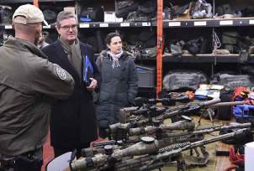

Fighting terrorism online

At July’s G20 Summit in Hamburg, Germany, Jean-Claude Juncker, President of the European Commission, was among the leaders who proposed and agreed on an Action Plan to counter terrorism, which included countering the use of the internet for terrorist purposes. Since the launch of the EU Internet Forum in 2015, concrete steps have been taken to stop international terrorist groups from abusing the internet. Approximately 86 % of content referred to internet companies by the European Union Agency for Law Enforcement Cooperation (Europol) has been removed. In July the Forum set out its own Action Plan to combat terrorist content online, which calls for immediate progress on a wide range of areas and sets up a regular reporting mechanism to measure and assess results.

In December, as part of its [Civil Society Empowerment Programme](https://ec.europa.eu/home-affairs/what-we-do/networks/radicalisation_awareness_network/civil-society-empowerment-programme_en), the Commission continued to support civil-society organisations in providing positive alternative narratives online to the messages coming from violent extremists and terrorists, providing €6 million of funding.

The fight against illicit drugs

A new [Regulation](http://eur-lex.europa.eu/legal-content/EN/TXT/?uri=CELEX:32017R2101) on an early warning system and risk assessment procedure for new psychoactive substances and a new [Directive](http://eur-lex.europa.eu/legal-content/EN/TXT/?uri=CELEX:32017L2103) to include new substances in the definition of ‘drug’ were adopted in 2017. Following this, in December the Commission proposed to ban seven new psychoactive substances across the European Union, in addition to nine others banned earlier in 2017.

Trafficking in human beings

In December the Commission adopted a [Communication](https://ec.europa.eu/home-affairs/sites/homeaffairs/files/e-library/documents/policies/organized-crime-and-human-trafficking/trafficking-in-human-beings/docs/20171204_communication_reporting_on_follow-up_to_the_eu_strategy_towards_the_eradication_of_trafficking_in_human_beings.pdf) to address trafficking in human beings and committed to a new set of priorities to be implemented in the coming period. The priorities set out by the Commission identify key areas that require immediate action from the EU and Member States to disrupt the modus operandi of traffickers, strengthen victims’ rights and intensify internal and external efforts by the EU to provide a coordinated and consistent response.

Criminal and civil justice

Stepping up the fight against crimes affecting the EU budget

In July the EU made a significant breakthrough on crimes affecting the EU budget when the Parliament and the Council adopted a new [Directive](http://eur-lex.europa.eu/legal-content/EN/TXT/?uri=CELEX:32017L1371) to fight against fraud, corruption and other crimes affecting the Union’s financial interests, including serious cross-border cases of VAT fraud. It is estimated that VAT fraud resulting from trade within the EU amounts to €50 billion per year.

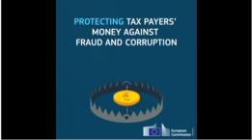

The European Public Prosecutor’s Office: keeping Europeans’ and EU money safe.

<https://www.youtube.com/watch?v=V68csxfjObo>

A major step forward was the agreement in November by 20 Member States to set up a European Public Prosecutor’s Office to investigate, prosecute and bring to justice those who commit criminal offences affecting the financial interests of the EU. It is expected to be operational by the end of 2020.

More efficient exchange of criminal records

The European Criminal Records Information System, created in 2012, enables the electronic exchange of information on the criminal records of people convicted in the EU Member States. In June the first [report](https://ec.europa.eu/info/sites/info/files/analytical_supporting_document_accompanying_the_proposal_2.pdf) on the use of the system by Member States was published. Negotiations on simplifying the exchange of criminal records of non-EU citizens progressed in 2017.

Protecting children when parents from different countries separate

In July the Commission proposed that the EU authorise some Member States to accept the accession of 10 non-EU countries to the Hague Convention on the Civil Aspects of International Child Abduction, helping to extend international protection against child abductions.

Helping businesses in the EU

The new [Business Registers Interconnection System](https://e-justice.europa.eu/content_find_a_company-489-en.do), launched in June, gives faster and easier access to company information in the EU. This will make cross-border trade easier and help increase confidence in the Single Market.

Companies in trouble benefit from better insolvency rules thanks to a [new law](http://europa.eu/rapid/press-release_IP-17-1743_en.htm) facilitating cross-border proceedings that became applicable in 2017. Negotiations also progressed on [proposed rules](http://europa.eu/rapid/press-release_IP-16-3802_en.htm) on [national insolvency proceedings](http://europa.eu/rapid/press-release_IP-16-3802_en.htm) to set up restructuring systems and give entrepreneurs a second chance.

Improving corporate governance

The law on shareholder rights was strengthened in May, with [new provisions](http://eur-lex.europa.eu/legal-content/EN/TXT/?qid=1496053453979&uri=CELEX%3A32017L0828) to improve corporate governance, facilitate the exercise of shareholder rights and put more long-term focus on investment. An amendment to the existing rules on corporate governance and remuneration for investment firms was also adopted.

Fundamental rights and judicial systems

Upholding the rule of law

The Commission pursued efforts to promote and uphold the respect of the rule of law in the European Union and further encouraged Member States to improve the independence, quality and efficiency of their national justice systems. These systems are crucial for upholding the rule of law, for the equal application of EU law and for a business- and investment-friendly environment. The [2017 EU Justice Scoreboard](http://ec.europa.eu/justice/effective-justice/scoreboard/index_en.htm) shows that further progress has been made, while challenges remain for certain Member States.

Throughout the year the Commission continued its dialogue with Poland under the Rule of Law Framework. In July the Commission sent a [third Rule of Law Recommendation](http://europa.eu/rapid/press-release_IP-17-2161_en.htm) to the Polish government explaining its concerns on the planned reform of the judiciary and the Constitutional Tribunal reforms. In December the Commission [concluded](http://europa.eu/rapid/press-release_IP-17-5367_en.htm) that there is a clear risk of a serious breach of the rule of law in Poland, and proposed that the Council [adopt a decision under Article 7(1) of the Treaty on European Union](http://europa.eu/rapid/press-release_IP-17-5367_en.htm). The proposal was accompanied by a fourth Rule of Law Recommendation clearly setting out the steps that the Polish authorities can take to remedy the current situation. Furthermore, the Commission [referred Poland to the Court of Justice of the European Union](http://europa.eu/rapid/press-release_IP-17-5367_en.htm) for breaches of EU law by the Polish Law on Ordinary Courts Organisation.

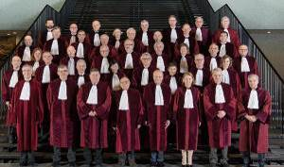

Koen Lenaerts, President of the Court of Justice (front row, fourth from right), with the Judges of the Court of Justice, Luxembourg, February 2017.

Stronger protection of personal data

Work continued with Member States, national data protection authorities and other stakeholders to prepare for [new rules](http://europa.eu/rapid/press-release_MEMO-17-1441_en.htm) to protect personal data, which will apply from May 2018. The new rules will give people more control over their personal data and simplify procedures for businesses. The changes are designed to make sure that the personal information of individuals in the EU is protected no matter where it is sent, processed or stored, even outside the EU.

In January the Commission set out a [strategy](http://eur-lex.europa.eu/legal-content/EN/TXT/?uri=COM%3A2017%3A7%3AFIN) on promoting [international data protection standards](http://europa.eu/rapid/press-release_MEMO-17-15_en.htm) to ensure a high level of personal data protection while facilitating data flows for both commercial and law enforcement purposes. Adequacy findings, requiring the existence in a non-EU country of data protection rules comparable to those in the EU, are one of the key elements of this strategy.

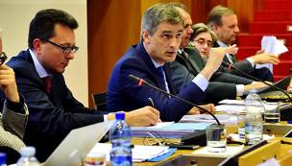

Giovanni Buttarelli, European Data Protection Supervisor, in a panel discussing new-technologies law, University of Milano-Bicocca, Italy, 15 May 2017.

The EU is exploring the possibility of engaging in adequacy dialogues with relevant trading partners and with countries playing a pioneering role in data protection in their region. Key target areas are east Asia, south-east Asia, Latin America and the European neighbourhood. Dialogues with Japan and South Korea opened in 2017.

The first annual review of the [EU–US Privacy Shield](http://europa.eu/rapid/press-release_IP-16-2461_en.htm), which has been in place since July 2016, was carried out in September 2017. Based on the review, and as expressed in the resulting report, the Commission found that the Privacy Shield continues to provide an adequate level of protection, but considered that there is still room for improvement and therefore made a number of recommendations. In addition, the [EU–US Umbrella Agreement](http://europa.eu/rapid/press-release_MEMO-16-4183_en.htm) entered into force in February, ensuring data protection standards for data transfers between the EU and the United States for law enforcement cooperation.

Protecting rights and fighting discrimination

Fighting hate crime and hate speech both online and offline

Almost 2 years after the adoption of the EU’s [Code of Conduct](http://europa.eu/rapid/press-release_IP-17-1471_en.htm) on countering illegal hate speech online, internet companies are responding faster and more efficiently to illegal content, in line with EU law.

Throughout 2017 the Commission liaised closely with Jewish and Muslim communities in the EU and with other organisations fighting racism, discrimination and all forms of intolerance. It listened to concerns and shared information on EU actions.

The Commission also provided targeted EU funding and produced operational guidance on victim support and on the training of police and judges to unmask hate crimes within the framework of its High-Level Group on Combating Racism. On 6 December national authorities agreed on key principles for recording hate crime data, prepared in cooperation with the Commission and the European Union Agency for Fundamental Rights.

Applying the EU Charter of Fundamental Rights

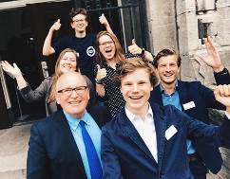

First Vice-President Frans Timmermans at a Citizens’ Dialogue at the Libanon Lyceum in Rotterdam, Netherlands, 27 June 2017.

The [2016 Report](http://ec.europa.eu/newsroom/just/item-detail.cfm?item_id=59189) on the Application of the EU Charter of Fundamental Rights was published in May 2017. In October the Council adopted its [Conclusions](http://data.consilium.europa.eu/doc/document/ST-10005-2016-INIT/en/pdf) on the report, noting that the protection of several rights was strengthened in the previous year through the adoption of a set of legal instruments. These concerned the presumption of innocence, the right to be present at trial, legal aid and procedural safeguards for children, along with a comprehensive set of data protection rules that will apply across the EU from 25 May 2018 and will help citizens take back control of their data.

On 7 December, to ensure the respect of the Charter of Fundamental Rights of the European Union, the Commission referred Hungary to the Court of Justice of the European Union for its law on foreign-funded non-governmental organisations and for its Higher Education Law.

Fighting discrimination

In 2017 the EU continued to fight discrimination, implementing a [list of actions](http://ec.europa.eu/justice/discrimination/files/lgbti_actionlist_en.pdf) to advance lesbian, gay, bisexual, transgender and intersex equality. Major achievements included the ‘[We All Share the Same Dreams](http://ec.europa.eu/justice/discrimination/orientation/awareness-raising/index_en.htm)’ campaign and the adoption of a [Diversity and Inclusion Charter](http://europa.eu/rapid/press-release_IP-17-2070_en.htm) for Commission staff.

The [mid-term review](http://ec.europa.eu/justice/discrimination/roma/index_en.htm) of the EU Framework for National Roma Integration Strategies assessed the progress made by Member States in improving the lives of Europe’s largest ethnic minority. It shows how the situation of Roma people has slowly improved since 2011, but also stresses that as much as [80 % of the Roma population is still at risk of poverty](http://fra.europa.eu/en/press-release/2016/80-roma-are-risk-poverty-new-survey-finds).

DOMESTIC VIOLENCE IN THE EU

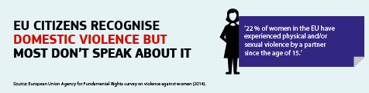

Combating violence against women

The EU took action in 2017 to raise awareness of violence against women and girls throughout the Member States. The EU-funded [‘NON.NO.NEIN.’ campaign](http://ec.europa.eu/justice/saynostopvaw/) encourages everyone — men and women — to take a stand against gender-based violence.

In June the EU signed the [Istanbul Convention](http://www.coe.int/en/web/istanbul-convention). This international treaty is the first European agreement to set legally binding standards to prevent violence against women and domestic violence, protect victims and punish perpetrators.

Ensuring the rights of people with disabilities

During the year a [state-of-play report](http://ec.europa.eu/social/main.jsp?langId=en&catId=89&newsId=2725) on the implementation of the European Disability Strategy since 2010 showed that concrete progress has been made in all eight of the priority areas (accessibility, participation, equality, employment, education and training, social protection, health and external action).

Achievements included a Commission proposal for a [European Accessibility Act](http://ec.europa.eu/social/main.jsp?catId=1202). This is a business-friendly Directive that improves the accessibility of certain everyday products and services, such as mobile phones, computers, e-books, e-commerce and banking services. In 2017 the Parliament adopted its report on the proposal and the Council adopted its general approach.

To help people with disabilities travel more easily within the European Union, the EU is implementing the [EU Disability Card](http://ec.europa.eu/social/main.jsp?catId=1139) on a pilot basis in eight Member States (Belgium, Estonia, Italy, Cyprus, Malta, Romania, Slovenia and Finland). In these Member States the Card will give people with disabilities equal access to certain specific benefits in the areas of culture, leisure, sport and transport. The first cards were made available in 2017.

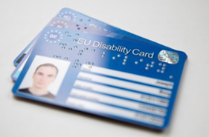

At a launch event on 19 October 2017 in Brussels, Belgium became the first Member State to roll out the EU Disability Card. Other Member States will follow.

THE EU’S RAPID ALERT SYSTEM

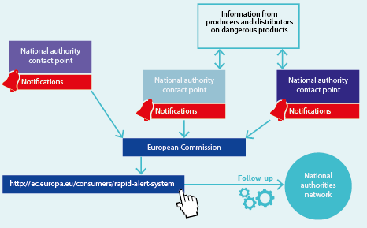

**European Union citizenship**

The [EU Citizenship Report 2017](http://ec.europa.eu/newsroom/just/item-detail.cfm?item_id=51132) presents actions to ensure citizens can fully enjoy their rights when working, travelling, studying or participating in elections.

**Protecting consumers**

The EU’s [Rapid Alert System for Dangerous Non-Food Products](https://ec.europa.eu/consumers/consumers_safety/safety_products/rapex/alerts/repository/content/pages/rapex/index_en.htm), which enables the quick exchange of information between the EU Member States and other countries that are part of the System, continued to protect the health and safety of consumers. During the year, 2 201 notifications and 3 952 reactions on dangerous products were circulated to the 31 [national authorities](http://ec.europa.eu/newsroom/just/item-detail.cfm?item_id=126363) participating in the system.

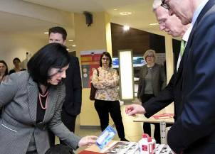

Commissioner Vĕra Jourová visiting a stand displaying potentially dangerous products following the presentation of the 2016 Annual Report on the Rapid Alert System, Brussels, 16 March 2017.

In a similar way, the [Rapid Alert System for Food and Feed](https://ec.europa.eu/food/safety/rasff_en) enables EU Member States and other countries to exchange information and respond collectively to food-safety threats on a round-the-clock basis. The [2016 Annual Report](http://europa.eu/rapid/press-release_IP-17-602_en.htm), published in March 2017, demonstrated the success of the EU’s integrated approach to food safety. This will be further strengthened on the basis of the lessons learned from the [fipronil contamination incident](https://ec.europa.eu/food/safety/rasff/fipronil-incident_en) during the summer. At a [Ministerial Conference](https://ec.europa.eu/food/sites/food/files/safety/docs/rasff_fipronil-incident_conclusions_201709.pdf) organised by the Commission on 26 September 2017, the Member States and the Commission agreed on a number of concrete measures that will reinforce EU action against food fraud and illegal activities affecting the safety of the food chain.

CRACKING THE DUAL QUALITY OF PRODUCTS

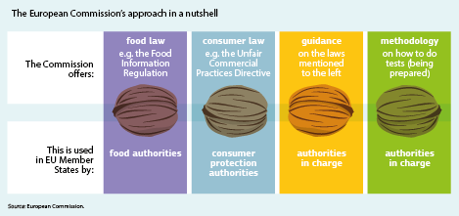

The EU is taking action to tackle the issue of dual-quality food products in the EU. In September the Commission [issued guidelines](http://europa.eu/rapid/press-release_IP-17-3403_en.htm) to help national authorities better tackle unfair practices.

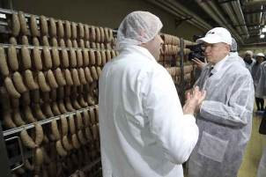

Commissioner Vytenis Andriukaitis on a visit to a sausage-making factory, Zagreb, Croatia, 2 February 2017.

The Commission has made €1 million available to Member States to finance studies and enforcement action, and a further €1 million for its Joint Research Centre to develop and implement a harmonised testing approach. In parallel the Commission is engaged in a constructive dialogue with the industry and all key stakeholders concerned. Producers and brand associations have also committed to developing a code of conduct.

As part of continued efforts in 2017 to defend consumers’ interests in the context of the [Volkswagen emissions scandal](http://europa.eu/rapid/press-release_IP-17-3102_en.htm), the EU consumer authorities and the Commission jointly urged Volkswagen to swiftly repair all affected cars and apply additional trust-building measures.

In March the Commission presented an [Action Plan](http://europa.eu/rapid/press-release_IP-17-609_en.htm) setting out ways to provide consumers with greater choice and better access to financial services across the EU. The Commission is also working on amending the Regulation on cross-border payments to reduce charges on non-euro payments; developing principles for quality-comparison websites that deal with financial products; and finishing work on transparent pricing in car rentals.

Small claims matter too

Revised rules to make the [European Small Claims Procedure](http://ec.europa.eu/newsroom/just/item-detail.cfm?item_id=118655) faster, cheaper and easier entered into force in the course of the year. The rules now cover claims of up to €5 000 (previously €2 000) and make the process simpler.

Protecting consumers online

The increasing importance of e-commerce and the multiplication of online shops and services have created new challenges for the enforcement of consumer protection laws. A new Regulation was adopted in December to ensure that national authorities get stronger powers to tackle illegal online practices spreading across the Single Market. This introduces an EU-wide coordination procedure to tackle such practices by multinational traders in an efficient and consistent manner. It will come into effect on 17 January 2020.

Negotiations progressed on [two important proposals on contract rules](http://ec.europa.eu/justice/contract/digital-contract-rules/index_en.htm): one on the supply of digital content and the other on the online sale of goods. In October an amended proposal was put forward by the Commission to ensure a consistent approach to online and offline sales of goods. It extended the scope of the second initiative from online sales of goods to all such sales. The two proposals will protect consumers who purchase goods or digital content.

Fitness check of consumer laws

A fitness check of EU consumer law in May showed that, while people in the EU enjoy strong rights, there is still room to improve consumer protection in the Single Market. This could be done in particular by making existing rights better known and by ensuring that they are effectively enforced.

rescEU

The [European Union Solidarity Fund](http://ec.europa.eu/regional_policy/en/funding/solidarity-fund/) was mobilised several times, providing assistance to Italy, the United Kingdom, Cyprus and Portugal, which were confronted by natural disasters in 2015, 2016 and 2017.

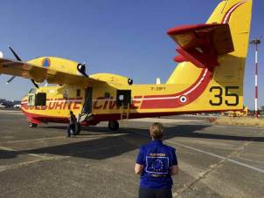

A French water bomber on its way to help fight forest fires in Italy — proof of EU solidarity.

In 2017 alone over 200 people were killed by natural disasters in the EU and over 1 million hectares of forest were destroyed. In response to more frequent natural disasters affecting Member States in recent years, in November the Commission proposed to strengthen the EU’s Civil Protection Mechanism with [rescEU](https://ec.europa.eu/commission/news/resceu-new-european-system-tackle-natural-disasters-2017-nov-23-0_en), a new system intended to increase overall disaster-response capacities.

It will create a reserve of European Union own capacity and encourage the pooling of assistance within a European Civil Protection Pool. It will also aim to strengthen investment in prevention and preparedness. The proposal strikes a careful balance between solidarity in the EU and Member States’ responsibility, contributing towards the goal of a ‘Europe that protects’.

Chapter 8

Towards a new policy on migration

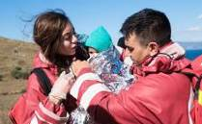

‘The recent terrible events in the Mediterranean have shown us that Europe needs to manage migration better, in all aspects. This is first of all a humanitarian imperative. I am convinced that we must work closely together in a spirit of solidarity.’

Jean-Claude Juncker, political guidelines, 15 July 2014

Europe has experienced an unprecedented influx of asylum applicants and other migrants in recent years. Around 3 million people have applied for international protection in the European Union since the beginning of the crisis, many of them fleeing war and terror in Syria and other countries. The EU is the first responder. In 2016 alone Member States granted asylum to and resettled over 720 000 refugees — three times as many as Australia, Canada and the United States combined.

Many new EU measures were introduced in 2016 to deal comprehensively with this challenge, and they were further intensified in 2017. These included rescue operations and saving more lives at sea; securing the EU’s external borders, in particular through the ‘hotspot’ approach; and setting up the European Border and Coast Guard Agency. Efforts were stepped up to relocate and resettle people in need of protection. Increased focus was also put on developing a fairer Common European Asylum System, strengthening the protection of unaccompanied minors and developing new measures in the fight against smuggling.

Opportunities arose to create new channels for legal migration, and action was taken to foster the integration of refugees and other migrants into the labour market. Through the Asylum, Migration and Integration Fund and the Internal Security Fund, the EU also increased its financial support for the development of a common approach to the efficient management of migration flows.

2017 saw stronger cooperation with migrants’ countries of origin and transit, with the EU helping them to address the root causes of irregular migration and to fight against smuggling. The EU supported these countries in improving their border and migration policies and their reception conditions. Many projects and programmes were supported through the EU Emergency Trust Fund for Africa. The EU has also stepped up its return operations.

The European Agenda on Migration

In 2017 the European Commission continued to implement the [European Agenda on Migration](http://ec.europa.eu/dgs/home-affairs/what-we-do/policies/european-agenda-migration/background-information/docs/communication_on_the_european_agenda_on_migration_en.pdf), proposing measures to tackle ongoing challenges. It also sought to equip the EU with tools to better manage migration in the medium and long term, in particular in the areas of irregular migration, borders, asylum and legal migration.

Protecting those in need

Since 2015 the Greek and Italian authorities, assisted by the European Border and Coast Guard Agency and Operation Sophia, have contributed to the rescue of over 620 000 people in the Mediterranean and Aegean Seas. The EU is disrupting criminal smuggling networks in the central Mediterranean and the Aegean with the help of the Turkish authorities and NATO.

A total of 313 050 asylum seekers were granted international protection in 2017.

Throughout the year the Commission presented several progress reports on measures taken under the European Agenda on Migration to stabilise the flows and better manage the EU’s external borders. The reports focused on relocation and resettlement, the implementation of the [EU–Turkey Statement](https://ec.europa.eu/home-affairs/sites/homeaffairs/files/what-we-do/policies/european-agenda-migration/background-information/eu_turkey_statement_17032017_en.pdf), European Border and Coast Guard operations and the [Partnership Framework on Migration](http://europa.eu/rapid/press-release_IP-17-3091_en.htm). They demonstrated that significant progress had been made in all areas and set out the next steps for further action.

In addition, in April the Commission set out [priority actions to protect children in migration](https://ec.europa.eu/home-affairs/sites/homeaffairs/files/what-we-do/policies/european-agenda-migration/20170412_communication_on_the_protection_of_children_in_migration_en.pdf), beyond the additional safeguards proposed in the reform of the Common European Asylum System. One of the priority actions involves integrating children into the new country of arrival, including by providing proper identification, good reception conditions and access to education.

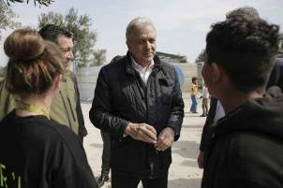

Commissioner Dimitris Avramopoulos in Lesbos, Greece, to visit the Moria refugee camp, 16 March 2017.

Relocation and resettlement

Most EU Member States are now carrying out relocations within the EU to alleviate the pressure on Greece and Italy. In November the Commission presented its latest progress report on the [European](https://ec.europa.eu/home-affairs/sites/homeaffairs/files/what-we-do/policies/european-agenda-migration/20170906_fifteenth_report_on_relocation_and_resettlement_en.pdf) Agenda on Migration. The number of people relocated in 2017 significantly increased compared to the previous year, proving that relocation works when all parties fulfil their commitments. 22 215 people were relocated in 2017 alone. In total, 33 140 people have been relocated since September 2015, of whom 21 704 were relocated from Greece and 11 436 from Italy — 93 % of all those eligible. The main goal of the emergency scheme to relocate all eligible applicants from Greece and Italy is therefore achievable. However, while most Member States were active, pledging and relocating regularly, some did not participate. The Commission launched infringement proceedings against three Member States (the Czech Republic, Hungary and Poland) in 2017 for not implementing the 2015 Decisions of the Council of the European Union on relocation, and in December the Commission decided to refer these Member States to the Court of Justice of the European Union.

Resettlement schemes have been in place since July 2015 to provide a legal and safe pathway for vulnerable people in need of international protection. Over 26 000 people have been resettled in 21 EU Member States, along with Iceland, Liechtenstein, Norway and Switzerland. In September the Commission called on Member States to resettle at least 50 000 additional people in need of international protection in the next 2 years (by 31 October 2019), from Jordan, Lebanon, Turkey and African countries along the central Mediterranean migratory route. The total number of pledges received by the end of the year was 39 839.

The EU–Turkey Statement

The [EU–Turkey Statement](https://ec.europa.eu/home-affairs/sites/homeaffairs/files/what-we-do/policies/european-agenda-migration/background-information/eu_turkey_statement_17032017_en.pdf) continued to deliver concrete results, ensuring the effective management of migratory flows in the eastern Mediterranean. The number of daily crossings remained at around 86 per day, with the number of lives lost falling substantially. Arrivals decreased by 97 % compared to the situation before the Statement began to be implemented. The pace of return operations has increased, with 2 032 migrants being returned. Of these, 228 were Syrians.

The EU and Turkey accelerated financial support under the Facility for Refugees in Turkey. The €3 billion of funding put in place under the Facility has been allocated and a total of [€1.85 billion has been paid](https://ec.europa.eu/neighbourhood-enlargement/news_corner/migration_en). Nearly 1.2 million refugees in Turkey were supported by the Emergency Social Safety Net in 2017, and the number of Syrians supported is expected to increase to 1.3 million. The resettlement aspect of the Statement has progressed well. By the end of December more than 11 700 Syrians had been resettled from Turkey to 16 Member States.

ARRIVALS AT THE SEA BORDERS OF THE EU

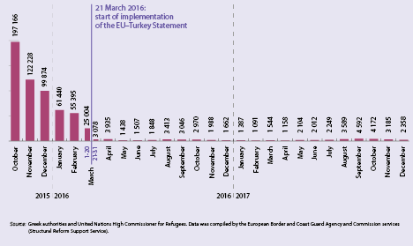

Return and readmission

In March the Commission highlighted the need to reinforce the EU’s policy on return, putting in place a renewed [Action Plan on Return](https://ec.europa.eu/home-affairs/sites/homeaffairs/files/what-we-do/policies/european-agenda-migration/20170302_a_more_effective_return_policy_in_the_european_union_-_a_renewed_action_plan_en.pdf) and a set of [recommendations](https://ec.europa.eu/home-affairs/sites/homeaffairs/files/what-we-do/policies/european-agenda-migration/20170302_commission_recommendation_on_making_returns_more_effective_en.pdf) to Member States on making procedures more effective. This was followed in September by a [revised Return Handbook](https://ec.europa.eu/home-affairs/sites/homeaffairs/files/what-we-do/policies/european-agenda-migration/20170927_recommendation_on_establishing_a_common_return_handbook_annex_en.pdf). Support for Member States in returning irregular migrants has been one of the priorities of the European Border and Coast Guard Agency, which has brought positive results. The pace of return operations coordinated by the Agency continued to grow, reaching a total of 350 such operations in 2017.

The fight against migrant smuggling

The [EU Action Plan against Migrant Smuggling](https://ec.europa.eu/anti-trafficking/sites/antitrafficking/files/eu_action_plan_against_migrant_smuggling_en.pdf), adopted in May 2015, continued to be implemented. The European Union Agency for Law Enforcement Cooperation’s European Migrant Smuggling Centre has provided basic support in more than 2 000 cases since its creation in 2016, and has fully supported more than 90 high-priority cases. In 2017 the Commission established a network of national contact points to facilitate strategic cooperation between Member States and to share information and best practices on tackling migrant smuggling.

Saving lives at sea and implementing the ‘hotspot’ approach

The European Border and Coast Guard Agency

The [European Border and Coast Guard Agency](https://ec.europa.eu/home-affairs/sites/homeaffairs/files/what-we-do/policies/securing-eu-borders/fact-sheets/docs/a_european_border_and_coast_guard_en.pdf) became operational in 2017. The Agency supports the frontline Member States with over 1 700 border guards and support staff. A Rapid Reaction Pool of experts and a Rapid Reaction Equipment Pool have also been set up, and can be mobilised in case of a need for rapid border intervention.

CURRENT EUROPEAN BORDER AND COAST GUARD DEPLOYMENTS

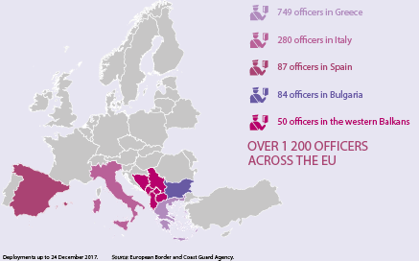

The Agency's role and activities have since been strengthened and significantly expanded since. Supporting Member States in the return of irregular migrants has now become one of its main target areas. The Agency also contributes to the detection and prevention of cross-border crime, and strengthening its cooperation with non-EU countries has also become another of the Agency’s priorities. The focus is now on making full use of its strengthened instruments and tools

‘Hotspots’ and support for Greece and Italy

The implementation of the ‘hotspot’ approach (the provision of operational and financial support by the EU and relevant EU agencies, such as the European Asylum Support Office, the European Border and Coast Guard Agency and the European Union Agency for Law Enforcement Cooperation) continued in 2017, both in Greece and in Italy. During the year the European Border and Coast Guard deployed over 1 000 officers in these two Member States through various operations. The European Asylum Support Office has deployed 153 guest officers to support the Greek and Italian authorities with fingerprinting, registration and security screenings, and the European Union Agency for Law Enforcement Cooperation (Europol) has also sent 24 guest officers.

Thanks to these efforts living conditions in the hotspots in Greece have improved. However, Italy continued to feel the pressure from migrants arriving on its shores via the central Mediterranean in the first half of the year, with levels comparable to previous years. Anticipating this possibility, the Commission, together with the European External Action Service, acted quickly to address the situation, and in January adopted the [Communication ‘Migration on the central Mediterranean route — managing flows, saving lives’](https://ec.europa.eu/home-affairs/sites/homeaffairs/files/what-we-do/policies/european-agenda-migration/proposal-implementation-package/docs/20170125_migration_on_the_central_mediterranean_route_-_managing_flows_saving_lives_en.pdf).

As a result of a seasonal spike, in July the Commission presented a further [Action Plan to Support Italy](https://ec.europa.eu/home-affairs/sites/homeaffairs/files/what-we-do/policies/european-agenda-migration/20170704_factsheet_-_central_mediterranean_route_commission_action_plan_to_support_italy_and_stem_flows_en.pdf), which, together with the January Communication, focused on five key areas: saving lives; fighting smuggling and trafficking in Libya (including through a €46.3 million project co-funded by the EU); increasing engagement with key non-EU countries; stepping up return operations; and building stronger solidarity in the EU.

Border management

Schengen

In autumn 2015 several Schengen-area states decided to temporarily reintroduce controls at certain internal borders. Following a proposal from the Commission, in May 2016 the Council recommended that Austria, Denmark, Germany, Norway and Sweden (which were particularly affected by secondary movements along the western Balkan route) temporarily reintroduce controls at certain sections of their internal borders. In line with the Schengen rules this recommendation was subsequently extended three times, with the last time being in May 2017.

The Commission remains fully committed to returning to an area without internal border controls as soon as possible. In its Recommendation of 12 May 2017 on [proportionate police checks and police cooperation in the Schengen area](https://ec.europa.eu/home-affairs/sites/homeaffairs/files/what-we-do/policies/european-agenda-migration/20170502_recommandation_on_schengen_area_police_checks_and_cooperation_en.pdf) the Commission called on the Schengen states to give priority to measures other than the temporary reintroduction of border controls, such as police checks.

In September the Commission made it clear that the border controls carried out by the abovementioned five Schengen states must be lifted by mid November. At the same time the Commission issued a reminder of the rules that must be complied with when Schengen states consider it justified and necessary to temporarily reintroduce border controls. Six Schengen states, however, notified the Commission of their intention to maintain temporary internal border controls based on various provisions in the Schengen Borders Code. As of the end of 2017 the Commission was assessing these notifications. The Commission also proposed in September that the Schengen Borders Code be updated to adapt the rules for the reintroduction of temporary internal border controls to current needs. This was in order to respond to evolving and persistent serious threats to public policy or internal security, while maintaining that internal temporary border controls must remain an exception and limited in time.

Better control of the EU’s external borders

New rules entered into force in April to ensure that all travellers crossing the EU’s external borders are checked against the relevant databases, such as the [Schengen Information System](https://ec.europa.eu/home-affairs/what-we-do/policies/borders-and-visas/schengen-information-system_en). The system now contains 70 million alerts and was consulted 4 billion times in 2016. This reduces the possibility for people who pose a security threat, including returning EU nationals, to cross borders unnoticed.

In 2016 the Commission proposed to strengthen the effectiveness of the Schengen Information System through improvements that reinforce its ability to assist law enforcement authorities in fighting terrorism, improve border management and ensure effective information exchange between Member States. An automated fingerprint identification system will also be introduced in February 2018 to help identify criminals and terrorists entering the Schengen area under false identities. The Commission proposed a [European Travel Information and Authorisation System](https://ec.europa.eu/home-affairs/sites/homeaffairs/files/what-we-do/policies/european-agenda-security/fact-sheets/docs/20161116/factsheet_-_etias_en.pdf), which would ensure that advance security checks can be carried out on all people travelling visa-free to the Schengen area. The system will help identify people who pose a risk before they reach the EU’s borders, while safeguarding visa-free travel for the majority of travellers. In June the Council agreed its position on the proposal. In addition, as of 2020 a new entry–exit system will also modernise external border management by recording the personal data of non-EU nationals and the time, date and place of their entry and exit.

THE EUROPEAN TRAVEL INFORMATION AND AUTHORISATION SYSTEM

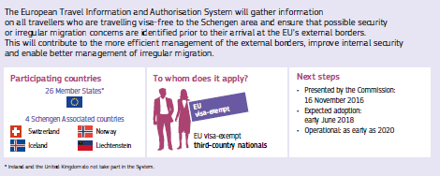

Opening new legal pathways and improving existing ones

In September negotiations started between the European Parliament and the Council on the [proposal for a revised Blue Card](http://ec.europa.eu/dgs/home-affairs/what-we-do/policies/european-agenda-migration/proposal-implementation-package/docs/20160607/directive_conditions_entry_residence_third-country_nationals_highly_skilled_employment_en.pdf), which would improve the EU’s ability to attract and retain highly skilled non-EU workers.

In July 2016 the Commission proposed an EU Resettlement Framework aimed at establishing a common European policy on resettlement to ensure orderly and safe pathways to Europe for people in need of international protection. The Council put forward its position in November 2017, and negotiations with the Parliament began in December.

Integration of non-EU nationals

In 2017 the Commission implemented several actions included in the [Action Plan for the Integration of Third-Country Nationals](https://ec.europa.eu/home-affairs/sites/homeaffairs/files/what-we-do/policies/european-agenda-migration/proposal-implementation-package/docs/20160607/communication_action_plan_integration_third-country_nationals_en.pdf). The first mutual learning activities of the newly established European Integration Network took place in Germany and Sweden.

The Commission also took several initiatives during the year to mobilise employers and other economic and social partners, in particular with the launch of [Employers Together for Integration](http://europa.eu/rapid/press-release_IP-17-1386_en.htm) in May, which was followed by a declaration on a [European Partnership for Integration](https://ec.europa.eu/home-affairs/sites/homeaffairs/files/e-library/documents/policies/legal-migration/integration/docs/20171220_european_partnership_for_integration_en.pdf) in December. An onlinemultilingual [Skills Profile Tool for Third-Country Nationals](https://ec.europa.eu/migrantskills/#/), developed and launched by the Commission as part of the [New Skills Agenda for Europe](http://ec.europa.eu/social/main.jsp?catId=1223&langId=en), can be used for the early identification and profiling of skills and qualifications of asylum seekers, refugees and other migrants. These initiatives show what the Commission, employers and other social partners are doing to support the integration into the labour market of refugees and legally residing migrants.

The [European Programme for Employment and Social Innovation](http://ec.europa.eu/social/main.jsp?catId=1081) and the [European Social Fund](http://ec.europa.eu/esf/main.jsp?catId=53&langId=en) continued to fund actions throughout the year to facilitate the labour-market integration of refugees and their families. The 2017 European Semester also increasingly focused on the integration challenges experienced by migrants and refugees.

Visa policy

In December 2017 all Bulgarian and Romanian citizens were granted visa-free access to Canada, leaving the United States as the only visa-free non-EU country that does not grant reciprocal visa-free travel to all EU citizens. As indicated in its last visa reciprocity report, also in December, the Commission is continuing to engage with the United States and the five Member States concerned by this issue (Bulgaria, Croatia, Cyprus, Poland and Romania).

On visa liberalisation, in March Georgian citizens were granted visa-free travel to the Schengen area for short stays of up to 90 days, and in June visa-free travel for Ukrainian citizens entered into force. The revised suspension mechanism also entered into force in March, with the Commission reporting on it in December. Although the requirements for visa liberalisation continue to be met, the Commission cautioned that the non-EU countries concerned need to continue to fulfil the requisite benchmarks, including improving the management of irregular migration and improving the prevention of and fight against organised crime and corruption.

FUNDING UNDER THE ASYLUM, MIGRATION AND INTEGRATION FUND AND THE INTERNAL SECURITY FUND 2014-2020

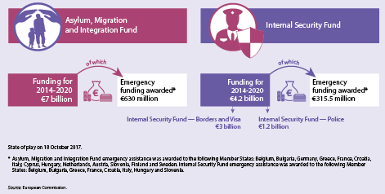

Financial support for the efficient management of migration

The EU’s home-affairs Funds are important policy instruments for addressing the ongoing migration challenges. For this reason the level of financial support remained high in 2017. The [Asylum, Migration and Integration Fund](https://ec.europa.eu/home-affairs/financing/fundings/migration-asylum-borders/asylum-migration-integration-fund_en), with €1.4 billion, and the [Internal Security Fund](https://ec.europa.eu/home-affairs/financing/fundings/security-and-safeguarding-liberties/internal-security-fund-police_en), with €692 million, continued to support capacity building in 2017, providing humanitarian, material and healthcare assistance and helping to develop operational cooperation. Additional funding was also made available through the Member States’ national programmes (€634 million under the Asylum, Migration and Integration Fund and €168 million under the Internal Security Fund).

In addition, more than €743 million has been provided to Member States in order to enable a swift response to urgent operational needs during the lifetime of these Funds. In parallel, the Trust Funds and other EU external action instruments helped to address major challenges in non-EU countries.

Chapter 9

A stronger global actor

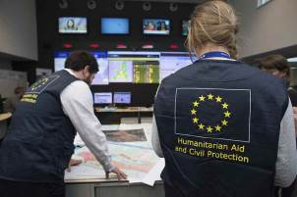

‘We need a stronger Europe when it comes to foreign policy. The Ukraine crisis and the worrying situation in the Middle East show how important it is that Europe is united externally.’

Jean-Claude Juncker, political guidelines, 15 July 2014

The EU’s foreign and security policy is centred on promoting international peace and security, development cooperation, human rights and the rule of law, and on responding to humanitarian and climate emergencies.

Internationally, the EU uses its diplomatic, political, economic, security and humanitarian tools for peaceful solutions to conflicts, notably in Libya, Syria and Ukraine.

In 2017 the EU continued to oversee the implementation of the Iran nuclear deal, with progress being made in many areas. It also worked towards a united response to North Korea.

Following the publication of the reflection paper on the future of European defence and the Global Strategy for the European Union’s Foreign and Security Policy, the EU continued to achieve remarkable progress in security and defence policy. The European Commission launched a European Defence Fund to encourage cooperation in research and development for joint industrial defence products and technologies.

The Fund, which is already set to invest €90 million in research and €500 million in development by 2020, will pave the way for a fully fledged European Defence Fund with a view to spending €1.5 billion per year thereafter.

In December a total of 25 Member States decided to establish a [Permanent Structured Cooperation](https://eeas.europa.eu/headquarters/headquarters-homepage/35496/defence-23-eu-member-states-sign-permanent-structured-cooperation_en), a legally binding framework to work together more closely on security and defence. This was a true milestone for the European Union.

Supporting the United Nations and its Sustainable Development Goals for 2030 was an important part of the EU’s work in 2017, with a new European Consensus on Development. The Commission proposed a new European External Investment Plan to encourage investment in Africa and the European neighbourhood, strengthen the EU’s partnerships and contribute to achieving the Sustainable Development Goals.

The EU gave humanitarian aid, food, shelter, education and healthcare to 120 million people in 80 countries, proving its solidarity with people around the world.

The European Union’s neighbourhood

The European neighbourhood policy translates the EU’s wish to build on common interests with partner countries to the east and south and its commitment to work jointly in key priority areas to promote stability. These priority areas include promoting democracy, the rule of law, respect for human rights and social cohesion.

Visa-free travel to the EU was granted to Georgians and Ukrainians in 2017. In addition, important association agreements came into force between the EU and Georgia, Moldova and Ukraine that will stimulate reforms and enable the creation of free trade areas. The EU called again for a peaceful settlement in eastern Ukraine through the full implementation of the Minsk agreements. These were concluded in September 2014 and February 2015, and aim at achieving a sustainable political solution to the conflict in eastern Ukraine while respecting the country’s independence, sovereignty and territorial integrity. It also continued sanctions against Russia for its illegal annexation of Crimea and Sevastopol and its role in destabilising Ukraine.

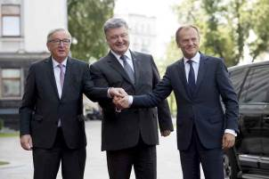

Jean-Claude Juncker, President of the European Commission, Petro Poroshenko, President of Ukraine, and Donald Tusk, President of the European Council, at the 19th EU–Ukraine Summit, Kyiv, Ukraine, 12 and 13 July 2017.

In addition, the EU supported [Georgia](https://ec.europa.eu/info/business-economy-euro/economic-and-fiscal-policy-coordination/international-economic-relations/enlargement-and-neighbouring-countries/neighbouring-countries-eu/neighbourhood-countries/georgia_en), [Jordan](https://ec.europa.eu/info/business-economy-euro/economic-and-fiscal-policy-coordination/international-economic-relations/enlargement-and-neighbouring-countries/neighbouring-countries-eu/neighbourhood-countries/jordan_en), [Moldova](https://ec.europa.eu/info/business-economy-euro/economic-and-fiscal-policy-coordination/international-economic-relations/enlargement-and-neighbouring-countries/neighbouring-countries-eu/neighbourhood-countries/moldova_en), [Tunisia](https://ec.europa.eu/info/business-economy-euro/economic-and-fiscal-policy-coordination/international-economic-relations/enlargement-and-neighbouring-countries/neighbouring-countries-eu/neighbourhood-countries/tunisia_en) and [Ukraine](https://ec.europa.eu/info/business-economy-euro/economic-and-fiscal-policy-coordination/international-economic-relations/enlargement-and-neighbouring-countries/neighbouring-countries-eu/neighbourhood-countries/ukraine_en#macro-financial-assistance) with [macrofinancial assistance programmes](https://ec.europa.eu/info/business-economy-euro/economic-and-fiscal-policy-coordination/international-economic-relations/macro-financial-assistance-mfa-non-eu-partner-countries_en), complemented by financial support provided by the International Monetary Fund. The aim is to help countries that are geographically, economically and politically close to the EU to overcome any economic or financial crises.

The [fifth Eastern Partnership Summit](http://www.consilium.europa.eu/en/meetings/international-summit/2017/11/24/) in November reconfirmed a clear and continued commitment to the Partnership by both the EU and the six partners: Armenia, Azerbaijan, Belarus, Georgia, Moldova and Ukraine. The Joint Summit Declaration welcomed the 20 deliverables for 2020 as the way forward in terms of focusing cooperation on providing tangible results entailing benefits for people. In the margins of the Summit the new Comprehensive and Enhanced Partnership Agreement with Armenia was signed.

**Russia**

The EU maintains restrictive measures against Russia for its role in the destabilisation of Ukraine, which were prolonged in December 2017 and remain linked to the full implementation of the Minsk agreements. Meanwhile, the EU continued to engage selectively with Russia on issues such as foreign policy and global matters, and intensified its support for Russian civil society and people-to-people contacts between EU and Russian citizens. The human rights situation in Russia and restrictions on civil society remained a key area of attention for the EU.

The European Union’s southern neighbourhood

During the year the EU continued to negotiate partnership priorities that cover economic and political cooperation. It concluded such priorities with [Algeria](http://www.consilium.europa.eu/en/press/press-releases/2017/03/13-eu-algeria/) and [Egypt](http://www.consilium.europa.eu/en/press/press-releases/2017/07/25-eu-egypt-adopt-partnership-priorities/).

The EU provided nearly €170 million to protect migrants, implement migration strategies and enable effective voluntary repatriation to and reintegration in Egypt, Libya, Morocco and Tunisia. The EU also stepped up its support for Tunisia to assist its democratic transition and economic recovery.

In July the EU joined the Partnership for Research and Innovation in the Mediterranean Area, committing to investing up to €220 million over the next few years in regional cooperation to improve water resources and food systems. Such improvements are necessary because the current severe water shortages and decreasing crop yields are affecting socioeconomic conditions and leading to political instability, driving short-term migration. The EU has remained committed to Libya and its move towards democracy, and has supported UN mediation efforts. In April a ministerial meeting on EU–Libya cooperation focused on education and health.

Throughout 2017 the EU continued to promote regional cooperation with the southern Mediterranean countries through the Union for the Mediterranean, the Arab League and the [Anna Lindh Foundation.](http://www.annalindhfoundation.org/)

The western Balkans and the enlargement process

The EU continued to support the countries of the western Balkans in their steps towards EU integration. Montenegro and Serbia continued their accession negotiations. The EU’s intensive engagement and progress on reforms and democracy in Albania and the former Yugoslav Republic of Macedonia opened the door to further EU integration steps for both. In addition, the EU supported reforms in Bosnia and Herzegovina and Kosovo (this designation is without prejudice to positions on status, and is in line with UNSCR 1244/1999 and the ICJ Opinion on the Kosovo declaration of independence). Furthermore, the EU is supporting reconciliation and helping to alleviate friction between the countries in the region.

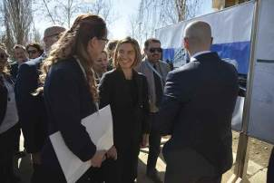

High Representative/Commission Vice-President Federica Mogherini (centre) and Goran Rakić, Mayor of North Mitrovica (right), during a bridge opening ceremony in Mitrovica, Kosovo, 4 March 2017.

Turkey

During the year, relations between the EU and Turkey were challenged by the serious deterioration in the rule of law and fundamental rights in Turkey. The EU made it clear that it was willing to continue a dialogue with a stable, democratic and inclusive Turkey. The EU–Turkey Statement of 2016 continued to deliver results, demonstrated by the significantly reduced numbers of irregular crossings of the Aegean Sea and reduced loss of life.

Western Europe

The EU continued to maintain excellent relations with non-EU countries in western Europe, with Norway and Switzerland among its main trade and investment partners. Relations with countries in the European Economic Area (Iceland, Liechtenstein and Norway) were improved, and closer relations with the Vatican were pursued in relation to foreign policy and other issues.

North America and Latin America

The EU engaged actively with the new administration in the United States, including at a Leaders’ Meeting in Brussels in May during President Donald Trump’s first trip abroad. Close cooperation on security, on foreign policy — including on North Korea, Russia, Syria and Ukraine — and on counterterrorism remained strong and vital.

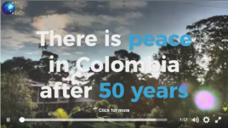

How is the EU fostering peace in Colombia after 52 years of conflict?

<https://www.facebook.com/EuropeanExternalActionService/videos/1560244804038216>

2017 was an important year for relations between the EU and Canada. All EU citizens can now travel to Canada without requiring a visa, and a [free trade agreement with Canada](http://ec.europa.eu/trade/policy/in-focus/ceta/) started to be provisionally applied in September.

At a time of change across [Latin America](https://eeas.europa.eu/diplomatic-network/latin-america-and-caribbean_en?page=1) the EU continued work to modernise and upgrade relations with its partners, including Chile, Cuba, Mexico, the Mercosur trading bloc and countries in the Caribbean. The EU also developed its relations with the region as a whole, through the Community of Latin American and Caribbean States, on a range of subjects covering security, business, gender and parliamentary relations. Building on years of partnership and cooperation, the EU continued to support peace in [Colombia](https://eeas.europa.eu/headquarters/headquarters-homepage/23219/eu-action-colombia_en).

China

The EU–China Summit in Brussels in June saw significant developments in areas including geographical indications, customs cooperation, State aid and the commitment to implement the Paris Climate Agreement. Exchanges on foreign policy and regional issues intensified with consultations and discussions on Africa, central Asia, Afghanistan, North Korea and Syria, along with counterterrorism and defence. Raising human rights concerns continued to be at the core of EU relations with China.

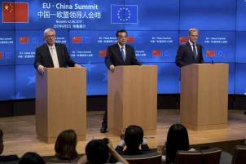

Jean-Claude Juncker, President of the European Commission, Li Keqiang, Prime Minister of China, and Donald Tusk, President of the European Council, at the 19th EU–China Summit in Brussels, 2 June 2017.

Asia and the Pacific

The Association of Southeast Asian Nations

2017 marked the 40th anniversary of official relations between the EU and the Association of Southeast Asian Nations. Areas of cooperation for the 2018-2022 period were set out at the [summit in Manila](https://eeas.europa.eu/headquarters/headquarters-homepage/30833/high-representative-mogherini-co-chairs-manila-eu-asean-ministerial-meeting_en), Philippines, in August, and covered security, trade, sustainable development and contacts between people.

The Middle East

Iran

Much [progress](https://eeas.europa.eu/headquarters/headquarters-homepage/29910/iran-nuclear-deal-being-successfully-implemented-two-years_en) was made in EU–Iran relations during the year, most notably in the areas of trade and investment, energy, environment, education, research, civil nuclear cooperation, humanitarian aid and human rights. The lifting of nuclear-related sanctions has enabled such significant progress. Furthermore, a regular dialogue has been established with Iran to engage in a constructive manner on regional issues and to foster approaches to resolving regional crises.

Israel, occupied Palestinian territory and Middle East peace process

The two-state solution has increasingly come under threat due to developments on the ground, such as the lack of essential progress on intra-Palestinian reconciliation and increased settlement activities by the government of Israel in the occupied Palestinian territory, including East Jerusalem. In December, however, the European Council reaffirmed the EU’s position in favour of a two-state solution. The first steps towards intra-Palestinian reconciliation were made at the end of the year. The EU launched a review of its methods of engagement on the ground to ensure that they are conducive to advancing and achieving a two-state solution.

The EU, together with its Member States, Norway and Switzerland, agreed on a 2017-2020 European Joint Strategy on financial support to the Palestinians, the first joint programme of aid in the European Union’s southern neighbourhood.

Syria

The Syrian crisis continued to mobilise the EU and the international community throughout the year. In April the EU co-hosted the [Brussels Conference](https://eeas.europa.eu/headquarters/headquarters-homepage/24606/supporting-future-syria-and-region-highlights-arabic-version_en) on supporting the future of Syria and the region. The participants pledged €5.6 billion in 2017 to address the crisis. The EU is ready to support reconstruction, but only when a sustainable and inclusive political solution to the conflict has been agreed between the parties in Syria.

THE SYRIAN CRISIS

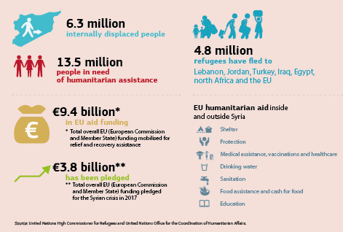

EU–Africa relations

The EU is Africa’s most important trade and investment partner, as well as its main source of aid. It is the largest provider of official development and humanitarian aid to the continent. The fifth African Union–European Union Summit in Abidjan, Côte d'Ivoire, in November focused on investing in Africa’s increasingly young population. The EU is also looking forward to working together with the continent in the future post-Cotonou Agreement framework.

Migration: the human dimension guides the EU’s approach

Migration continued to be high on the EU’s agenda throughout the year, with a strong focus on the human dimension. There was a considerable reduction in the number of people crossing the Mediterranean Sea and the Sahara Desert during the year. This is due to increased EU cooperation and coordination with African partner countries and international organisations, and also coordination with Member States. In addition, the EU’s naval mission, Operation Sophia, continued anti-smuggling operations and training of the Libyan Coast Guard. The EU Emergency Trust Fund for Africa has already mobilised almost €3.2 billion to create jobs, improve skills, strengthen migration management and improve security conditions for countries to build their economies and create other opportunities that reduce the desire to migrate.

Since the launch of the [Migration Partnership Framework](http://europa.eu/rapid/press-release_IP-16-2072_en.htm) a number of tangible results have been achieved across the five sub-Saharan priority countries: Ethiopia, Mali, Niger, Nigeria and Senegal. Much of this work is reflected in the [Progress Report](https://eeas.europa.eu/sites/eeas/files/4th_progress_report_partnership_framework_with_third_countries_under_european_agenda_on_migration.pdf) presented in 2017 by High Representative of the Union for Foreign Affairs and Security Policy/Commission Vice-President Federica Mogherini.

Sustainable development

The EU is the world’s biggest development and humanitarian aid donor. The EU’s aid is not about charity; it is a concrete investment in people. The Commission alone is providing €31 billion in official development assistance to Africa between 2014 and 2020.

The EU continued to show commitment and leadership in the implementation of the UN’s 2030 Agenda for Sustainable Development with the signing of a new [European Consensus on Development](http://europa.eu/rapid/press-release_IP-17-1503_en.htm). Efforts to put this new approach into practice received a welcome boost with the launch of a new [European External Investment Plan](https://ec.europa.eu/commission/priorities/stronger-global-actor/external-investment-plan_en), which aims to generate up to €44 billion of additional investment in Africa and the European neighbourhood.

The External Investment Plan: a new way of supporting African and neighbourhood countries

The [External Investment Plan](https://ec.europa.eu/commission/priorities/stronger-global-actor/external-investment-plan_en), an innovative approach to EU development assistance, was set up in 2017. Its key component, the European Fund for Sustainable Development, was established on 28 September.



Commissioner Neven Mimica visits the Nafasi Art Space and talks with young people in Dar es Salaam, Tanzania, 3 November 2017.

The Plan will encourage investment in the EU’s partner countries in Africa and the neighbourhood region. It will promote inclusive growth, job creation and sustainable development, and will thus also tackle some of the root causes of irregular migration. With €4.1 billion from the EU budget and the European Development Fund, the Plan is expected to leverage more than €44 billion in investments by 2020. The Commission hasalso called on the Member States and other partners to contribute.

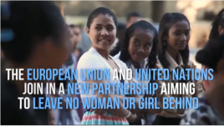

The EU and the UN launch the Spotlight Initiative to eliminate violence against women and girls.

<https://www.youtube.com/watch?v=VpsfYKdGFso>

In 2017 the EU also launched a €500 million initiative in partnership with the UN to eliminate all forms of violence against women and girls worldwide.

The EU’s mandate to begin formal negotiations on a new partnership with the African, Caribbean and Pacific countries after 2020 was proposed by the Commission.

The 2007 Aid for Trade policy was revised to move towards a broader trade-for-sustainable-development approach aimed at increasing the development impact of economic relations with partner countries.

The EU as a defender of human rights

During the year the EU reaffirmed its role as a leading human rights actor in the global arena. In June the EU published a mid-term review of the EU Action Plan on Human Rights and Democracy (2015-2019). The review identifies areas in which the EU should further focus its efforts concerning human rights in non-EU countries in the remaining implementation period of the current Action Plan.

In line with the priorities of the Global Strategy for the European Union’s Foreign and Security Policy, the EU strongly supported an enabling environment for non-governmental organisations and human rights defenders through human rights dialogues and financial support, and in multilateral forums. A backlash against civil society throughout the world continued during the year. The EU remained firmly opposed to any unjustified restrictions to the rights of freedom of association and peaceful assembly.

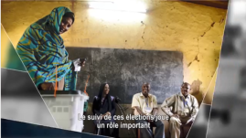

Promoting democracy: EU election observation missions.

<https://www.youtube.com/watch?v=fNtMq6nFvWc>

Security and defence

The EU moved quickly in 2017 on the implementation of the [Global Strategy](https://europa.eu/globalstrategy/en/global-strategy-foreign-and-security-policy-european-union) on security and defence. The first-ever [single command centre](https://eeas.europa.eu/sites/eeas/files/mpcc_factsheet.pdf) for EU military training and advisory missions was established. A [European Centre of Excellence](https://www.hybridcoe.fi/) to improve analysis and the capacity to address hybrid threats was launched (following the 2016 Joint Communication of the Commission and the High Representative of the Union for Foreign Affairs and Security Policy on countering hybrid threats), and [cooperation with NATO](https://eeas.europa.eu/sites/eeas/files/eu_nato_factsheet.pdf) was also stepped up.

In June the Commission launched a [European Defence Fund](https://eeas.europa.eu/sites/eeas/files/defence_fund_factsheet_0.pdf) that will invest €90 million in research and €500 million in the development of industrial defence products and technologies by 2020. Through this Fund the EU budget will be used for the first time to support defence-related projects. It will thus reduce the risk of duplications and promote efficiency in spending by national governments through cooperation in research, development and joint acquisitions.

INVESTING IN RESEARCH AND DEVELOPMENT FOR INDUSTRIAL DEFENCE PRODUCTS AND TECHNOLOGIES

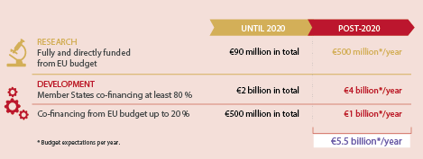

THE EUROPEAN DEFENCE FUND

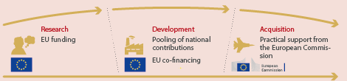

The first calls for research projects have been launched, and the first research projects to be fully financed were announced before the end of 2017 in the fields of unmanned systems and soldier systems. The Commission also proposed a European Defence Industrial Development Programme, deploying €500 million from the EU budget, to co-finance industrial defence products and technologies in their development phase, such as prototypes.

In December, only 6 months after the Commission’s proposal, the Council of the European Union agreed a general approach. With the ongoing work in the European Parliament, the European Defence Fund is on course to be fully up and running to support the first projects from 2019.

PERMANENT STRUCTURED COOPERATION

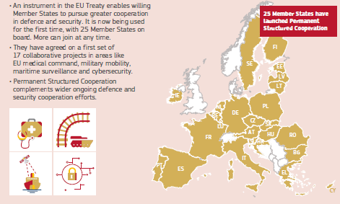

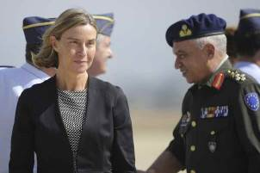

High Representative/Commission Vice-President Federica Mogherini visiting the Zaragoza Air Base, Spain, 8 June 2017.

Acknowledging the need for more coordination and cooperation in the field of security and defence, leaders from 25 Member States launched the [Permanent Structured Cooperation](https://eeas.europa.eu/headquarters/headquarters-homepage_en/34226/Permanent%20Structured%20Cooperation%20(PESCO)%20-%20Factsheet) on defence in December. This will allow those Member States that are willing and able to jointly develop defence capabilities, invest in shared projects and enhance the operational readiness and contribution of their armed forces. They have agreed on 17 collaborative projects, including: rapid-response teams and mutual assistance in cybersecurity; military disaster relief; upgrades to maritime security; establishing a European Medical Command; and establishing an EU Training Mission Competence Centre.

In addition, Member States are sharing their defence spending plans for the first time to better identify shortfalls, be more consistent and benefit from economies of scale through the [Coordinated Annual Review on Defence](https://eeas.europa.eu/headquarters/headquarters-Homepage/36453/coordinated-annual-review-defence-card_en).

Responding to humanitarian crises and emergencies

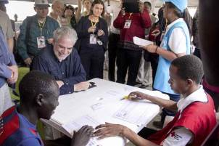

Commissioner Christos Stylianides with South Sudanese refugees in Imvepi, Uganda, 22 June 2017.

In 2017 the EU allocated more than €1.8 billion for humanitarian aid and civil protection. Relief assistance for food, shelter, education, protection and healthcare was provided to more than 120 million people in need in over 80 countries. The EU financed humanitarian aid in all of the world’s major conflict zones, from Iraq and Syria to Afghanistan, the Central African Republic, South Sudan and Yemen.

Over the course of the year more than 65.6 million people worldwide were forcibly displaced due to conflict and war. Some 90 % of the EU’s annual humanitarian aid budget was allocated to projects helping these refugees in 56 countries. The EU also scaled up its response to the threat of starvation and famine faced by millions of people in Nigeria, Somalia, South Sudan and Yemen by allocating €326 million to these countries in 2017.

The EU helped refugees and migrants in Greece through cash assistance and the provision of rental accommodation via the Emergency Support to Integration and Accommodation programme. The Emergency Social Safety Net, the EU’s largest-ever humanitarian programme, has helped over 1.1 million of the most vulnerable refugees in Turkey to meet their essential needs by providing prepaid debit cards.

In 2017 the EU allocated more than 6 % of its humanitarian aid budget to education programmes for children in humanitarian crises, up from 1 % in 2015.

EU HUMANITARIAN AID IN 2017

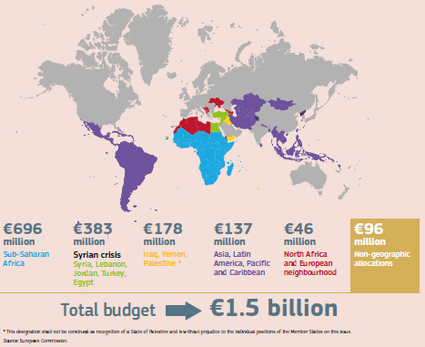

Through the Civil Protection Mechanism the EU also provides and coordinates relief assistance for people in areas hit by disasters in Europe and around the globe. The Mechanism was activated 32 times during the year, including following forest fires in Europe, floods in Peru and hurricanes in the Caribbean.

Multilateral cooperation

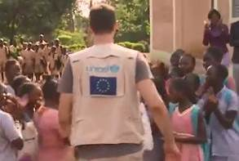

The EU and the UN: working together to improve lives.

<https://www.facebook.com/EuropeanExternalActionService/videos/1574235752639121/>

The EU cooperated closely with the United Nations throughout the year and supported the three priorities of António Guterres, the new UN Secretary-General: conflict prevention, sustainable development and UN reform. Collectively the EU and its Member States are the largest financial contributors to the UN system. In line with its Global Strategy, the EU advocated for stronger global governance, conflict prevention and peace, and the implementation of key agreements on climate change and sustainable development.

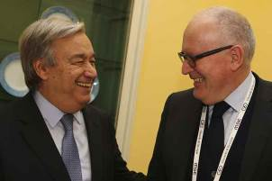

Commission First Vice-President Frans Timmermans greets António Guterres, Secretary-General of the United Nations, at the Munich Security Council, 18 February 2017.

Cooperation between the [EU and NATO](https://eeas.europa.eu/headquarters/headquarters-homepage/29052/eu-nato-cooperation-stronger-ever_en) continued to increase in 2017. This was based on the 2016 Warsaw Declaration regarding mutual cooperation in the face of common threats. EU–NATO cooperation constitutes an integral pillar of the EU’s work aimed at strengthening European security and defence within the framework of the EU Global Strategy. In autumn, parallel and coordinated exercises were held for the first time.

Chapter 10

A Union of democratic change

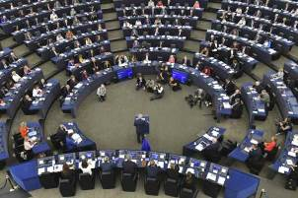

‘A European Commission under my leadership will be committed to fulfilling the special partnership with the European Parliament … I am also committed to enhanced transparency when it comes to contact with stakeholders and lobbyists.’

Jean-Claude Juncker, political guidelines, 15 July 2014

2017 marked the 60th anniversary of the European Union’s founding Treaties. This was an important opportunity to recognise past achievements and celebrate the values that continue to bind Europeans together today. It was also a chance to consider areas for further improvement and the challenges ahead as a new chapter in the EU’s history begins.

To launch the debate on the way ahead, in March the European Commission published a White Paper on the Future of Europe. This set out the main challenges and opportunities expected in the coming decade, together with five scenarios for how the EU could evolve by 2025. It was followed by a series of reflection papers on the issues that will most affect the EU’s future, which stimulated discussions in more than 2 000 public events across Europe.

[The State of the Union speech](https://ec.europa.eu/commission/state-union-2017_en) in September by Jean-Claude Juncker, President of the European Commission, reflected on a year of renewed optimism and ambition for the European project thanks to strong political leadership from the EU institutions and Member States. He presented his vision for a more united, stronger and more democratic union. This was accompanied by a roadmap with key actions needed to complete work on the Commission’s 10 political priorities before the end of its mandate, along with a series of forward-looking initiatives. A special summit of EU-27 leaders on the way forward for the European Union will be held in the Romanian city of Sibiu on 9 May 2019.

The Commission continued to focus on improving the quality of EU policy and law-making to ensure that legislation better serves the people it affects.

Delivering on a positive agenda for Europe

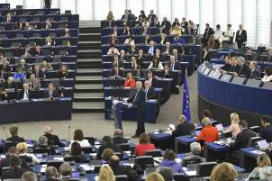

Jean-Claude Juncker, President of the European Commission, giving his State of the Union address at the European Parliament, Strasbourg, France, 13 September 2017.

In his 2016 State of the Union address President Juncker presented a positive agenda for ‘A Europe that protects, empowers and defends’, which was welcomed by the European Parliament and by the EU-27 leaders at the Bratislava Summit in Slovakia in September 2016.

Work on the positive agenda continued in 2017 with the publication on 1 March of a [White Paper on the Future of Europe](https://ec.europa.eu/commission/white-paper-future-europe-reflections-and-scenarios-eu27_en), presenting the Commission’s vision for a future EU of 27 Member States. The White Paper sets out the main challenges and opportunities for the European Union in the coming decade and presents five scenarios for how the EU could evolve by 2025 depending on how it chooses to respond. A series of five reflection papers were subsequently published to open the discussion on the issues that will most affect Europe’s future:

* [the social dimension of Europe](https://ec.europa.eu/commission/publications/reflection-paper-social-dimension-europe_en),
* [harnessing globalisation](https://ec.europa.eu/commission/publications/reflection-paper-harnessing-globalisation_en),
* [the deepening of the Economic and Monetary Union](https://ec.europa.eu/commission/publications/reflection-paper-deepening-economic-and-monetary-union_en),
* [the future of European defence](https://ec.europa.eu/commission/publications/reflection-paper-future-european-defence_en),
* [the future of EU finances](https://ec.europa.eu/commission/publications/reflection-paper-future-eu-finances_en).

On 25 March the leaders of the EU-27 gathered in Rome to celebrate the 60th anniversary of the Treaties of Rome, which created the European Economic Community, a forerunner of today’s EU, and to renew their vows to the Union. In the Rome Declaration adopted at the end of the celebrations leaders set out a joint vision to ‘make the European Union stronger and more resilient, through even greater unity’.

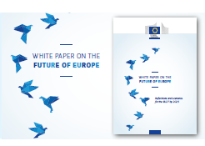

The Commission published the White Paper on the Future of Europe on 1 March 2017.

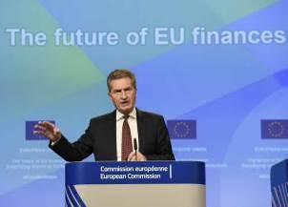

Commissioner Günther Oettinger presenting the final report on simplified rules for EU funds under the next budgetary framework after 2020 at a press conference in Brussels, 11 July 2017.

There is now a window of opportunity to engage on a broader reform of the European Union. The European Commission, together with the European Parliament and the Member States, began a series of Future of Europe Debates across the EU. The European Economic and Social Committee and the European Committee of the Regions were actively involved, organising national and regional debates in the Member States. Discussions will continue in parliaments, cities and regions, leading to a special summit of EU-27 leaders on 9 May 2019 in Sibiu, Romania.

Roadmap for a More United, Stronger and More Democratic Union

In his [State of the Union](https://ec.europa.eu/commission/state-union-2017_en) address in September 2017 President Juncker outlined his vision of how the EU could evolve by 2025. To steer the reform agenda set out in his speech he proposed a [Roadmap](https://ec.europa.eu/commission/sites/beta-political/files/roadmap-factsheet-tallinn_en.pdf) for a More United, Stronger and More Democratic Union. A series of concrete initiatives on trade, investment screening, cybersecurity, industry, data and democracy were adopted by the Commission. President Juncker and Commission First Vice-President Frans Timmermans also [proposed new rules](https://ec.europa.eu/commission/publications/proposal-regulation-statute-and-funding-european-political-parties-and-european-political-foundations_en) on the financing of political parties and political foundations to ensure that funding better reflects the democratic choices made by citizens in the European Parliament elections by increasing transparency, improving democratic legitimacy and strengthening enforcement.

Building on the momentum of renewed optimism and ambition, the Roadmap sets out actions to be achieved by the end of the Commission’s 5-year mandate, together with more forward-looking initiatives that will shape the EU until 2025. Milestones along the way include a credible enlargement strategy for front-runner EU candidate countries in the western Balkans; a future Union budget to match the EU’s ambition and ensure it can deliver on its promises; and a proposal for a European Minister for Economy and Finance.

To complete the work on President Juncker’s 10 political priorities and help shape the EU of the future, the Commission set out key initiatives for the year ahead in its [2018 Work Programme](https://ec.europa.eu/info/publications/2018-commission-work-programme-key-documents_en). This was drawn up in consultation with the Parliament and the Council of the European Union in the context of the Interinstitutional Agreement on Better Law-Making. EU leaders also agreed the new [Leaders’ Agenda](http://www.consilium.europa.eu/media/21594/leaders-agenda.pdf), which should steer the European Council’s work until the end of the current legislative cycle in 2019.

The Commission’s Work Programme includes concrete proposals to deliver on the Circular Economy Action Plan to boost jobs and growth and to complete the Digital Single Market, the Energy Union, the Capital Markets Union, the Economic and Monetary Union, the Banking Union and the Security Union.

Progress was made before the end of the year on a number of actions relating to the Roadmap. In September, at the [Tallinn Digital Summit](https://www.eu2017.ee/political-meetings/tallinn-digital-summit) in Estonia, Member States agreed to complete the Digital Single Market by 2018. The [European Pillar of Social Rights](https://ec.europa.eu/commission/priorities/deeper-and-fairer-economic-and-monetary-union/european-pillar-social-rights_en), which supports fair and well-functioning labour markets and welfare systems, was agreed at the Gothenburg Summit in Sweden in November. In December the Commission set out a [Roadmap for Deepening Europe’s Economic and Monetary Union](http://europa.eu/rapid/attachment/IP-17-5005/en/EMU%20Roadmap.pdf), including concrete steps to be taken over the following 18 months. It also proposed [a political roadmap towards agreeing a comprehensive migration package](https://ec.europa.eu/commission/news/political-roadmap-sustainable-migration-policy-2017-dec-07_en) by June 2018. At the [One Planet Summit](https://www.oneplanetsummit.fr/en/) in Paris, France, marking the second anniversary of the Paris Agreement on climate change in December, the EU took action in the area of climate finance.

The European Parliament

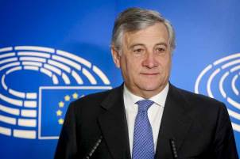

Antonio Tajani was elected President of the European Parliament on 17 January 2017, succeeding Martin Schulz.

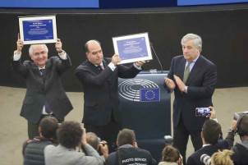

Representatives of the democratic opposition of Venezuela received the European Parliament´s Sakharov Prize for Freedom of Thought during a ceremony in Strasbourg, France, 13 December 2017.

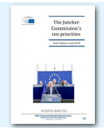

The European Parliamentary Research Service regularly publishes a [report](http://www.europarl.europa.eu/RegData/etudes/IDAN/2018/614679/EPRS_IDA(2018)614679_EN.pdf) on the state of play of the 10 priorities of the Juncker Commission.

On 17 January 2017 Antonio Tajani was elected as the new President of the European Parliament. The Parliament tackled a wide range of policy issues during the year, including the renewed and extended European Fund for Strategic Investments; accessibility requirements for products and services; controlling firearms and action against terrorism; reforming the asylum and legal migration systems; the smart borders entry–exit system; reforming copyright and the telecoms market; preventing geoblocking; reforming the EU Emissions Trading System and developing energy efficiency rules; and the electricity market.

High-profile visitors who addressed the Parliament in 2017 included António Guterres, the United Nations Secretary-General, along with Alexander Van der Bellen, President of Austria, and Frank-Walter Steinmeier, President of Germany, who both chose the European Parliament for one of their first official visits. Justin Trudeau, Prime Minister of Canada, also addressed the Parliament, as did Moussa Faki Mahamat, Chairperson of the African Union Commission.

The European Council

The European Council re-elected Donald Tusk as its President from 1 June 2017 until 30 November 2019.

The European Council held an informal meeting in Valletta, Malta, in February to discuss the external aspects of migration and the central Mediterranean route. The spring European Council focused on the economy, and in particular on the Single Market and trade.

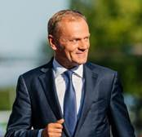

On 9 March 2017 the European Council re-elected Donald Tusk as its President for a second term of 2½ years, from 1 June 2017 to 30 November 2019.

On 29 March the United Kingdom gave formal notification under Article 50 of the Treaty on European Union of its intention to leave the European Union and the European Atomic Energy Community. One month later, at a special meeting, the European Council, in the format of the 27 other Member States, adopted political guidelines setting out the EU’s approach to the Brexit negotiations. The guidelines set out the objective of agreeing on arrangements for an ‘orderly withdrawal’ by the United Kingdom in a first phase of negotiations, before a common understanding on the framework for a future relationship is established in a second phase. In May the General Affairs Council adopted a decision translating these guidelines into detailed negotiating directives and authorising the Commission to act as the EU’s negotiator with the United Kingdom. Negotiations began in June under the leadership of chief negotiator Michel Barnier, who heads the Commission’s [Taskforce on Article 50 Negotiations](https://ec.europa.eu/info/departments/taskforce-article-50-negotiations-united-kingdom_en) with the United Kingdom.

In June the commitment to strengthening EU cooperation on security and defence was reiterated, and leaders agreed on the need to launch an inclusive and ambitious Permanent Structured Cooperation.

In October the European Council reconvened for its ordinary meeting to discuss migration, the digital economy, security and defence, and external relations. Leaders also assessed the progress of the delivery on the Bratislava Agenda and endorsed the new Leaders’ Agenda, which should steer the European Council’s work until the end of the current legislative cycle in 2019. Also, the October European Council, meeting in the format of 27 Member States, reviewed the negotiations for the withdrawal of the United Kingdom, concluding that sufficient progress had not yet been achieved. The European Council invited the 27 Member States, together with the EU’s negotiator, to start internal preparatory discussions on possible transitional arrangements and the framework of future relations with the United Kingdom.

Another informal meeting of Heads of State or Government took place in November in Gothenburg, Sweden, to discuss education and culture. Ahead of this the Commission presented the [Communication ‘Strengthening European identity through education and culture’](http://europa.eu/rapid/press-release_IP-17-4521_en.htm), in which it set out a vision to work towards a European Education Area. This first Social Summit in 20 years gave EU leaders the opportunity to reiterate their ambition to reinforce the social dimension of the EU and to discuss the future of education and culture. During the Summit the Parliament, the Council and the Commission proclaimed and signed the European Pillar of Social Rights, which aims to strengthen rules and laws defining the social policy of the EU, deliver more effective rights to citizens and support fair and well-functioning labour markets and welfare systems.

At its last meeting of 2017, in December, the European Council came back to the issues of defence, the social agenda, education and culture. It welcomed the launch of Permanent Structured Cooperation and identified priorities for taking forward the results of the Gothenburg Social Summit. Under the Leaders’ Agenda the Heads of State or Government discussed both the external and the internal dimensions of migration. During a Euro Summit held in an inclusive format of 27 Member States, leaders also discussed issues related to Economic and Monetary Union and Banking Union. The European Council also met in this format to adopt guidelines that confirmed the Commission’s assessment that sufficient progress had been achieved in the first phase of withdrawal negotiations with the United Kingdom to move to the second phase on transitional arrangements and future relations.

The Council of the European Union

Malta and Estonia held the rotating presidency of the Council of the European Union for the first time. During the first half of the year Malta focused on migration, security, social inclusion, the Single Market and the EU’s neighbourhood and maritime policies. In the second half of the year Estonia paid particular attention to digital Europe and innovation.

The European Economic and Social Committee and the European Committee of the Regions

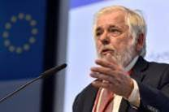

Georges Dassis, President of the European Economic and Social Committee, speaking at the European Solidarity Corps Stakeholder Forum, Brussels, 12 April 2017.

In 2017 the European Economic and Social Committee was actively involved in the debate on the future of Europe, adopting a resolution on the Commission’s White Paper and holding national debates in Member States. In June the Committee also hosted the annual [Civil Society Days](http://www.eesc.europa.eu/?i=portal.en.events-and-activities-civil-society-days-2017-webstream), which focused on providing strong civil-society input into the reflections on the future of Europe.

Karl-Heinz Lambertz was elected President of the European Committee of the Regions in July 2017. During the year the Committee held a series of town-hall events with citizens on the future of Europe, culminating in 29 events in all Member States during the European Week of Regions and Cities in October. The Committee also hosted the eighth European Conference on Public Communication, dedicated to improving governments’ communication with citizens and raising awareness of EU policies.

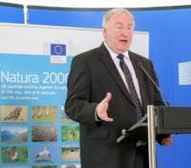

Karl-Heinz Lambertz, President of the Committee of the Regions, at the signature of the Joint Declaration proclaiming 21 May to be European Natura 2000 Day, Brussels, 15 May 2017.

Completing the Better Regulation Agenda

When the Juncker Commission took office in 2014 it decided to focus on issues for which an EU solution is the best option and for which national or local solutions are not effective. This has meant cutting the number of initiatives in the annual work programmes by more than 80 % compared to previous Commissions. To achieve better results and respond better to citizens’ demands, the Commission has opened up policy- and law-making and is listening more closely to the people, with public consultations and special feedback tools being used at each stage of the policymaking and legislative process.

The Better Regulation Agenda is about creating and evaluating EU policies and laws in a transparent manner, with evidence, and backed up by the views of citizens and stakeholders.

Better regulation underpins all of the Commission’s work, ensuring that the EU does only what is needed and does it well. As well as featuring a limited number of priority initiatives each year, this means paying constant attention to the current body of EU law, ensuring it is fit for purpose and carrying out revisions, repeals and simplifications where needed. Everyone can contribute to this process by sharing their views on how to improve existing EU laws via an [online tool](https://ec.europa.eu/info/law/better-regulation/lighten-load).

The Regulatory Fitness and Performance Programme aims to identify opportunities to simplify legislation and reduce unnecessary expenditure. Every time the Commission proposes to revise existing law it checks whether it can be simplified and any unnecessary costs removed. The results under each of the Juncker Commission’s 10 political priorities can be monitored through the [REFIT Scoreboard](http://publications.europa.eu/webpub/com/refit-scoreboard/en/index.html), which also shows how recommendations by [experts and stakeholders](https://ec.europa.eu/info/law/law-making-process/evaluating-and-improving-existing-laws/refit-making-eu-law-simpler-and-less-costly/refit-platform_en) have been taken into account by the Commission. To date 69 opinions have been adopted, drawing on over 280 public suggestions on how to make EU laws more effective and efficient.

The [Regulatory Scrutiny Board](https://ec.europa.eu/info/law/law-making-process/regulatory-scrutiny-board_en) is an independent body providing quality control for impact assessment and evaluation work. In 2017 it continued its work, strengthening monitoring, quantification and upstream guidance and developing regular outreach activities with other institutions and regulatory watchdogs.

The Commission Work Programme for 2018 was accompanied by the [Communication ‘Completing the Better Regulation Agenda: better solutions for better results’](http://europa.eu/rapid/press-release_IP-17-4004_en.htm), which takes stock of the progress made so far and sets out additional steps the Commission intends to take. More extensive engagement with the public, systematic evaluation, high-quality impact assessments and a strengthened approach to the regulatory fitness check have led to improved appraisal of new proposals and existing legislation. This has helped both policymakers and stakeholders to argue on the basis of evidence and expected impacts.

The Task Force on Subsidiarity, Proportionality and ‘Doing Less More Efficiently’

To complete the work on the Better Regulation Agenda, on 14 November 2017 President Juncker officially established a [Task Force](http://europa.eu/rapid/press-release_IP-17-4621_en.htm) on Subsidiarity, Proportionality and ‘Doing Less More Efficiently’. The Task Force is chaired by Commission First Vice-President Frans Timmermans and will make recommendations on how to better apply the principles of subsidiarity and proportionality to make sure that the EU acts only where it adds value. This means making sure that decisions are taken as closely as possible to the citizen — at national, regional or local level — unless action at EU level is more effective. It also means ensuring that regulation goes no further than required. The Task Force identifies policy areas in which results could be more effectively achieved by Member States and ways to better involve regional and local authorities in EU policymaking and delivery.

The Interinstitutional Agreement on Better Law-Making

In 2017 the Parliament, the Council and the Commission implemented the new Interinstitutional Agreement on Better Law-Making. Following the adoption of the Agreement in 2016 the three institutions agreed for the first time ever on a [Joint Declaration establishing a list of 58 legislative priorities for 2017](https://ec.europa.eu/commission/publications/joint-declaration-eus-legislative-priorities-2017_en). The initiatives focused on jobs, growth and investment; the EU social dimension; EU security and migration policy; the Digital Single Market; and ambitious energy- and climate-policy solutions.

Of the 58 initiatives presented by the Commission 28 were delivered by the end of the year, following agreement by the Parliament and the Council. These include the renewal and extension of the European Fund for Strategic Investments and new rules to prevent money laundering. This total includes initiatives agreed politically, with the final formal steps of the legislative process to be completed early in 2018.

THE 2017 JOINT DECLARATION

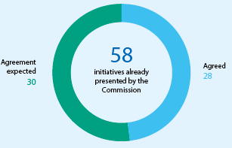

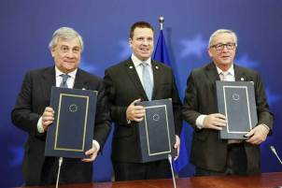

Jean-Claude Juncker, President of the European Commission (right), with Antonio Tajani, President of the European Parliament (left), and Jüri Ratas, Prime Minister of Estonia (centre), at the signing of the Joint Declaration on the EU legislative priorities for 2018-2019, Brussels, 14 December 2017.

In December the Presidents of the three institutions reviewed the progress that had been achieved and [agreed 31 further priorities](https://ec.europa.eu/commission/publications/joint-declaration-eus-legislative-priorities-2018_en) on which to work more closely together to tackle the major challenges that lie ahead. With 18 months until the next European Parliament elections this effective setting of priorities shows that the EU can deliver for its citizens when and where it matters.

During the year the Commission started formal negotiations with the Parliament and the Council on a major legislative proposal to align more than 160 existing pieces of EU legislation with the Lisbon Treaty. This includes old legal provisions that have to be updated to ensure uniform implementation in the Member States, and also takes into account technological and scientific progress.

In addition, the three institutions began to negotiate criteria that, when agreed, will help distinguish more easily between delegated and implementing acts, the two types of empowerment offered by the Lisbon Treaty. Together they developed the Interinstitutional Register for Delegated Acts, which was formally launched on 12 December and will provide complete information and transparency on all the steps in the life cycle of a delegated act.

Monitoring the application of EU law

In order for citizens and businesses to reap the full benefits of EU law it is crucial that Member States transpose EU directives into their national legislation within the deadlines they have committed to, and that they apply EU law correctly.

In July the Commission adopted its [Annual Report](http://europa.eu/rapid/press-release_IP-17-1846_en.htm) on monitoring the application of EU law, highlighting the main trends in 2016. This report noted an overall increase of 21 % in open infringement cases compared to the previous year. There were more than 1 500 open infringement cases against the 28 Member States at the end of 2017, compared to just 1 300 at the end of 2013.

INFRINGEMENT CASES OPENED BY THE EUROPEAN COMMISSION

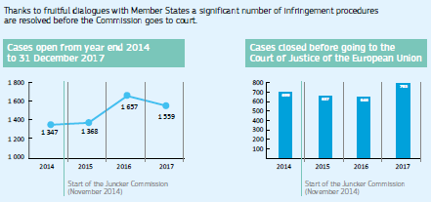

In line with its [Communication ‘EU law: Better results through better application’](http://europa.eu/rapid/press-release_IP-16-3963_en.htm), which was adopted in December 2016, the Commission stepped up its efforts to apply, implement and enforce EU law. In particular it will make full use of the financial sanction system in cases in which Member States fail to transpose a Directive into national law within the agreed deadline.

Giving citizens a say in EU law-making

As part of the Better Regulation Agenda there are now more opportunities for citizens to contribute to the EU law-making process. In February 2017 a [new web portal](https://ec.europa.eu/info/law/contribute-law-making/participate-law-making-process_en) was launched for citizens and stakeholders to have their say throughout the policymaking cycle. Feedback is collected on new initiatives, from the initial ideas set out in roadmaps all the way through to legislative proposals, and is published instantly online, thereby increasing transparency. During the year the feedback section of the portal received almost half a million visits.

Transparency and accountability

Comitology

To ensure greater transparency and accountability the European Commission has proposed a reform of the comitology [system](http://europa.eu/rapid/press-release_IP-17-264_en.htm), through which EU Member States control how the Commission implements EU law. This will oblige them to take clear positions, and thus more political responsibility, when their opinion on sensitive decisions is requested.

The Joint Transparency Register

More than 11 500 entities feature on the existing [Transparency Register](http://ec.europa.eu/transparencyregister/public/homePage.do), and more than 7 000 of them have joined since the Commission adopted new rules in November 2014 making registration mandatory to get a meeting with its top decision-makers.

In 2016 the Commission presented a proposal to establish a mandatory Joint Transparency Register covering the Parliament, the Commission and, for the first time, the Council. This proposal aims to achieve a robust system and high standards of transparency in the three institutions. The Parliament and the Council adopted their negotiation mandates in 2017, and [negotiations are set to begin early in 2018](http://europa.eu/rapid/press-release_IP-17-5250_en.htm).

A new Code of Conduct for Members of the Commission

A new Code of Conduct that will set new standards and strengthen ethical rules for the Members of the European Commission is due to enter into force in February 2018, after the Parliament’s consultation procedure.

Access to documents

In September the Commission’s [2016 Report on Access to Documents](https://ec.europa.eu/info/about-european-commission/service-standards-and-principles/transparency/freedom-information/access-documents_en) was adopted, showing that citizens and organisations are making active use of this right, which is an important tool in promoting transparency. More than 6 000 initial applications for access to documents were received. The requested documents were fully or partially disclosed in more than 81 % of cases.

Control of the EU budget

After a positive recommendation from the Council, the Parliament gave its final approval in April 2017 to the way the Commission implemented the EU budget in 2015.

THE BETTER REGULATION AGENDA

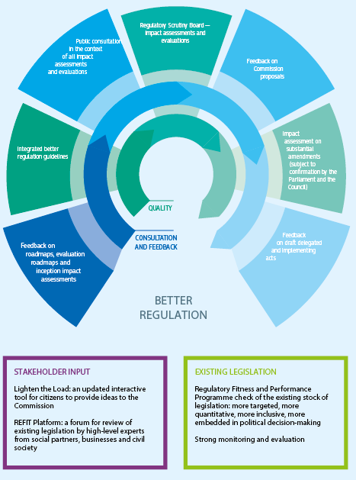

In July the Commission presented its [Integrated Financial Reporting Package](http://ec.europa.eu/budget/biblio/media/2017package_en.cfm) on the 2016 EU budget, putting together all the available information on the EU’s revenue, expenditure, financial management and performance. The reports demonstrated that the EU budget delivered results in line with the Commission’s priorities and was implemented properly. In September, for the 10th year in a row, the [European Court of Auditors](https://publications.europa.eu/en/publication-detail/-/publication/54dec854-a41e-11e7-9ca9-01aa75ed71a1/language-en) issued a clean bill of health on the [EU’s annual accounts](http://ec.europa.eu/budget/library/biblio/publications/2017/EU_Annual_Accounts_2016_en.pdf), finding them to be true and fair. Moreover, the Court detected fewer errors across the areas of spending than reported in the previous 3 years, and for the first time issued a qualified (rather than an adverse) opinion on the final overall level of estimated error. For roughly half of the EU’s spending the error rate did not even reach the level considered by the Court to be material. No errors were found on the revenue side of the budget.

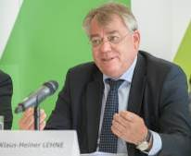

Klaus-Heiner Lehne, President of the European Court of Auditors, presenting the 2016 Annual Activity Report of the European Court of Auditors, Luxembourg, 24 April 2017.

National parliaments

In June two annual reports were published: the [Annual Report 2016 on Subsidiarity and Proportionality](http://eur-lex.europa.eu/legal-content/en/TXT/?uri=CELEX:52017DC0600); and the [Annual Report 2016 on Relations between the European Commission and National Parliaments](http://eur-lex.europa.eu/legal-content/EN/TXT/?uri=COM:2017:601:FIN).

VISITS TO AND BY NATIONAL PARLIAMENTS

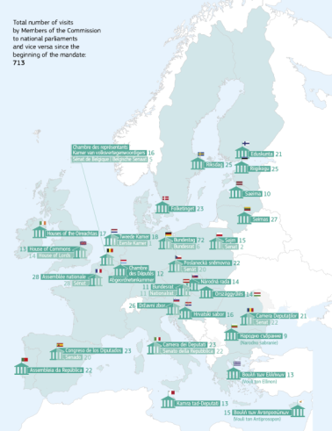

A total of 576 opinions from national parliaments were received during 2017, including 53 reasoned opinions submitted under the [Subsidiarity Control Mechanism](https://ec.europa.eu/info/law-making-process/how-eu-laws-are-adopted/relations-national-parliaments/subsidiarity-control_en) arguing that legislative acts presented by the Commission did not comply with the [subsidiarity principle](http://eur-lex.europa.eu/summary/glossary/subsidiarity.html). The Commission continued to strengthen its political dialogue with national parliaments. In particular, Commissioners met with national parliaments 217 times over the course of the year, either during visits to Member States or when parliamentarians visited Brussels. Members of the Commission also attended a variety of interparliamentary meetings and other events at which they engaged with national parliamentarians.

The European Ombudsman

In 2017 the European Ombudsman’s inquiries into alleged maladministration in the institutions and bodies of the European Union covered horizontal topics such as the Code of Conduct of Commissioners, the Ad Hoc Ethical Committee, the appointment of Commission special advisors, the transparency and composition of the Commission’s expert groups and the handling of infringement complaints under the [EU Pilot](http://ec.europa.eu/internal_market/scoreboard/performance_by_governance_tool/eu_pilot/index_en.htm) scheme. Specific topics such as issues relating to call for tenders, contracts, late payments, individual staff matters and access to documents were also addressed.

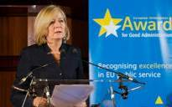

Emily O’Reilly, the European Ombudsman, presenting the European Ombudsman Award for Good Administration, Brussels, 30 March 2017.

The European Citizens’ Initiative

The Commission registered eight new Initiatives during the year, and acknowledged the successful collection of signatures for [one Initiative](http://ec.europa.eu/citizens-initiative/public/initiatives/successful/details/2017/000002). In September, as part of the State of the Union package, a [proposal](http://ec.europa.eu/citizens-initiative/public/regulation-review) was made to reform the [European Citizens’ Initiative](http://ec.europa.eu/citizens-initiative/public/welcome) to make it more accessible and user friendly. The revision aims to achieve the full potential of the Citizens’ Initiative as a tool to foster democratic debate and enable citizens to contribute to the EU’s agenda.

Following the European Citizens’ Initiative [‘Ban glyphosate and protect people and the environment from toxic pesticides’](http://ec.europa.eu/citizens-initiative/public/initiatives/successful/details/2017/000002), the Commission committed on 12 December to presenting a legislative proposal in 2018 to further increase the transparency and quality of studies used in the scientific assessment of substances by the European Food Safety Authority. As regards the request to ban glyphosate, the EU considered that there are neither scientific nor legal grounds to justify such a ban.

Citizens’ Dialogues

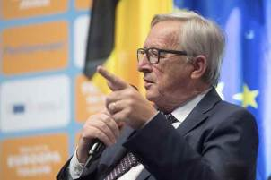

Jean-Claude Juncker, President of the European Commission, at the Citizens’ Dialogue event at the National Museum of Art, Bucharest, Romania, 11 May 2017.

Throughout 2017 the Commission continued to engage with the public through Citizens’ Dialogues. The Commission President, Vice-Presidents and all Commissioners, along with a number of Members of the European Parliament and national politicians, took part in 156 Dialogues during the year. These were complemented by another 161 Citizens’ Dialogues with senior officials from the Commission.

Highlights included Dialogues with President Juncker and Miro Cerar, Prime Minister of Slovenia, in [Ljubljana](https://ec.europa.eu/info/events/citizens-dialogues/citizens-dialogue-president-jean-claude-juncker-ljubljana-2017-mar-02_en), Slovenia on the day after the adoption of the White Paper on the Future of Europe in March; with Commission First Vice-President Timmermans in [Stockholm](https://ec.europa.eu/info/events/citizens-dialogues/citizens-dialogue-stockholm-first-vice-president-frans-timmermans-2017-may-11_en), Sweden, to mark Europe Day in May; and with High Representative of the Union for Foreign Affairs and Security Policy/Commission Vice-President Federica Mogherini and Joseph Muscat, Prime Minister of Malta, in [Rome](https://ec.europa.eu/info/events/citizens-dialogues/citizens-dialogue-rome-high-representative-vice-president-federica-mogherini-2017-mar-24_en), Italy, on the eve of the 60th anniversary of the signature of the Treaties of Rome.

CITIZENS’ DIALOGUES TOOK PLACE IN 160 LOCATIONS ACROSS THE EU IN 2017

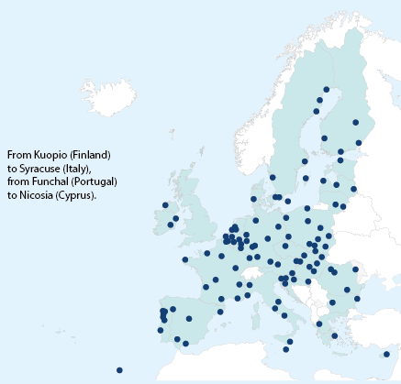

CITIZENS’ DIALOGUES IN 2017: OUTREACH

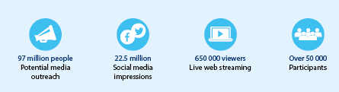

In September Antonio Tajani, President of the European Parliament, participated in a Citizens’ Dialogue in [Norcia](https://ec.europa.eu/info/events/citizens-dialogues/citizens-dialogue-norcia-president-european-parliament-antonio-tajani-and-commissioner-tibor-navracsics-2017-sep-04_en), Italy, with Commissioner Tibor Navracsics, while Commissioner Corina Crețu and Karl-Heinz Lambertz, President of the European Committee of the Regions, took part in [a Dialogue in Bucharest](https://ec.europa.eu/info/events/citizens-dialogues/citizens-dialogue-bucharest-commissioner-corina-cretu-and-president-committee-regions-karl-heinz-lambertz-2017-sep-08_en), Romania.

The 317 Citizens’ Dialogues that took place during the year gave citizens and decision-makers the opportunity to talk face to face, with particular priority given to discussing citizens’ reactions to the White Paper on the Future of Europe and the issues that are most important to them, including social Europe, the involvement of young people and the concern that democracy and unity in the EU are being challenged by populists. The Dialogues took place in 160 towns and cities in 27 Member States and were attended by over 50 000 people, with a further 193 000 people following nine Facebook Live Citizens’ Dialogues.

The withdrawal of the United Kingdom from the European Union

On 23 June 2016 a majority of the citizens of the United Kingdom who voted in the referendum on membership of the European Union voted to leave the EU. On 29 March 2017 the United Kingdom formally [notified the European Council](http://www.consilium.europa.eu/en/press/press-releases/2017/03/29/euco-50-statement-uk-notification/) of its intention to leave the EU and the European Atomic Energy Community (Euratom). In doing so it triggered Article 50 of the Treaty on European Union, which sets out the procedure for a Member State to withdraw from the Union.

**The negotiation process**

At a special [meeting of the European Council](http://www.consilium.europa.eu/en/meetings/european-council/2017/04/29/) on 29 April the leaders of the other 27 Member States adopted political [guidelines](http://www.consilium.europa.eu/en/press/press-releases/2017/04/29/euco-brexit-guidelines/) on the orderly withdrawal of the United Kingdom from the EU. These defined the framework for the negotiations and set out the EU’s overall positions and principles. Four days later the Commission sent a [Recommendation](https://ec.europa.eu/info/sites/info/files/recommendation-uk-eu-negotiations_3-may-2017_en.pdf) to the Council to open Article 50 negotiations with the United Kingdom, including [draft negotiating directives](https://ec.europa.eu/info/sites/info/files/annex-recommendation-uk-eu-negotiations_3-may-2017_en.pdf).

On 22 May the Council adopted a Decision authorising the opening of negotiations with the United Kingdom and formally nominating the Commission as the EU’s negotiator. It also adopted the first set of negotiating directives. These provided for a clear structure and a united EU approach to the negotiations.

The EU is represented by Michel Barnier, who was appointed as Chief Negotiator by the European Commission. At the European Commission a Taskforce under the authority of Michel Barnier coordinates the work on all of the strategic, operational, legal and financial issues related to the negotiations. The Commission reports back to leaders and to the Council throughout the negotiations, and also keeps the European Parliament closely and regularly informed.

**The first phase of negotiations**

The first phase of the talks began on 19 June, shortly after the UK general election. It set out to provide as much clarity and legal certainty as possible and to settle the disentanglement of the United Kingdom from the EU.

Six negotiating rounds were held during 2017. Negotiations focused on three priority issues: protecting citizens’ rights; the framework for addressing the unique circumstances in Ireland and Northern Ireland; and the financial settlement to ensure that both the EU and the United Kingdom respect their financial obligations undertaken before the withdrawal. In addition, the negotiations covered other separation issues.

On 20 October the leaders of the EU-27, meeting in the [European Council](http://www.consilium.europa.eu/en/meetings/european-council/2017/10/20/), agreed to start internal preparations for the second phase of the talks, while calling for more progress on the three priority areas. They also said that they would reassess the state of progress to determine whether 'sufficient progress' had been achieved on each of the three issues at their summit in December.

On 8 December the European Commission [recommended](http://europa.eu/rapid/press-release_IP-17-5173_en.htm) to the European Council to conclude that sufficient progress had been made in the first phase of the Article 50 negotiations with the United Kingdom. The Commission’s assessment was based on a [Joint Report](https://ec.europa.eu/commission/files/joint-report-negotiators-european-union-and-united-kingdom-government-progress-during-phase-1-negotiations-under-article-50-teu-united-kingdoms-orderly-withdrawal-european-union_en) agreed by the negotiators of the Commission and the UK government, endorsed by Theresa May, Prime Minister of the United Kingdom, during a meeting with Jean-Claude Juncker, President of the European Commission.

On [15 December the European Council](http://www.consilium.europa.eu/en/meetings/european-council/2017/12/14-15/) confirmed that sufficient progress had been achieved, and the leaders adopted [guidelines](http://www.consilium.europa.eu/en/press/press-releases/2017/12/15/european-council-art-50-guidelines-for-brexit-negotiations/) to move to the second phase of negotiations, on possible transitional arrangements and the future relationship between the EU and the United Kingdom.

**The next phase of negotiations**

Following this achievement of sufficient progress in the first phase of negotiations, on 20 December the European Commission sent a [Recommendation](https://ec.europa.eu/commission/publications/commissions-recommendation-including-supplementary-negotiating-directives_en) to the Council to begin discussions on the next phase of negotiations, including draft negotiating directives. These supplement the negotiating directives from May 2017 and set out [additional details](http://europa.eu/rapid/press-release_IP-17-5342_en.htm) on possible transitional arrangements.

The Recommendation also recalls the need to translate into legal terms the results of the first phase of the negotiations, as outlined in the Commission’s [Communication](https://ec.europa.eu/commission/publications/communication-commission-european-council-article-50-state-progress-negotiations-united-kingdom-under-article-50-treaty-european-union_en) and Joint Report. It underlines that work needs to be completed on all withdrawal issues. This includes those not yet addressed in the first phase, such as the overall governance of the Withdrawal Agreement, as well as substantive issues, for instance public procurement, intellectual property rights, data protection and goods placed on the market before the United Kingdom’s withdrawal from the EU. In line with the European Council’s guidelines of 15 December, the additional negotiating directives on transitional arrangements were to be adopted in January 2018.

Negotiations should be completed by autumn 2018 in order to allow enough time before 29 March 2019 for the Withdrawal Agreement to be concluded by the Council, after obtaining the consent of the European Parliament, and to be approved by the United Kingdom in accordance with its own procedures.

The Withdrawal Agreement should take into account the framework of the future relationship. The actual agreement on a future relationship between the EU and the UK can only be concluded after the United Kingdom has left the EU. EU leaders declared their readiness to start preliminary and preparatory discussions on the framework for that future relationship during the second phase of the Article 50 negotiations.

Exceptional moments in 2017

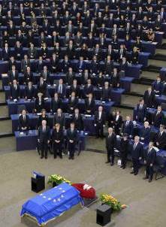

A [European Ceremony of Honour](https://www.youtube.com/watch?v=Lk_qabMPzcQ) for Helmut Kohl (1930-2017), the former Chancellor of Germany, at the European Parliament, Strasbourg, France, 1 July 2017.

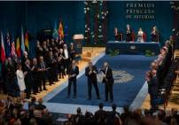

Donald Tusk, President of the European Council, Antonio Tajani, President of the European Parliament, and Jean-Claude Juncker, President of the European Commission, receive the [2017 Princess of Asturias Award for Concord](http://www.fpa.es/en/princess-of-asturias-awards/laureates/2017-european-union.html?especifica=0&idCategoria=0&anio=2017&especifica=0) on behalf of the European Union from King Felipe VI of Spain, Oviedo, 20 October 2017.